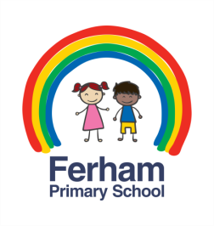
Home Learning Challenges
Year 1 & 2 – Spring 1

How many of these challenges can you complete?

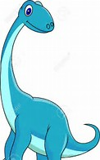  Work with a grown-up  at home to research  more amazing facts  about dinosaurs. | 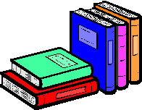  Visit the library and borrow a book about dinosaurs.
Create a dinosaur  mask or hat and bring  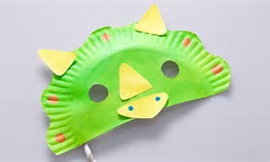  it into school. | 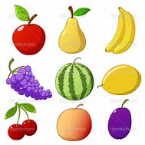  Make a dinosaur  out of fruit  and eat it.
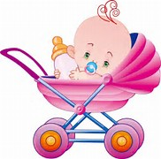  Talk to a grown-up  about how you  have changed  since you were a baby. | Draw a picture of things you used to do when you were a baby.

Red | Complete the basic weekly home learning  (daily reading, spellings, number facts)
Yellow | As red, plus 2 of the challenges
Green | As red, plus 4 of the challenges
Blue | As red, plus all 6 of the challenges

What colour of the home learning rainbow will you achieve?

