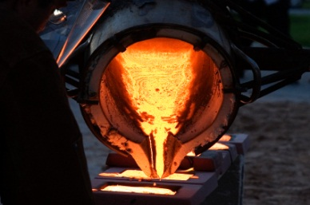

How you can help at home

* Reading little and often and talking about what you have read
* Enjoy reading the poem of the week together
* Practice reading and spelling the spelling words every week and using them in sentences.
* Do the homework with your child every week and talk about it with them!
* Look around you and talk about the different materials that are used to make things.

Computing

We will be learning about researching topics and saving documents.

Maths

We will be learning all about place value and then how to use this knowledge help us to add and subtract numbers accurately.

**This half term we will be learning about Mighty Metals! We will be learning about types of metals and whether they are magnetic or not. We will also be learning about all the different types of forces that control our lives and using our knowledge of these forces to design many things, including cars and playgrounds!**

RE

We will be learning about Hinduism.

DT

We will be exploring levers and spinners.

**Mighty Metals!**

Literacy

We will be writing poetry, instructions and non-chronological reports..

Art

We will be making beautiful pictures out of foil.

PE

Our PE days are Tuesday and Thursday. We will be learning large ball skills and football.

Science

We will be learning all about forces, magnets and how to complete a fair test.

PSHE

We will be learning about how to express their views confidently and how important it is to recognise their own worth.