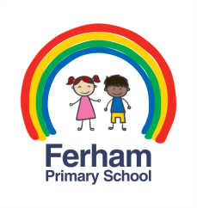
Ferham Primary School
Cornerstones Learning Project Overview 2017-19

 | 2017-18 | 2018-19
Foundation 1 | - Why do you love me so much?  - Why do leaves go crispy?  - Where does snow go?  - Are eggs alive?  - Did dragons exist?  - How many pebbles on a beach? | - Why do you love me so much?  - How many colours in a rainbow?  - Can we explore it?  - Why can't I eat chocolate for breakfast?  - Is it shiny?  - How high can I jump?
Foundation 2 | - Do you want to be friends?  - Why do squirrels hide their nuts?  - Where does snow go?  - Are eggs alive?  - Will you read me a story?  - Who lives in a rockpool? | - Do you want to be friends?  - Are carrots orange?  - Are we there yet?  - Do cows drink milk?  - What is a reflection?  - How high can I jump?
Year 1 & 2 | - Moon Zoom!  - Dinosaur Planet  - Splendid Skies  - Towers, Tunnels and Turrets  - Wriggle and Crawl | - Street Detectives  - Bright Lights, Big City  - Superheroes  - Bounce!  - Paws, Claws and Whiskers  - Scented Garden
Year 3 & 4 | - Heroes and Villains  - Potions  - 1066  - Predators  - Gods and Mortals  - Burps, Bottoms and Bile | - Mighty Metals  - Tremors  - Traders and Raiders  - Blue Abyss  - Tribal Tales  - Scrumdiddlyumptious
Year 5 & 6 | - World War II  - Mexico  - Blood Heart | - Tudors  - Beast creator  - Space

