Home Learning Challenges
Foundation Stage – Spring 1

How many of these challenges can you complete?

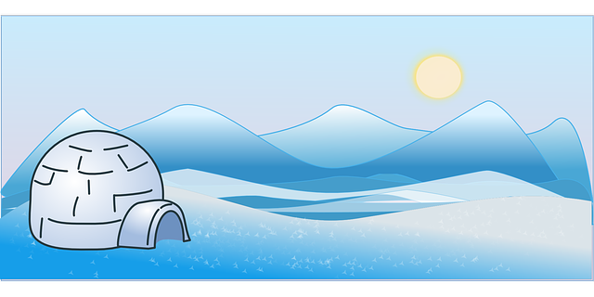  Find out about an animal that lives in a cold place. | 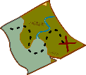  Play a treasure hunt game where you have to listen to instructions to find the next “clue”
Design a winter scarf. You could draw it, paint it or even make a collage. | Make fruit kebabs or vegetable faces to try different types of fruit and vegetables.
Go on a Winter walk with a grown up and look around to see things that have changed. | Play a game like football, basketball or throwing balls into bowls or boxes.
Red | Complete the basic weekly home learning  (daily reading, spellings, number facts)
Yellow | As red, plus 2 of the challenges
Green | As red, plus 4 of the challenges
Blue | As red, plus all 6 of the challenges

What colour of the home learning rainbow will you achieve?

