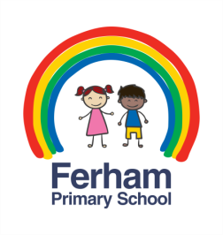
Home Learning Challenges
Year 3 & 4 – Autumn 2

How many of these challenges can you complete?

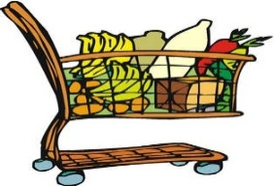  Make a list of all the solids, liquids and gases you can find at home. | Make a comic strip story.
Make ice lollies at home! | 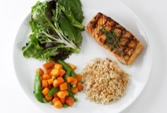  Help cook a meal for your family.
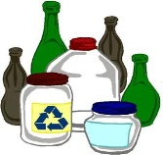  Make a sketch of any interesting bottles you have at home, add patterns, texture and shading. | 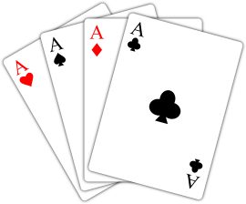  Play a card game or board game.

Red | Complete the basic weekly home learning  (daily reading, spellings, number facts)
Yellow | As red, plus 2 of the challenges
Green | As red, plus 4 of the challenges
Blue | As red, plus all 6 of the challenges

What colour of the home learning rainbow will you achieve?

