This week’s learning for Year 4 Date:02.11.20
Hello children,
I hope you have all had a lovely half term! Please do make sure you’re sending me things on class dojo. Here is this week’s home learning. Remember the parts in blue are really important and you should try your best to do these. The bits in red are other activities that you should do in an afternoon. These green parts are optional but I think you will find them interesting. I have also suggested times for you to do the activities as your brain is more alert in the morning. However, these times can be adjusted by you and your parents, if they don’t fit into your daily routine.
Take care,
Miss Moss
Monday
9.00am – Spellings (for 15 minutes)
Can you practise page these five spellings from the Y3/4 statutory spellings using this format please?
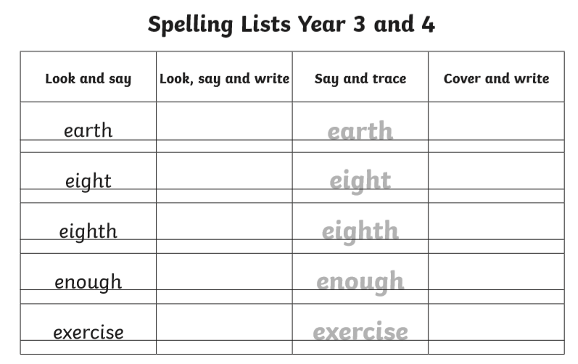

9.15am – Success for All/Literacy (for 60 minutes)
Can you find some children’s poetry on the internet? What is the first thing you notice about the sounds in the poem? Why do you think the poet did this? How would you change this poem if you could?

Can you write a poem about your favourite animal?

10:15 – Phonics (30 minutes)
Phonicsplay is an exciting website which is free to login – there are plenty of games to choose from, make sure you choose phase 3 please.

10.45am – Fit 15/break (for 15 minutes)
Spend this time doing something active to release all your excess energy!
Have a go at sonic cosmic yoga
https://www.youtube.com/watch?v=QM8NjfCfOg0

11am – Maths (for 60 minutes)
This week we are moving onto subtraction. Can you watch this video to show you how to subtract two digit numbers: https://www.youtube.com/watch?v=REr2ggdvSRc

Can you complete these subtractions please?
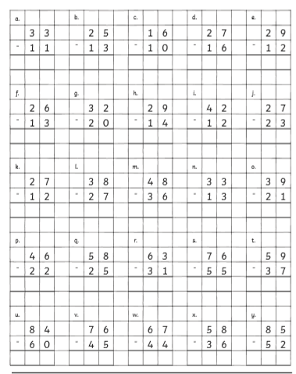

Optional Afternoon Activity – Art
.
Can you find a picture of a famous Sheffield landmark and draw and add colour any way you like?

Tuesday
9.00am – Spellings (for 15 minutes)
Using the five spellings from yesterday, can you try and use each word in a sentence? Remember your full stops and capital letters.

9.15am – Success for All/Literacy (for 60 minutes)
Can you write a poem about someone you see as a role model? Be prepared to read this to the class when you come back.
Here is a great example:
Top of Form
Bottom of Form

Submit your work, meet writers and drop the ads. Become a member

Words
rojo role rolemodel roles roll
Wolfgang Blacke May 2013
Everybody needs a Superman
Every kid needs a rolemodel
Someone to look up to
For me it was Superman
The 'Man of Steel'
To me, Superman was who I wanted to be
A giant of a man who could move mountains
Saving the world each day
But always coming back to Lois Lane
When I was a kid I would read for hours
About how the world was kept safe from harm
How justice found evil men
How there is always a happy ending
Now it is time for me to become my own Superman
Become the man I have always thought I would be
Always wanted to be
Needed to be
I need to be strong for myself and those around me
A giant of a man, a mountain to latch onto
To protect you, my world
And make sure there will be a happy ending for us all

10.15am – Phonics (for 30 minutes)
Using the digraph ‘ph’ can you find five words with this sound in? Remember the ph makes the ‘f’ sound – like in the words phonics or phone. Can you place those words into sentences?

10.15 – Fit 15 (15 minutes)
Can you practise your times table routines ready to move onto your next times tables next week?

11.00am – Maths (up to 60 minutes)= Subtracting 2 digit numbers with regrouping.
Use this video to support you with today’s learning: https://www.youtube.com/watch?v=sBJp_Toqlhw

Can you complete these subtraction sums using the video as support please.
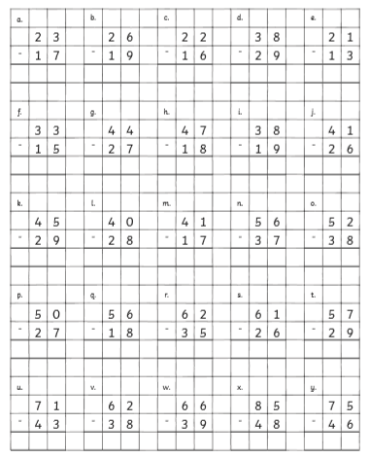

Optional Afternoon Activity – Science
Can you watch this Solids, liquids and gases video: https://www.youtube.com/watch?v=24Yromifcss
Using the information from the video can you complete a solids, liquids and gases hunt around your house and place the items into the correct circle. DON’T FORGET SOME ITEMS CAN COME UNDER MORE THAN ONE HEADING.

Wednesday
9.00am – Bedrock (for 30 minutes)
Using your login details can you complete one lesson with 70% or over.

9.30am – Success for All/Literacy (for 60 minutes)
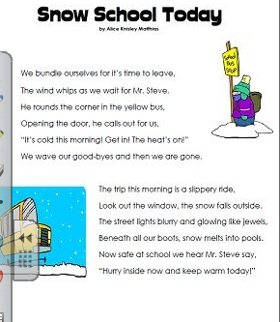

Read this poem about a ‘Snow Day’. Can you create your own poem about what you enjoy doing when school is closed due to a snow fall?

10.30am – Reading (for 20 minutes)
Choose a book to read and enjoy.
Use the phonics you know to sound out the words. Don’t forget to try and spot the digraphs and tricky words.
Talk about what happened in the book and ask/answer up to 3 questions with your grown up.
If you don’t have many books, sign up to Oxford Owl to read an e-book.
https://home.oxfordowl.co.uk/

10.50am – Maths (up to 30 minutes) – Subtracting two digit numbers with regrouping.
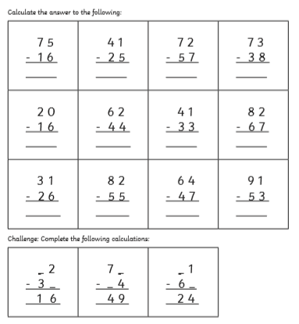

Can you complete these additions please? Remember to use this video to support your learning: https://www.youtube.com/watch?v=sBJp_Toqlhw

11.20am- Number Logik (up to 30 minutes)
Using your login details, challenge yourself to improve your score each time.

Optional Afternoon Activity – PE
Think back to last week’s PE session. Can you have a go at practising some of those stations e.g. press ups, star jumps, jogging on the spot and the plank. See if you can challenge yourself to do ten different exercises!
Look at the circuit cards to help you.

Thursday
9.00am – Maths (for 45 minutes) – Green group (Mrs Southalls group), Blue group (Miss Moss’ group)

Green group can you continue to practise these two digit subtractions until you are confident:
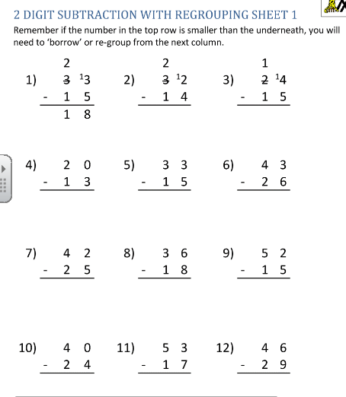
Blue group can you watch this video on 3 digit subtractions: https://www.youtube.com/watch?v=BkzoUfyAXDU

And complete these subtractions:
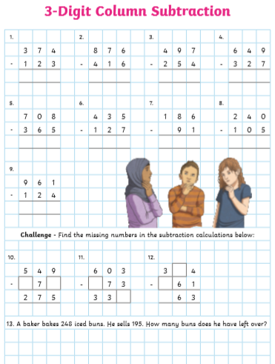

9.45am – Success for All/Literacy (for 60 minutes)
Today I would like you to write a poem about your experiences during COVID. Can you describe how it has changed your day to day life? Also, can you include what we have to do to make sure we are COVID safe?

10.45am – Phonics (for 30 minutes)
Using the digraphs ‘ph’ and ‘ff’, can you create some yes or no questions? Eg Is a phone fluffy?
REMEMBER YOUR CAPITAL LETTERS, FULL STOPS AND QUESTION MARKS.

10.45 – Fit 15 (for 15 minutes)
Spend fifteen minutes jogging and stretching in the garden to release your excess energy!

11.00am – Spellings (up to 20 minutes)
Using your spellings from Monday and Tuesday try to put your spellings into different sentences. To challenge yourselves why don’t you try extending your sentences using FANBOY conjunctions (for, and, nor, but, yet or so).

11.20am – Times tables (30 minutes)
Login and challenge yourself to beat yesterday’s scores.

Optional Afternoon Activity – Design and Technology/Craft
Can you go on an Autumn hunt and collect things you can use to make an autumn collage. Here are some examples:
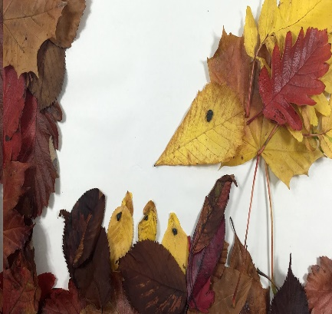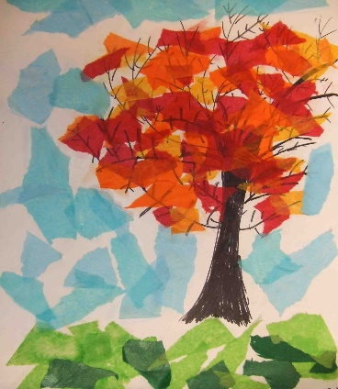

Friday
9.00am – Maths (for 40 minutes) – Revision day - Both Groups!
Can you complete these addition and subtraction sums please?
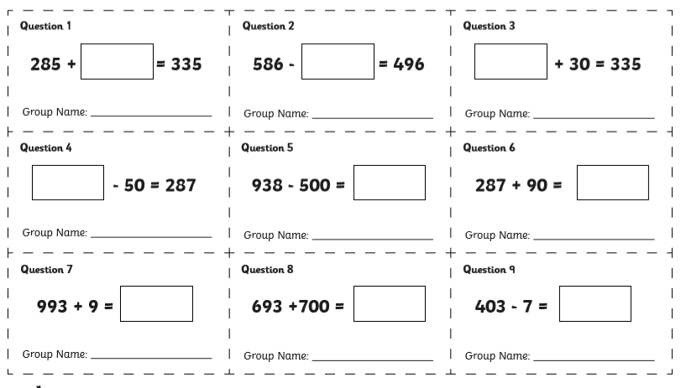

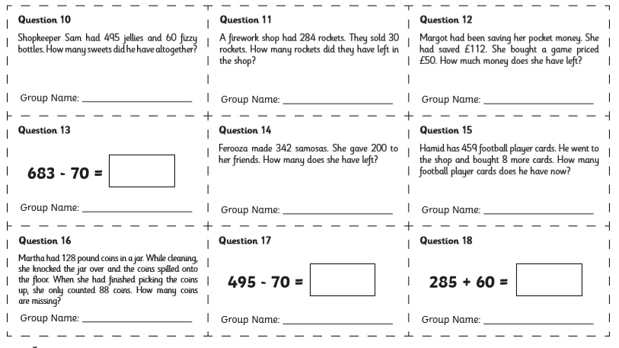

9.40am – Success for All/Literacy (for 60 minutes)
Using your poem from yesterday can you edit it using this success criteria:
Does each line rhyme?
Does each line make sense?
Have you included adjectives and are they used correctly?
Have you used all five senses within your writing?

Once you have finished editing can you rewrite the whole poem using your best handwriting. Remember to use Capital letters and the correct punctuation!

10.40am – Reading (for 20 minutes)
Choose a book to read and enjoy.
Use the phonics you know to sound out the words. Don’t forget to try and spot the digraphs and tricky words.
Talk about what happened in the book and ask/answer up to 3 questions with your grown up.
If you don’t have many books, sign up to Oxford Owl to read an e-book.
https://home.oxfordowl.co.uk/

11.00am – Times tables (up to 20 minutes)
Starting with the times tables I gave your to practise in class, complete those and move on as quickly as possible to the next. See how many you can complete. Make sure you record your times table level to improve on next week.

11.20 – Spellings (10 minutes)
Get an adult to test you on your spellings.
This week’s spellings are: earth, eight, eighth, enough and exercise.

11.30 – Bedrock
Login to your bedrock account and try to complete one lesson with a score of 70% or more.

Optional Afternoon Activity - PSHE
Have a think about what you know about black lives matter. Why is it important to discuss this issue? Why is this issue currently in the media? What can we do to support someone who is being bullied for their skin colour?

Watch the assembly that Mrs Gill created on the website or have a look at the assembly on the Remote learning page.

