Ferham Recommended Reads

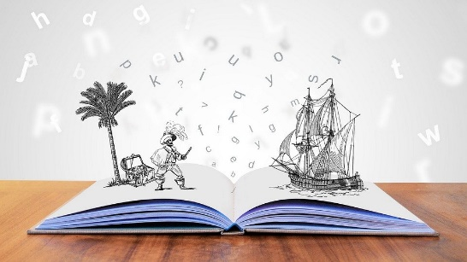
“One you learn to read, you will be forever free” – Frederick Douglass
The following list includes only books that our staff have personally read and would fully recommend to our classes. We have hard copies of most of these books so if you would like to borrow one, ask and we will see what we can do!
December 2020 – These are all recommended reads from staff in school
Book Cover | Title | Author | A Brief Guide
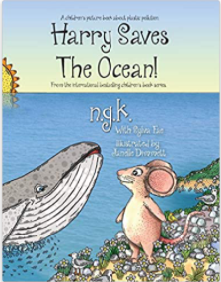 | Harry Saves the Ocean | N G K (Author),  Sylva Fae (Author),  Dimmett Janelle (Illustrator) | Whilst on holiday Harry meets a whale who is in trouble. The whale then tells Harry about the growing problem of plastic pollution, and decides to do something about it. This is an excellent book to help children to learn about taking care and looking after our planet.  Review by Mrs Winder
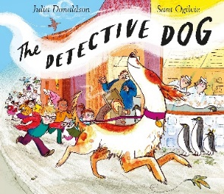 | The Detective Dog | Julia Donaldson | The children love reading their stories to Nell the Detective Dog. But what happens when all the books disappear from the classroom!  Can Nell the Detective dog find them? A beautiful story using rhyme and suspense to captivate the reader, leaving you wanting more.  Review by Mrs Robinson
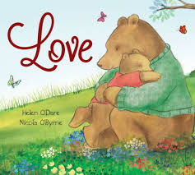 | Love | Helen O’Dare | Love can be many things. It can be small and precious, or tall like a tree, or strong and true, or all of these things and more.  This book explores the joy of unconditional love between a parent/carer and child. The perfect story to create beautiful memories together. A firm favourite at our house.  Review by Mrs Robinson
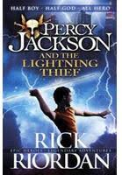 | Percy Jackson and the Lightning Thief | Rick Riordan | HALF BOY, HALF GOD, ALL HERO!  He was just a normal kid. Then he got expelled and sent to Camp Half Blood to battle monsters and try to stay alive. It all changed when Zeus thought he had stolen his lightning bolt. Staying alive is going to be even harder.  An amazing story with brilliant and funny characters, I could read this again and again and again.  Review by Mrs Robinson
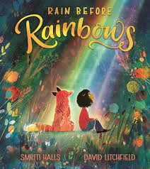 | Rain Before Rainbows | Smitri Halls | The story of a girl and her fox friend who have to leave their home after a terrible fire engulfs the castle they lived in. The girl and the fox encounter some scary thing on their long journey before finally finding a new land where there are new friends to meet and eventually the darkness turns into a bright and wonderful new day. With amazing illustrations.  A simple story with a powerful message. It’s a great message to share with children. Indeed, as the title says you can’t have a rainbow without first having some rain!  Review by Mrs Robinson
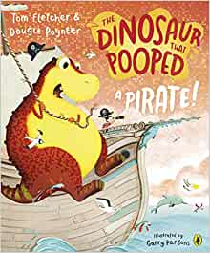 | The Dinosaur that Pooped a Pirate | Tom Fletcher and Dougie Poynter | A Dinosaur that eats things and poops them back out.  This story makes us laugh a lot!  Written by two members of my favourite childhood bands Mcfly and Busted.  Review by Mrs Robinson

