Morning maths Monday 22nd February 2021
WALT: to divide by using a formal written method (the bus stop)
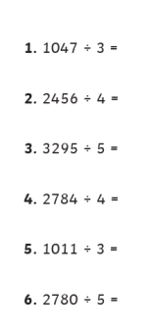
Morning maths Tuesday 23rd February 2021
WALT: use BIDMAS (brackets, indices, division, multiplication, add, subtract)
Can you remember the order in which operations must be performed?
1) 7 + 8 x 3 | 2) 20 – 4 x 2 | 3) 17 + 3 x 6 | 4) 23 – 18 ÷ 3
5) 7 x 3 – 2 x 4 | 6) 3 x 6 + 8 x 2 | 7) 8 + 3 x 2 - 4 | 5) 14 ÷ 2 – 10 ÷ 5

Morning maths Wednesday 24th February 2021
WALT: recognise square numbers
Solve the following:
a) $4^{2}$ b) ${10}^{2}$ c) $8^{2}$
d) ${12}^{2}$ e) $1^{2}$ f) $6^{2}$
g) $7^{2}$ h) $5^{2}$ i) ${15}^{2}$
j)${14}^{2}$ k) ${11}^{2}$ l) $9^{2}$
m) $3^{2}$ n) $2^{2}$ o) ${13}^{2}$

Morning maths Thursday 25th February 2021
WALT: convert fractions to decimals.

Morning maths Friday 26th February 2021
WALT: add fractions with the same denomiator

