This week’s learning for Year 1 Date: 11.1.21
Hello children,
Here is your home learning for this week:
Here are some useful websites you may also want to visit to help with home learning:
https://home.oxfordowl.co.uk/ - access a library of books to read at home
https://www.phonicsplay.co.uk/ - phonics games. It is entirely free due to schools being closed.
https://www.topmarks.co.uk/maths-games/5-7-years/counting - free maths games
If you have any questions or worries, please don’t hesitate to contact us on class dojo, or ring school on 01709 740962.
Take care,
Miss Platts and Mrs. Gregory x
Monday
9.15 - Success for All
Phonics
Miss Platts – watch the powerpoint and complete the activities. We will be practising spelling our ‘oi’ words.
After the session you can practise them again on www.phonicsplay.co.uk - choose a game to play such as ‘trash or treasure’, recapping all sounds up to phase 5.
Mrs Gregory – watch the powerpoint and follow the instructions. We will be practising our ‘o’ words. After the session you can practise them again on www.phonicsplay.co.uk- choose a game to play such as ‘trash or treasure’, recapping all phase 2
Roots Group 1 – Miss Platts
Watch the power point and follow the instructions. We will be reading ‘Is there a monster in the lake’ as our shared story (this will be uploaded to class dojo and the school website)
Our STaR story is ‘Shark in the Dark’ by Nick Sharratt. You can listen to the story here https://www.youtube.com/watch?v=lpOxjl9MOR0
Roots group 2 – Mrs Gregory
Watch the power point and follow the instructions. Our shared story is ‘Card for Dad’ (this will be uploaded to class dojo and the school website)
We will be reading ‘Happy Birthday Winnie’ as our STaR story. You can listen to the story here https://www.youtube.com/watch?v=jfYmfeBcRPc

11.00 - Assembly – see school website

11.15 - Maths - adding ones using number bonds.
Watch the video for today’s lesson here: https://vimeo.com/490879867
Answer questions 1 - 4 on the worksheet. If you need to, you can go back and watch the video at any time to help.
Afternoon -RE: The Creation Story
Ask children: Which day of the week do you like best? Why?
Share the Bible story of ‘Creation’ from Genesis 1. In Jewish belief there is one God, who created the world and everything and everyone in it. Watch the Creation story here – https://www.youtube.com/watch?v=teu7BCZTgDs
Why do you think it says that God rested on the 7th day?
Why do you think it is important for us to rest?
Complete the story board worksheet that details what God created on each day, by drawing a picture in the box. Re-tell the story to someone using the storyboard.
.
Tuesday
9.15 - Success for All
Phonics
Miss Platts – watch the powerpoint and complete the activities as modelled in the video. We will be practising spelling our oi words.
After the session you can practise them again on www.phonicsplay.co.uk - choose a game to play such as ‘trash or treasure’, recapping all sounds up to phase 5.
Mrs Gregory – watch the powerpoint and follow the instructions. We will be practising our ‘c’ words. After the session you can practise them again on www.phonicsplay.co.uk - choose a game to play such as ‘trash or treasure’, recapping all phase 2
Roots Group 1 – Miss Platts
Watch the power point and follow the instructions. We will be reading ‘Is there a monster in the lake’ as our shared story.(this will be uploaded to class dojo and the school website)
Our STaR story is ‘Shark in the Dark’ by Nick Sharratt. You can listen to the story here: https://www.youtube.com/watch?v=lpOxjl9MOR0
Roots group 2 – Mrs Gregory
Watch the power point and follow the instructions. Our shared story is ‘Card for Dad’ (this will be uploaded to class dojo and the school website)
We will be reading ‘Happy Birthday Winnie’ as our STaR story. You can listen to the story here: https://www.youtube.com/watch?v=jfYmfeBcRPc

11.00 - Assembly – see school website

11.15 - Maths - adding ones using number bonds.
Watch the video for today’s lesson: https://vimeo.com/490880277
Answer questions 5 and 6 on the worksheet. If you need to, you can go back and watch the video at any time to help.
Afternoon: History
Explore space exploration key dates by looking at the ‘Space Travel Timeline’ power point.
Make your own ‘Space Travel Timeline’ .You could use the blank timeline and the facts sheet uploaded on to the website/class dojo, or watch this video here which helps you to draw and make your own: https://teachers.thenational.academy/lessons/when-and-how-was-space-discovered-cmv64t

Wednesday
9.15 - Success for All
Phonics
Miss Platts – watch the powerpoint and complete the activities as modelled in the video. We will be practising spelling our oa words.
After the session you can practise them again on www.phonicsplay.co.uk - choose a game to play such as ‘trash or treasure’, recapping all sounds up to phase 5.

Mrs Gregory – watch the powerpoint and follow the instructions. We will be practising our ‘k’ words. After the session you can practise them again on www.phonicsplay.co.uk - choose a game to play such as ‘trash or treasure’, recapping all phase 2
Roots Group 1 – Miss Platts
Watch the power point and follow the instructions. We will be reading ‘Is there a monster in the lake’ as our shared story.(this will be uploaded to class dojo and the school website)
Our STaR story is ‘Shark in the Dark’ by Nick Sharratt. https://www.youtube.com/watch?v=lpOxjl9MOR0
Roots group 2 – Mrs Gregory
Watch the power point and follow the instructions. Our shared story is ‘Card for Dad’(this will be uploaded to class dojo and the school website)
We will be reading ‘Happy Birthday Winnie’ as our STaR story. https://www.youtube.com/watch?v=jfYmfeBcRPc

11.00 - Assembly – see school website

11.15 - Maths - finding and making number bonds.
Watch the video for today’s learning here: https://vimeo.com/490882337
Complete the questions on the accompanying worksheet. If you need to, you can go back and watch the video at any time to help.
Afternoon: Science – The Planets
Can you remember the name of any planets?
Which planet do we live on?
Can you remember any facts you found out last week.
Use the internet to search and find out the order of the planets from the sun.
Which is the closest planet to the sun?
Which is the furthest planet from the sun?
Make your own mobile (use the the ‘solar system mobile’ sheet on the school website / class dojo for the instructions and the planet cut outs) and put the planets in the order they are from the sun. Use the pictures below as a guide for which planet is which.
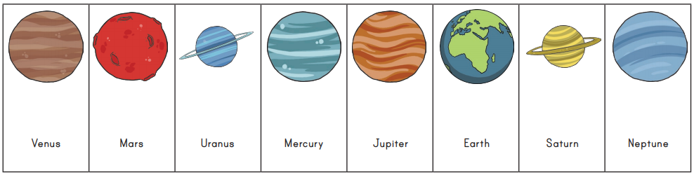

Thursday
9.15am - Success for All
Phonics
Miss Platts – watch the powerpoint and complete the activities as modelled in the video. We will be practising spelling our oa words.
After the session you can practise them again on www.phonicsplay.co.uk - choose a game to play such as ‘trash or treasure’, recapping all sounds up to phase 5.
Mrs Gregory – watch the powerpoint and follow the instructions. We will be practising our ck words. After the session you can practise them again on www.phonicsplay.co.uk - choose a game to play such as ‘trash or treasure’, recapping all phase 2
Roots Group 1 – Miss Platts
Watch the power point and follow the instructions. We will be reading ‘Leaves Fall’ as our shared story.(this will be uploaded to class dojo and the school website)
Our STaR story is ‘Weather and Seasons', This book will be uploaded to class dojo being read aloud for you to listen to.
Roots group 2 – Mrs Gregory
Watch the power point and follow the instructions. Our shared story is ‘Miss Sid meets Sad Sam’(this will be uploaded to class dojo and the school website)
We will be reading ‘Birds’ as our STaR story. This book will be uploaded to class dojo being read aloud for you to listen to

11.00 – Assembly– see school website

11.15 – Maths - finding and making number bonds
Recap yesterday’s learning (you could watch the video here again if you need to: https://vimeo.com/490882337)
Warm up by looking at these questions:
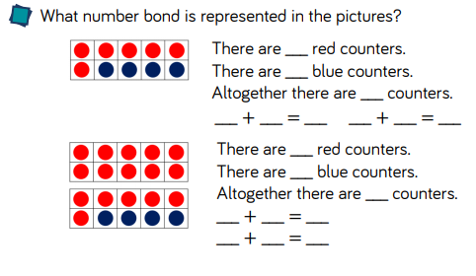
If you know that 6 + 4 = 10, then you also know that 4 + 6 = 10.
If you know that 16 + 4 = 20, then you also know that 4 + 16 = 20.
Look at the numbers used in both 10 frames and talk about what you notice is similar about 6 and 4 = 10, 16 + 4= 20
Answer these using the same rule:
1. 7 + 3 = 10, so _______ + ________ = 10 17+ 3 = 20, so _________ + ________ = 20
2. 9 + 1 = 10, so _______ + ________ = 10 19 + 1 = 20, so _________ + ________ = 20
3. 8 +2 = 10, so _______ + ________ = 10 18 + 2 = 20, so _________ + _________ = 20
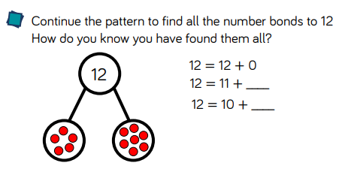
12 = 12 + 0
12 = 11 + ______
12 = 10 + _____
12 = 9 + ______
`12 = 8 + ______
12 = 7 + ______
12 = 6 + ______
12 = 5 + ______
12 = 4 + ______
12 = 3 + ______
12 = 2 + ______
12 = 1 + ______
12 = 0 + ______
What do you notice is happening to the numbers on the left and right side? Is there a pattern?
Can you now find all the number bonds in the same way that make:
1. 7 2. 10 3. 15 4. 20
Afternoon: D&T
Examine vehicles eg lorries, prams, cars, vans, ambulances, caravans, fire engines, tractors, buses, carnival floats. Discuss with the children the different features of the vehicle and ask the children to identify the different parts of vehicles - wheel, axle, chassis, body, cab. They could draw a picture of a car and label these parts.
Now discuss:
Why do vehicles have wheels?
Do they all have the same number and size of wheels?
In preparation for designing and making our own moon buggy, explore the use of wheels and axel mechanisms that make things move. Look at a selection of toys/objects in your house which have wheels.
Look at the power point, ‘wheels and axels’ and have a go at making your own wheel and axel mechanism.

Friday
Success for All
Phonics
Miss Platts – watch the powerpoint and complete the activities as modelled in the video. We will be practising spelling our ‘ur’ words
After the session you can practise them again on www.phonicsplay.co.uk - choose a game to play such as ‘trash or treasure’, recapping all sounds up to phase 5.
Mrs Gregory – watch the powerpoint and follow the instructions. We will be practising our ‘u’ words. After the session you can practise them again on www.phonicsplay.co.uk - choose a game to play such as ‘trash or treasure’, recapping all phase 2

Roots Group 1 – Miss Platts
Watch the power point and follow the instructions. We will be reading ‘Leaves Fall’ as our shared story.(this will be uploaded to class dojo and the school website)
Our STaR story is ‘Weather and Seasons ‘. This book will be uploaded to class dojo being read aloud for you to listen to
Roots group 2 – Mrs Gregory
Watch the power point and follow the instructions. Our shared story is ‘‘Miss Sid meets Sad Sam’(this will be uploaded to class dojo and the school website)
We will be reading ‘Birds’ as our STaR story. This book will be uploaded to class dojo being read aloud for you to listen to

11.00 – Assembly – see school website

11.15 - Maths - adding by making 10.
Watch the video for today’s learning here: https://vimeo.com/492195041
Complete the activity suggested at the end – adding by making 10.
Make 2 large 10’s frame like this (draw them on to paper)

Use anything you can as counters – coins, sweets, buttons – to help you work out these questions using the method shown in the video:
- 7 + 5 =
- 6 + 6 =
- 8 + 4 =
- 9 + 2 =
- 5 + 8 =
- 4 + 7 =
- 7 + 9 =
- 8 + 8 =

Afternoon: PSHE: Keeping Healthy - Why and What do I Eat?
Listen to the story, ‘Eat Your Greens Goldilocks’ - https://www.youtube.com/watch?v=lYLoIgR4Bx0.
In this story, Goldilocks hates eating vegetables and only wants to eat ice cream – is this a good idea? Why/why not?
Discuss which kinds of foods we know are healthy for us and why it is important for us to eat healthily.
Get a selection of different fruits and vegetables and have a tasting session – try and have a go at trying something new. Make a list of the foods you liked, and a list of the foods you disliked.

