

**Name of Education Setting: Ferham Primary School**

**Academic year: 2014-15**

Nothing is more important than children’s welfare. Children who need help and protection deserve high quality and effective support as soon as a need is identified.

If you have any concerns about the health and safety of a child or young person at this education setting or feel that something may be troubling them, you should share this information with an appropriate member of staff straight away.

Some issues such as a child’s appearance, hygiene, general behaviour, can be shared with any teacher or member of support staff in this setting. Do not worry about reporting small matters – we would rather that you tell us things which turn out to be small than miss a worrying situation.

**However, if you think that a child, a young person or an adult who cares for them has been or might be harmed, please talk to one of the people below immediately.**

**You can ask any member of staff to find them and ask them to speak to you straight away about a confidential and urgent matter.**

**Our Designated Safeguarding Lead is:**

Name: Mrs Emma Gill (Headteacher)

Her office is located in the main school reception area

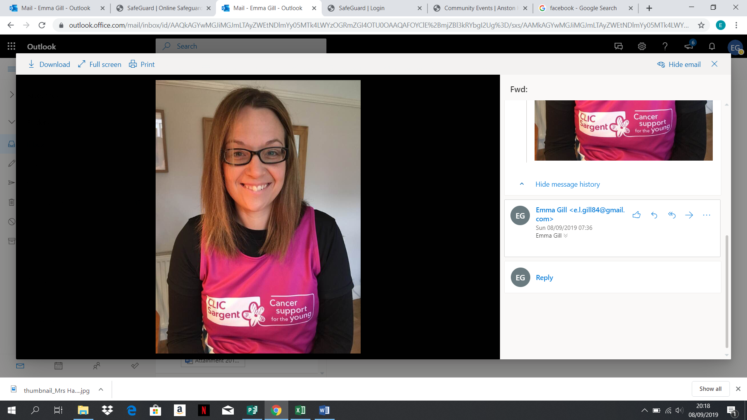

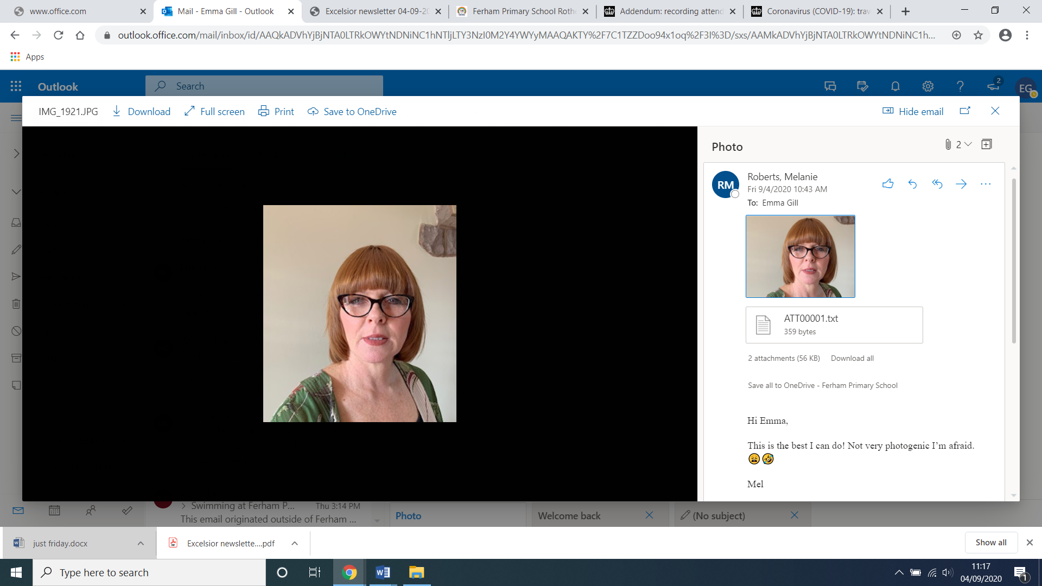

**Our Designated Safeguarding Deputies are:**

Name: Mrs Mel Roberts (Learning Mentor)

Mrs Smith (JMAT lead)

Their places of work are:

Mrs Roberts – Office on KS1 corridor

Mrs Smith – In the Heads’ office located in the main school reception area

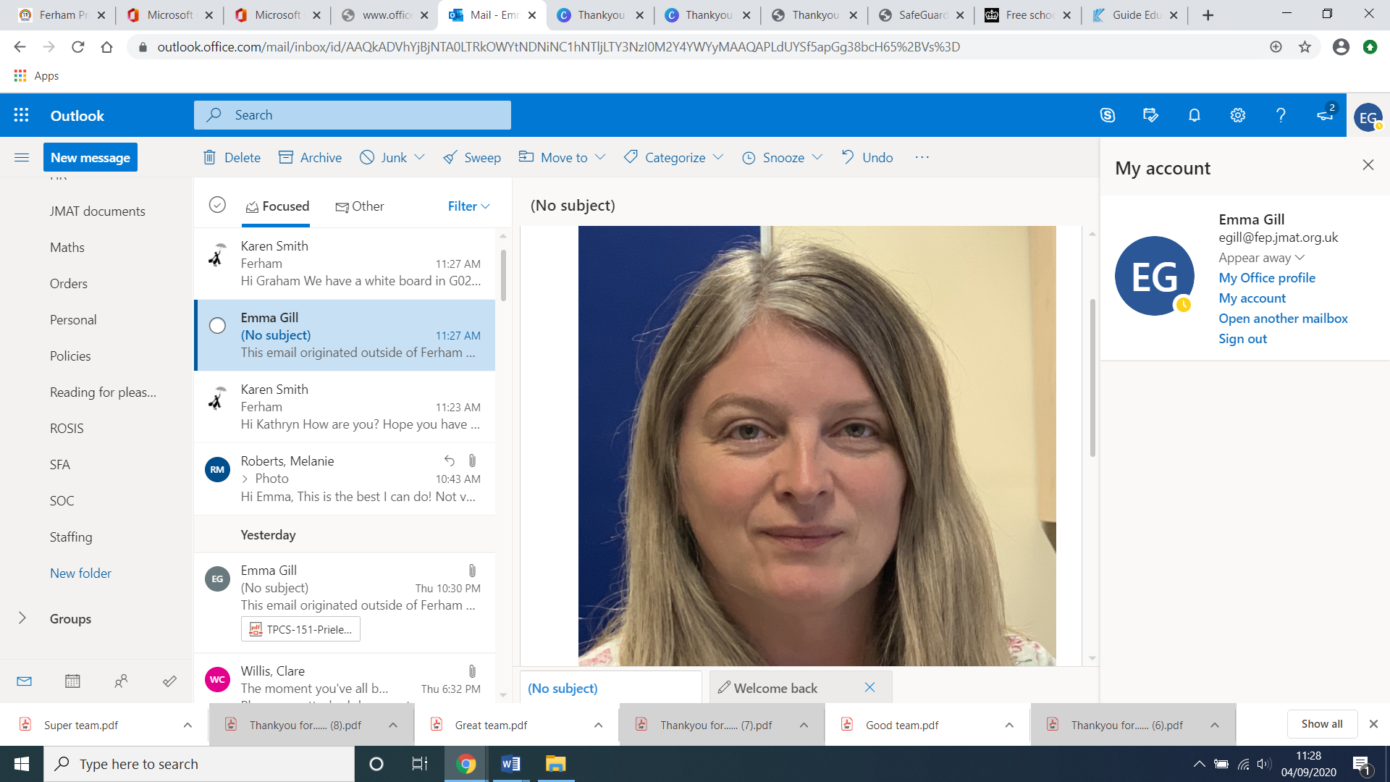

An allegation or disclosure involving someone working with children in a paid or unpaid capacity **must** be reported directly to the Head Teacher or Deputy DSL (if the Head is absent) unless it involves them and then it should be reported directly to the Chair of the Governing Body.

**The Safeguarding Children Team in your setting includes:**

**Head Teacher:** responsible for implementing policies & procedures, allocating resources to the safeguarding team & addressing staff safeguarding concerns.

Name: Mrs Emma Gill

**Designated Safeguarding Lead (DSL):** amember of senior leadership team responsible for addressing safeguarding issues, providing advice & support and liaising with the local authority & other agencies.

Name: Mrs Emma Gill

**Designated Safeguarding Deputy (DSD):** ateacher or support worker (not admin or finance worker) who works with and covers for the DSL role above.

Name: Mrs Mel Roberts

**Special Educational Needs and Disabilities Coordinator (SENDCo):** providesadvice, liaison & support for staff & agencies working with pupils with special education needs & disabilities and their families

Name: Mrs Clare Willis

**SEMH support/Attendance:** supports pupils to reach their full potential by addressing their behaviour, attendance, achievement, timekeeping, homework and some safeguarding issues

SEMH/Behaviour Name: Mrs Katrina Utley (Learning Mentor), Miss Amy Longden (Attendance)

**Children Looked After Children (CLA) Designated Teacher:** promotes the educational achievement of ‘looked after’ children and young people by helping staff understand issues that affect how they learn and achieve

Name: Mrs Emma Gill (Headteacher)

**E-Safety Coordinator:** develops and maintains an e-safe culture within a setting

Name: Miss Alicia Montgomery

**Child Sexual Exploitation (CSE) Lead:** develops and maintains policies & staff awareness of CSE, the Rotherham Safeguarding Children Board responsibilities and the Sexual Exploitation Service key priorities

Name: Mrs Emma Gill

**Your Safeguarding Children Team also links with the:**

**Safeguarding Governor:** helps the Governing Body tohave safeguarding policies & procedures in place, ensures they are followed and addresses general safeguarding issues that staff and parents raise

Name: Mrs Wendy Leak

**Chair of Governors:** addresses allegations of abuse made against the Head Teacher (and other members of staff when the Head Teacher is not available), liaises with the Local Authority; and works with the Head to ensure safe recruitment practices

Name: Mr Andrew Bull

All school staff and the Safeguarding Governor/Chair of Governors can be contacted via the school office or on **01709 740962**