This week’s learning for Daycare Date: 04-101-2021
Hello Everyone.
This week’s home learning for the 2 year old children.
If any grown-ups are unsure of the activities please feel free to contact school on 01709 740962 or email school@fep.jmat.org.uk.
Take care and stay safe.
Holly and the Daycare team.
Person, Social and Emotional Development.
DayCare Support children with settling in at school. Discuss going to school, what they have done that day and address any feelings they have about starting school, reassuring your child that school is a positive place to be and fun.
Communication and Language
DayCare- Talk to your child whilst carrying out daily activities. If you child has a dummy encourage children not to speak with their dummy in and to not have it during the day and eventually give it up completely. This also applies to bottles.
Permanent activity- Singing Nursery rhymes.
Physical Development
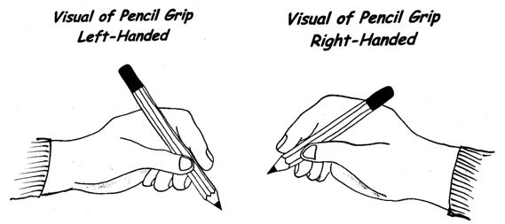
Daycare- Children to draw lines and circles parents to support children to start using a tripod grip.

Literacy
Share books with your child supporting the hold the book the correct way up and turn the pages.
Camille and the sunflowers. https://www.youtube.com/watch?v=0ax9UVo8oRQ
Bear Hunt https://www.youtube.com/watch?v=-d1_Z068z74
Katie and the British artists. https://www.youtube.com/watch?v=ObHIQ2JonsA
Mathematics
Daycare – Support counting 1-5. This could be stairs, cars or other objects from around your house.
Understanding the world.
Daycare- Observe nature and the changing seasons. Discuss the current season winter and how we know its winter.
Expressive arts and design
Daycare Paint using finger paints, water colours and sponges.
Make a collage using different materials.
Experiment with string and paint.

