Ferham Recommended Reads

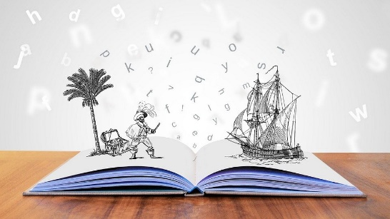

The following list includes only books that our staff have personally read and would fully recommend to our classes. We have hard copies of most of these books so if you would like to borrow one, ask and we will see what we can do!
‘Keep reading, it’s one of the most marvellous adventures anyone can have’ – Lloyd Alexander
April 2021 – These are all recommended reads from staff in school
Book Cover | Title | Author | A Brief Guide
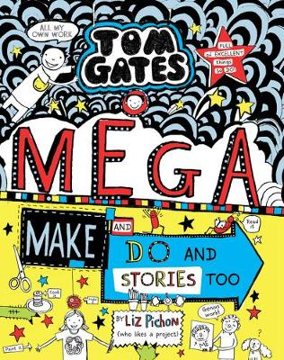 | Tom Gates – Mega Make and Do and Stories too | Liz Pichon | This was my first experience of Tom Gates. I really wasn’t disappointed. There are so many times when I laughed out loud and having little activities to do as you read through the story was brilliant. I really enjoy the relationships between the characters and how Tom refers to his grandparents as ‘the fossils’.  I love how Liz writes these books and I can’t wait to read some more!  Review by Mrs Robinson
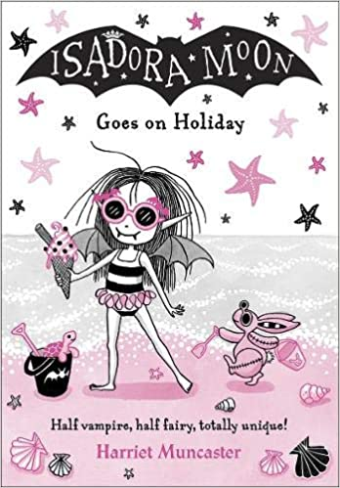 | Isadora Moon  Goes on Holiday | Harriet Muncaster | This book hooked me in just with the front cover! Isadora is half fairy and half vampire. This story follows Isadora and her family as they go on their first overseas holiday that Isadora won for them! They enjoy the sun, swimming and eating ice-cream. But when Isadora meets her magical mermaid friend Marina they discover a baby turtle in trouble. Can Isadora help the turtle find a way home?  This story also looks at the issues facing the ocean and how pollution is endangering wildlife.  I am really looking forward to reading another one of Isadora’s adventures!!  Review by Mrs Robinson
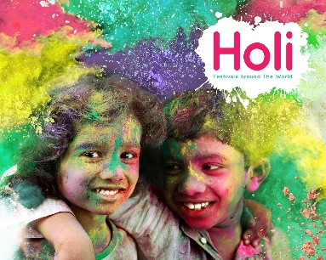 | Holi  Festivals around the World | Grace Jones | Holi is a Hindu festival that celebrates spring, love, and new life. ... It's a colourful festival, with dancing, singing and throwing of powder paint and coloured water. Holi is also known as the "festival of colours".  An amazing way to learn about a religion I am not familiar with. I love learning about different cultures and seeing how they celebrate, and also what is important to them. My son would love to get really messy and see all that colour flying around.  Review by Mrs Robinson
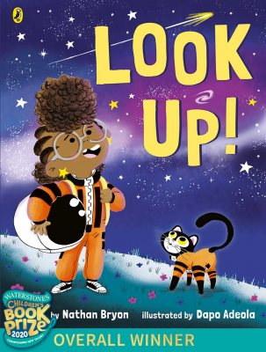 | Look up! | Nathan Bryon | Rocket's going to be the greatest astronaut, star-catcher, space-traveller that has ever lived!  But...  First, she needs to convince her big brother Jamal to stop looking down at his phone and start LOOKING UP at the stars.  A great story that made me want to put down my phone and enjoy the gorgeous world around us. Rockets passion for science and space exploration is contagious.  Review by Mrs Robinson
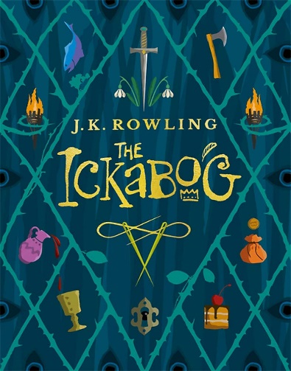 | The Ickabog | J.K Rowling | The Harry Potter series are my all-time favourite books. So when I saw that J.K Rowling had released a new children’s book I was a little apprehensive. However, I shouldn’t have been. Released during Lockdown 2020 and including children’s imaginative illustrations from around the world.  The Kingdom of Cornucopia was once the happiest in the world. The finest meats, cheeses and moustaches there ever was. But the misty marshlands weren’t so perfect and happy. They were reportedly home to the Ickabog! Two brave children thrust into an adventure they didn’t ask for and never expected!  Storytelling at its finest, I was hooked from start to finish and the ending is not what I expected at all!  Review by Mrs Robinson
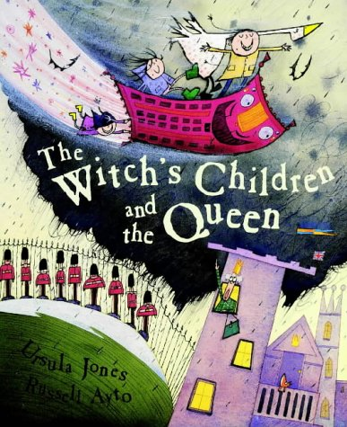 | The Witch’s Children and the Queen | Ursula Jones | The Witch's Children are back and that means TROUBLE! This time they are using their magical spells to visit the Queen. But when they change the Number 16 Bus into a magic carpet, who knows what will happen?  This story had my little boy mesmerized, what will happen next? Will Mum come to help them? We need to read the other titles in the series.  Review by Mrs Robinson

