This week’s learning for Year 1 Date: 1.2.21
Hello children,
I hope you’re all keeping safe at home and looking after yourselves.
In the back of your home learning pack you will find a weekly well-being journal. Each week you will get one to fill in. On the journal, each day log how you are feeling and think of something you are thankful for. It is to try and keep us feeling positive through this weird time. It also asks you to try and do a daily act of kindness to spread positivity to others, so think of what little things you could do to brighten someone else’s day.
Keep sending me in your home learning, too! If you are having trouble uploading work to classdojo, you can send any files to our class email address at: Class1@fep.jmat.org.uk or bring any work in to school. If you haven’t sent me any yet, please do try.
If you have any questions or worries, please don’t hesitate to contact us on class dojo, or ring school on 01709 740962.
Take care,
Miss Platts and Mrs. Gregory x
Monday
9.15 - Success for All
Phonics
Miss Platts – watch the powerpoint and complete the activities. We will be revisiting the digraph ‘oa’. After the session you can practise them again on www.phonicsplay.co.uk - choose a game to play such as ‘trash or treasure’, and choose to recap all sounds up to phase 5.
Mrs Gregory – watch the powerpoint and follow the instructions. We will be revisiting the phoneme ‘b’. After the session you can practise them again on www.phonicsplay.co.uk- choose a game to play such as ‘trash or treasure’, recapping all phase 2
Roots Group 1 – Miss Platts
Our shared story is ‘Home with a Cold’ (this will be uploaded to class dojo and the school website) Todays objective is to blend the sounds that we know to read, including words with o-e.
We will be reading ‘This Moose Belongs to Me’ by Oliver Jeffers as our STaR story.
You can listen to the story here: https://www.youtube.com/watch?v=4p7cbOtVl78
Today you will retell the main events of the story to produce a story map.
Roots group 2 – Mrs Gregory
Our shared story is ‘A Game of Tag at the Farm’ (this will be uploaded to class dojo and the school website) Read the story to your grown up, talking about what you have read and the events. Today you will focus on blending the sounds you know to read words, including words ending in -s.
We will be reading ‘Catch That Egg!’ by Lucy Rowland as our STaR story.
You can listen to the story here: https://www.youtube.com/watch?v=EgIloeJfJ0U
Today you will retell the main events of the story to produce a story map.

11.00 - Assembly – see school website

11.15 - Maths – Subtraction (crossing 10)
We are going to continue looking at subtracting where we have to cross 10. This focuses on the strategy of partitioning to make 10.
The video you will need to use today is at: https://vimeo.com/497919464 We will be pausing this video when it asks us to, to answer the questions.
Pause the video when it asks you to answer questions 1 and 2 on the worksheet. Look at, and answer, questions 1 and 2. Discuss how we can find out what the number sentence will be to find the answer by using the details in the question.
For question 1, think about how many cakes have been made, and how many has been eaten. (15 and 6).
How would we put these numbers in to a subtraction number sentence to find how many cakes are left? (15 – 6)
How many cakes are left? (9)
Use the same method to answer question 2.
Continue watching the video. In this part, it talks about partitioning to cross 10 when subtracting. Pause the video to answer question 3.
What is the same and what is different about Ron and Eva’s method?
Eva and Ron have both gotten the same answer, but Eva has partitioned 5 to count back. Can you use Eva’s method of partitioning to answer the questions?
12 – 6 – what will 6 be partitioned in to? (2 and 4, because we first have to jump back 2 to 10, and have 4 left to jump)
15 – 8 – What will 8 be partitioned in to? (5 and 3, because we first have to jump back 5 to 10, and there’s 3 left to jump)
Continue watching the video, and then answer question 4.
How can I find the missing numbers? What do we already know?
(to find the missing number to first question, we need to jump back from 14 to 8 and then count the jumps, for the next question we need to jump on from 6 7 times to find the answer)

Afternoon -RE: Jewish Celebrations – What makes Pesach (Passover) a special time for Jewish people?
Pesach (or Passover) is an important celebration for Jewish people. It lasts for about a week, and happens every year in either March or April.
Passover is a time to remember and celebrate the freedom of the Jewish slaves in ancient Egypt over 3000 years ago. The slaves were a group of people called the Israelites, and they were made to work by the mean Pharaoh (king). A man called Moses was chosen by God to help free the slaves. At first, Pharaoh wouldn’t let the slaves go, so God sent 10 plagues to Egypt.
1 – The river Nile turned to blood.
2 – A swarm of frogs covered the land.
3 – People were covered in lice.
4 – A swarm of flies covered the land.
5 – All of the livestock (cows, sheep, goats) died.
6 – People broke out in boils.
7 – Hail fell from the sky.
8 – A swarm of locust covered the land and ate all of the food.
9 – Darkness covered Egypt for 3 days.
But each time when Moses asked, after each plague, for Pharaoh to free the slaves, Pharaoh said no. So God sent the last, and worst, plague
10 – Every first born son, in every family, died.
Finally after the last plague, and losing his own son, Pharaoh let the slaves go.
Listen to the story here: https://www.youtube.com/watch?v=rzcYLCYItuc
Can you remember any of the 10 plagues that the people of Egypt had to suffer?
Which one do you think was the worst?
Why do you think Pharaoh finally let the slaves go?
On the first night of Passover, a special meal called the ‘Sedar’ is held. Look here to find out about the Sedar meal and what symbolic foods are eaten: https://www.dkfindout.com/uk/more-find-out/festivals-and-holidays/passover/
Make your own ’10 Plague Wheel’ – cut out the wheels and colour. Use a split pin the hold the 2 wheels together. Use it to re-tell the story of Moses and the 10 plagues.
Tuesday
9.15 - Success for All
Phonics
Miss Platts – watch the powerpoint and complete the activities as modelled in the video. We will be revisiting the digraph ‘oa’. After the session you can practise them again on www.phonicsplay.co.uk - choose a game to play such as ‘trash or treasure’, and choose to recap all sounds up to phase 5.
Mrs Gregory – watch the powerpoint and follow the instructions. We will be revisiting the phoneme ‘f’. After the session you can practise them again on www.phonicsplay.co.uk - choose a game to play such as ‘trash or treasure’, and choose to recap all sounds in phase 2.
Roots Group 1 – Miss Platts
Our shared story is ‘Home with a Cold’ (this will be uploaded to class dojo and the school website) Todays objective is to blend the sounds that we know to read, including words with o-e.
We will be reading ‘This Moose Belongs to Me’ by Oliver Jeffers as our STaR story.
You can listen to the story here: https://www.youtube.com/watch?v=4p7cbOtVl78
Today you will write about why the moose (or another animal) would make a good pet.
Roots group 2 – Mrs Gregory
Our shared story is ‘A Game of Tag at the Farm’ (this will be uploaded to class dojo and the school website) Read the story to your grown up, talking about what you have read and the events. Today you will focus on blending the sounds you know to read words, including words ending in -s.
We will be reading ‘Catch That Egg!’ by Lucy Rowland as our STaR story.
You can listen to the story here: https://www.youtube.com/watch?v=EgIloeJfJ0U
Today you will write sentences about life on a farm.
11.00 - Assembly – see school website

11.15 - Maths –Subtraction
The video we will need today to help us can be found here: https://vimeo.com/497919984 We will be pausing this video when it asks us to, to answer the questions.
Pause the video when it asks you to answer questions 1 and 2, and answer these questions on the worksheet. For question 2, we need to use the details in the question to get the number sentence to find the answer. You could use some visual aids to help you.
Which numbers in the question do we have to help us find the answer? (13 and 6)
How will I write these as a number sentence? (13-6)
What is the answer? (7)
Continue watching the video, and pause it when it asks to answer question 3.
How many animals altogether? (17)
Where would this go in the part/part/whole model? (in the top circle of the part/part/whole model, as this is our whole)
How many horses are there? (9)
Where would this go in the part/part/whole model? (put this in one of the bottom part circles, as it is one part of 17)
How can we find out how many sheep there are using what we already know? (there are 9 animals out of 17 that are horses, so we need to take this away 9 from 17 and see what is left)
How would we write this as a number sentence in the empty boxes? (17 – 9 =) – work it out.
How many animals are sheep? (8)
What is the missing number in the part/part/whole model? (8, because 9 + 8 = 17)
Continue watching the video, and then answer question 4.
How many different number sentences can you make using the cards 4, 6 and 9?
You can only use each number once in each number sentence you make, so you cannot have 14 – 4, 16 – 6, 19 = 9..
(the options you could have are 14 – 6, 14 – 9, 16 – 4, 16 – 9, 19 – 4, 19 – 6)
Afternoon: History –Neil Armstrong
Last week, we looked at the Apollo 11 moon landing of 1969. This space mission was the first time man had stepped on the moon.
Can you remember the names of any of the astronauts from the mission?
Neil Armstrong is the most famous astronaut from this moon landing because he was the first man to walk on the moon.
Look at the ‘Neil Armstrong’ information power point, and do your own research using the internet, to make a fact file about him using the template.
What makes him a significant person?
When was he born/ when did he die?
Where was he born?
What were his most famous words?
Can you find any interesting facts?
Wednesday
9.15 - Success for All
Phonics
Miss Platts – watch the powerpoint and complete the activities as modelled in the video. We will be revisiting the digraph ‘ur’. After the session you can practise them again on www.phonicsplay.co.uk - choose a game to play such as ‘trash or treasure’, and choose to recap all sounds up to phase 5.
Mrs Gregory – watch the powerpoint and follow the instructions. We will be revisiting the phoneme ‘e’. After the session you can practise them again on www.phonicsplay.co.uk - choose a game to play such as ‘trash or treasure’, recapping all phase 2
Roots Group 1 – Miss Platts
Our shared story is ‘Home with a Cold’ (this will be uploaded to class dojo and the school website) Todays objective is to re-read the story, trying to build fluency and confidence in word reading.
We will be reading ‘This Moose Belongs to Me’ by Oliver Jeffers as our STaR story.
You can listen to the story here: https://www.youtube.com/watch?v=4p7cbOtVl78
Today you will write about why the moose (or another animal) wouldn’t make a good pet.

Roots group 2 – Mrs Gregory
Our shared story is ‘A Game of Tag at the Farm’ (this will be uploaded to class dojo and the school website) Read the story to your grown up, talking about what you have read and the events. Today you will focus on re-reading the story, trying to build fluency and confidence.
We will be reading ‘Catch That Egg!’ by Lucy Rowland as our STaR story.
You can listen to the story here: https://www.youtube.com/watch?v=EgIloeJfJ0U
Today you will write sentences about why you like farms.
11.00 - Assembly – see school website

11.15 - Maths –using related facts
Today we are going to make addition and subtraction fact families using related facts. We can work out fact families using the inverse (opposite) of each calculation – so addition is the opposite of subtraction and vice versa, so 5 +5 = 11 and 11-5 =5 are related facts.
The video you will need today can be found at: https://vimeo.com/497920336 Pause the video when it asks you to, to answer the questions.
Watch the video, then pause it to answer question 1.
For this question, count the spiders and the bees to fill in the missing parts of the part/part/whole model. This will generate the 3 numbers of our fact family (18, 10 and 8). Use these numbers to fill in the 2 addition and subtraction fact sentences
Which numbers will we put in the boxes to make the addition sentences, why? (8 and 10, because they need to equal 18)
if we have 8 + 10 = 18, so we also know ___+ ____ = 18. (10 + 8 = 18) – this will get the 2 addition facts.
to work out: 18 - ____ = ____ and 18 - ___ = _____, use the 10 and 8 in the right places to make a correct number sentence.
Continue watching the video, and then answer question 2.
Look at the bar models to find the 3 numbers that will make up your fact family. Notice this time that the number sentence has the answer/total first, so the sentence is written as: ___ = ____ + ____ and ____ = _____ - ______,
a) 11, 7 and 18 –
How will these 3 numbers be arranged to make a correct addition sentence?
Can we have 11 = 18 + 7? (no, because 18 + 7 doesn’t = 11)
If we know 18 = 11 + 7, what else do you know? (18 = 7 + 11)
How will these 3 numbers be arranged to make a correct subtraction sentence?
Can we have 18 = 7 – 11? (no because the sentence isn’t correct)
b) 4 , 15 and ? –
how will we find the whole for the bar model? ( 4 + 15)
How will these 3 numbers be arranged to make a correct addition/ subtraction sentence? (use the same kind of questioning as highlighted for question a)
Optional c) make your own bar model fact families.

Afternoon: Science – which material is the best for different objects?
So far we have looked at different types of materials and thought about their properties.
Can you remember any words we can use to describe the properties of materials?
How would you describe a pair of wellington boots? (material it’s made of, and properties)
How would you describe a teddy bear? (material it’s made of, and properties)
Today we are going to combine our knowledge of materials and their properties to think about which materials are best used for making different things, and why.
Watch this lesson video about which materials are the best for different jobs here: https://classroom.thenational.academy/lessons/which-material-is-best-for-different-objects-60vkar?step=2&activity=video
Complete the activity that accompanies the lesson – which material would we use to make different objects.
You could then have a go at this quiz to see how much you remember from today: https://classroom.thenational.academy/lessons/which-material-is-best-for-different-objects-60vkar?step=4&activity=exit_quiz

Thursday
9.15am - Success for All
Phonics
Miss Platts – watch the powerpoint and complete the activities as modelled in the video. We will be revisiting the digraph ‘ur’. After the session you can practise them again on www.phonicsplay.co.uk - choose a game to play such as ‘trash or treasure’, and choose to recap all sounds up to phase 5.
Mrs Gregory – watch the powerpoint and follow the instructions. We will be revisiting the phoneme ‘l’. After the session you can practise them again on www.phonicsplay.co.uk - choose a game to play such as ‘trash or treasure’, recapping all phase 2
Roots Group 1 – Miss Platts
Complete the reading comprehension, ‘The Snow Queen’. Read through the text, then answer the questions about the story.
We will be reading ‘This Moose Belongs to Me’ by Oliver Jeffers as our STaR story.
You can listen to the story here: https://www.youtube.com/watch?v=4p7cbOtVl78
Today you will write a list of rules for pets.

Roots group 2 – Mrs Gregory
Complete the reading comprehension, ‘The Big Dig’. Read through the text and answer the accompanying questions.
We will be reading ‘Catch That Egg!’ by Lucy Rowland as our STaR story.
You can listen to the story here: https://www.youtube.com/watch?v=EgIloeJfJ0U
Today you will write sentences about why you like towns.

11.00 – Assembly– see school website

  - – Maths – comparing number sentences
Today we will be comparing number sentences using the symbols < = >
>- greater than < - less than = - equal to, or the same
The video you will need to use today can be found here: https://vimeo.com/497920660 Pause the video when it asks you to, to answer the questions.
Watch the video and pause it to answer question 1.
a), b) and c) - Remember to use 2 different colours, and fill up the first 10 frame before starting in the next one. e.g 9 + 3
Write the answers at the side of the 10 frames, and then use the answers to compare them in question part d).
For example, to compare 9 + 3, and 6 +7. 9 + 3 = 12, and 6 + 7 = 13, so 9 + 3 is LESS THAN 6+ 7, as 12 is less than 13.

Continue watching the video, and stop to answer question 2. Cross out the amount of counters to find the answer, and put them at the side of the 10 frame so that the amounts can be compared.
Continue watching the video, and stop it to answer question 3. When comparing, you will need to work out the answers to the + and - number sentences each time, and write them above, so that you can compare them with either < > or =.
Continue watching the video to the end, and answer question 4. For this, you will need to make sure the answers to each part of the number sentence is the same on both sides of the = sign.
E,g, 5 + 5 = 15 – 5, because 5 + 5 = 10, and 15 – 5 = 10.

Afternoon: Art
Have a go at making your own cardboard tube rocket to zoom in to space in.
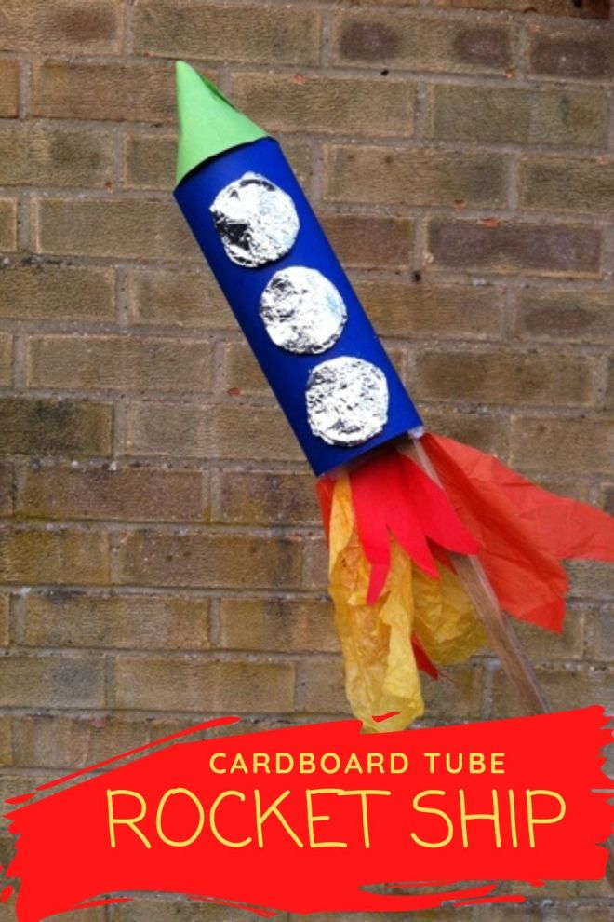
Friday
Success for All
Phonics
Miss Platts – watch the powerpoint and complete the activities as modelled in the video. We will be revisiting the digraph ‘ow’. After the session you can practise them again on www.phonicsplay.co.uk - choose a game to play such as ‘trash or treasure’, and choose to recap all sounds up to phase 5.
Mrs Gregory – watch the powerpoint and follow the instructions. We will be revisiting the phoneme ‘h’. After the session you can practise them again on www.phonicsplay.co.uk - choose a game to play such as ‘trash or treasure’, recapping all phase 2
Roots Group 1 – Miss Platts
Read your colour banded reading book.
We will be reading ‘This Moose Belongs to Me’ by Oliver Jeffers as our STaR story.
You can listen to the story here: https://www.youtube.com/watch?v=4p7cbOtVl78
Today you will make a fact file about moose. Use the challenge sheet to research which of the facts are true or not (type the fact in to google) and then write the true facts in to the writing box.
Roots group 2 – Mrs Gregory
Read your colour banded reading book from school.
We will be reading ‘Catch That Egg!’ by Lucy Rowland as our STaR story.
You can listen to the story here: https://www.youtube.com/watch?v=EgIloeJfJ0U
Today you will write a new ending for the story, ‘Catch That Egg!’

11.00 – Assembly – see school website

11.15 – Maths-
Complete the end of unit booklet.
Afternoon: PSHE: Keeping Healthy - Hygiene
We are going to look at personal hygiene and how to look after ourselves.
What does the word ‘hygiene’ mean?
Hygiene means keeping clean and looking after ourselves and our bodies.
What should you do to keep yourselves clean?
Look at the power point, ‘personal hygiene’. Talk through what we can do to keep ourselves clean and healthy, then complete the attached activity by drawing 3 pictures with a sentence about what we should be doing.
Finish the session by listening to the story, ‘Rapunzel, Rapunzel, wash your Hair’: https://www.youtube.com/watch?v=WUOpN3z1Kxs

