This week’s learning for F1 Date: 22-02-2021
Hello Everyone
This week’s Success for All (SFA) theme is stay safe. There are so many things we want to warn our children about! How can we protect them? Sometimes we wish we could prevent even the most minor scratch. It is a never ending process to protect our children and help them protect themselves.
Books to support this theme are: Eric calls for help, Topsy and Tim; safety first, The children’s book of keeping safe, Topsy and Tim meet the firefighters. See story tree section for links to the stories on YouTube.
If you have any questions please feel free to contact us this can be through DOJO, email or phone. Our number is 01709 740962. Email school@fep.jmat.org.uk

Daily Message for each day.
Monday- We should touch only things that we know are safe.
Tuesday- We ride and walk safely near the road
Wednesday- We use child safety seats or seat belts when we ride in cars
Thursday- We can practise what to do in case we ever see a fire at home or at school
Friday- We must not touch dangerous things.

Clues and Question
Clues and questions requires a little bit of acting. You can make a Curiosity cat by using the picture and sticking it to a lollypop stick.
Monday- say The daily message gave you a clue about what we are going to talk about today. I have some more clues in these books.
Let’s see what the pictures I have are about. Show your child pages 1 and 2 from Hooray for bread. You will find these at the end of the home learning sheet. Then say Do you see anything here that we have to be careful about? Wait for your child’s replies, then explain that it is important to be careful around hot steaming drinks such as tea. Point to the bread knife and remind your child that adults would only use this equipment.
Do you see anything that would be too hot to touch? Is a toaster warm or hot when its toasting bread?
What is the hot part of the toaster? Wait for replies.
Yes, the sides are very hot. Sometimes we can burn our hands on this part. Point to the sides of the toaster.
What part can we touch? (The knob that pushes the bread down in the toaster) This part isn’t hot but we only touch it if an adult says we can.

Tuesday- Watch the YouTube story “Curious George and the pizza party” explain that the pizza will be put in the over to cook it. Bring curiosity out and let her tell the children that this book is a clue about another thing we need to remember to be safe. What is it? ( wait for a reply) Curiosity says That’s right, we should not touch the stove or the oven. The door of the oven can even be very hot on the outside.
When riding a bike or skating what do we wear? (replies helmet) Do you think it’s easy to fall and hurt yourself? (Yes) So that’s why we wear a helmet to protect our heads and stay safe.
Let’s pretend we’re skating or riding on a scooter or bike. Put on your helmet, if you want you can put something on your knees and elbows.
Now, which one do you want to pretend to have- a bike, a scooter or skates? If you have a bike or scooter, get on it if you have skates put them on. Okay are you ready let’s go.
Curiosity says We’ve learned a lot of things, haven’t we? We need to remember helmets when we ride real bikes, fast skates, scooters or skateboards and always wear a seat belt.
Wednesday- Say What do we do in cars so that we are protected? Do we wear helmets in cars? (replies seatbelt)
Does anyone know why they’re important in cars and aeroplanes too? Wait for your child to suggest why they are important.
They keep us from falling out of our seats. And we could bump our heads, especially if the car stopped quickly.
Is there something else that children use in cars that make them safe Wait for a reply. That’s right children use safety seats or car seats when they are too small to wear seat belts. Have you ever sat in a safety seat?

Thursday- Today we are going to talk about fires. We have fire drills at school. What sound do we hear when we have a fire drill?
What do we do when the bell rings? That’s right we stop what we are doing and go out quickly and we all meet at the foundation gate.
If you were at home you would do the same thing. Do you know where all your family would meet? Maybe you can talk to your family today about that.
What would we hear or smell if there was a fire? Sometimes if there’s a lot of smoke we can crawl on our hands and knees to get under the smoke.
You could practise crawling and pretend to crawl under the smoke.
Friday- Discuss the unsafe items that your child identified from the daily message.
We said before that matches are not safe. What other things can you think of that we might find that we shouldn’t touch?
There are many things outside that we should tell an adult about can you think of any others?
What things might be in your houses that you should not touch?

Rhyme Time
Phonological awareness activity
Have your child clap the rhyming words in “1, 2 buckle my shoe” rhyme. (Rhyming words are two, shoe, four, door, six and sticks.

Phonological awareness activity
Using the play safe rhyme, learn the first verse then the next day add the second verse and the third verse on day 3. After this give your child one line and you do the next alternating each line of the rhyme between you both. Take it in turns to say each line supporting your child to keep pace.

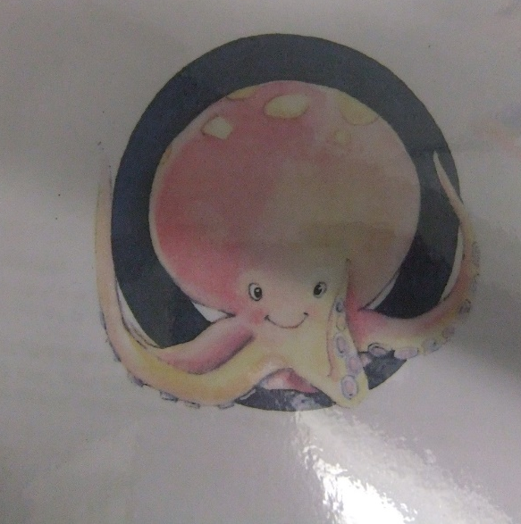
Phonics We are revisiting theses sounds this week.
Monday
Hear the new sound “the octopus observes oranges” ask your child what sound they hear at the start of “octopus”, “observe” and “orange”.
Say The octopus observes oranges. Let’s look at the octopus and stretch the o sound at the start of each word.
The first sound I hear in octopus is “o” say “o”

Make the sound. Say When I say “o” my mouth is open and my chin drops down a little. Say the sound with your child. “o”

Ask your child to name each picture and see if they can name the first sound they hear at the start.
Introduce the shape of the letter: say Now I’m going to show you the letter that says “o” Let’s look at the octopus. Run your finger over the “t” and say Left around the octopus
Say it fast
Break each word down then put it back together fast:
t-o-p/ top
P-o-t/ Pot
g-o-t/ got

Tuesday
Hear the new sound “the curly caterpillar crawls” ask your child what sound they hear at the start of “curly”, “caterpillar” and “crawls”.
Say The curly caterpillar crawls. Let’s look at the caterpillar and bounce the c sound at the start of each word.
The first sound I hear in caterpillar is “c” say “c”

Make the sound. Say When I say “c” I can feel the sound right in the back of my mouth. It sounds a lot like another sound we know “g” but “c” is a little bit different. When I say “c” I can hear air coming out.
Ask your child to name each picture and see if they can name the first sound they hear at the start. (Car, Cake, Camel, Cane)
Introduce the shape of the letter: say Now I’m going to show you the letter that says “c” Let’s look at the Caterpillar. Run your finger over the “c” and say Curl left around the caterpillar
Say it fast
Break each word down then put it back together fast:
c-a-p/ cap
c-o-t/ cot
c-a-n/ can

Wednesday
Hear the new sound “the kangaroo carries her kid” ask your child what sound they hear at the start of “curly”, “caterpillar” and “crawls”.
Say The kangaroo carries her kid. Let’s look at the kangaroo and bounce the k sound at the start of each word.
The first sound I hear in kangaroo is “k” say “k”

Make the sound. Say Do you remember this sound it’s the same sound we made yesterday.
Ask your child to name each picture and see if they can name the first sound they hear at the start. (King, key, kite, kitten)
Introduce the shape of the letter: say Now I’m going to show you the letter that says “k” Let’s look at the kangaroo. Run your finger over the “k” and say From head to toe, arm up, kick out.
Say it fast
Break each word down then put it back together fast:
k-i-c-k/ kick
r-o-c-k/ rock

Thursday
Hear the sound
We are going to learn about a sound that we already know. This is the sound that we use when we say “the curly caterpillar crawls” and “the kangaroo carries her kid”. What is the sound for today? It’s the “c” sound.
So far we have learned that there are two ways to write the sound “c”. Today we are going to learn one more way that you can write “c”.
Here are some pictures that have the “c” sound. (Cube, clock, sock, lock)
Introduce the shape of “ck”
Now we’re going to write the sound “ck” another way. This will be easy for you to remember because we’re going to write it with the letters that we already know.
Write the letters “ck” on some paper. Then say “ck, ck, ck”. We already know that both of these letters make the sound “c” Today we will learn that sometimes these letters stand together and they also make the sound “ck”.
Stretch and read
d-o.c-k/ dock
s-a-ck/ sack
p-i-ck/ pick

Friday
Hear the new sound
The upside down umbrella is unusual. Can you hear the “u” sound at the start of upside, umbrella and unusual.
The upside down umbrella is unusual. Stretch the “u” sound at the start of upside, umbrella, unusual.
Ask your child to name the pictures emphasising the “u” sound at the start of each word. ( umbrella, urgh, uncle ubb)
Make the sound
When I say “u” my mouth is open just a little. I just have to push the air out as I say “u”.
Lets look at the umbrella. Listen to the letter cue to help you remember how to make “u”. Right under the umbrella, up and down.
Say it fast
d-u-ck/ duck
d-u-g/ dug
m-u-d/ mud

Art
Print with kitchen gadgets.
Decorate safety helmets. You can make a helmet from paper and decorate it.
Make firefighter hats.

Dramatic Play
Practise safety in the kitchen.
Put some of your dolls in safety seats.
Practise fire safety. Crawling under pretend smoke
Maths
Have a random amount of objects support your child to give you chosen amounts.
Separate the objects into two piles of different amounts and see if your child can identify which group has more or less.

Permanent activity Discuss with the children what day of the week it is including the date and month. Discuss what the weather is like each day and what season it is.
NEW counting 1-30 this can be objects around the house, stair or cars. Support children to recognise numbers 1-5 or 1-10 if they can recognise 1-5.
Science
No special setup this week.
Writing
Use a needle and nave thread to lace the “N” (Template at the end of the home learning sheet)
Permanent activity Encourage your child to practise writing their name
Writing the sounds we do daily.

Story Tree
Monday- Eric calls for help- This is the one from last theme which was added to DoJo as a PDF.
Tuesday- Topsy and Tim: Safety first https://www.youtube.com/watch?v=20rj44lJf-g
Wednesday- The Children’s book of keeping safe
Thursday- Topsy and Tim meet the firefighters https://www.youtube.com/watch?v=kQ9OsAp6ohw
Friday- Chose your favourite
Please note Holly will read each book and post it on DOJOs.

