This week’s learning for Year 3 Date: 08.02.21
Special Events:

Monday –
9.15am – Success for All (for 90 minutes)
Please see the Success for All videos posted by myself or Mrs Robinson on classdojo.
Our SFA book today is: The Hodgeheg by Dick King Smith – Cycle 2 – Lesson 4.2

Today’s SFA story is a chapter book, so here are the YouTube links broken up into three parts:
Part 1: https://www.youtube.com/watch?v=htPjCiZxoZ4
Part 2: https://www.youtube.com/watch?v=2epukcKBpDc
Part 3: https://www.youtube.com/watch?v=_V7ga2_x_hk

Learning packs
Starter:

11.00am – Maths (for 60 minutes)
Subtract Money
Today we are going to learn how to subtract money away from an amount that we have. This is really useful knowledge for when you have to go and buy something from the shop. It will also help you with tomorrows learning of giving change.
Watch the video here: https://vimeo.com/498297373
Complete the worksheet below (see also in your learning pack or on classdojo).

1.00pm – Assembly
Vaccines – please see PowerPoint on school website or classdojo.

1.15pm – SPAG (up to 20 minutes)
Practise this week’s spellings.
This week’s spellings are: scent, sent, vain, vein, rode, road, steel, steal, waist, waste, pressure, promise

History
This week we are looking at why and how the Romans built new roads in Britain.
Here is a PowerPoint to support your learning:
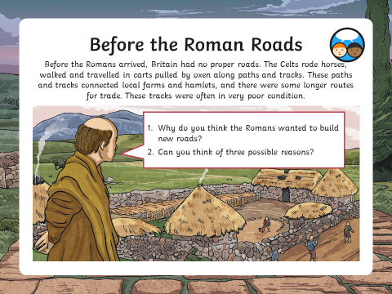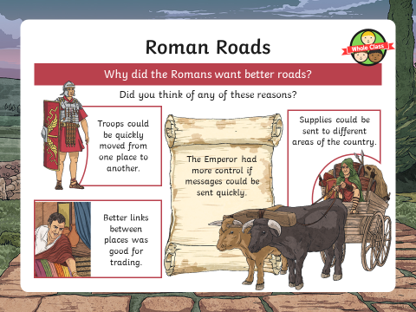

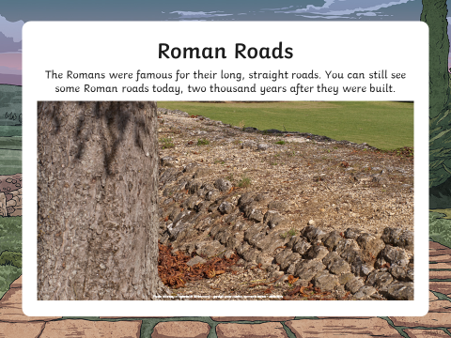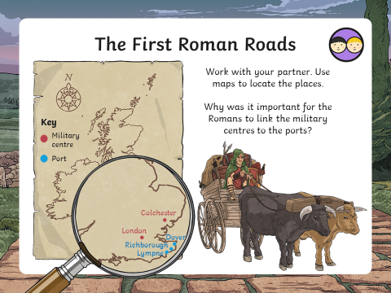

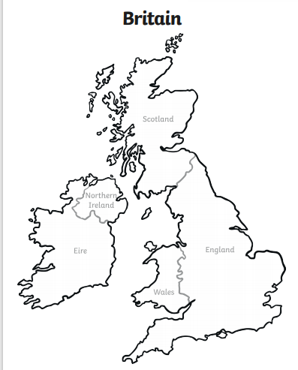
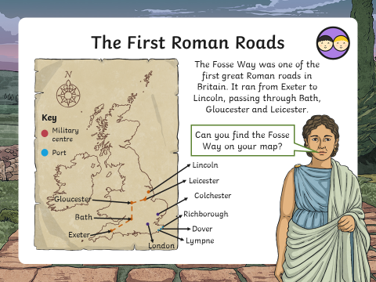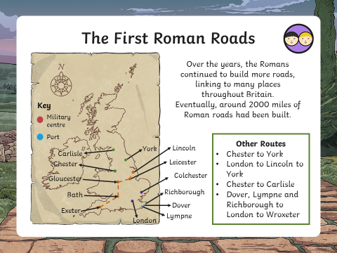
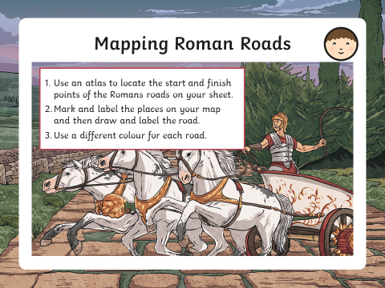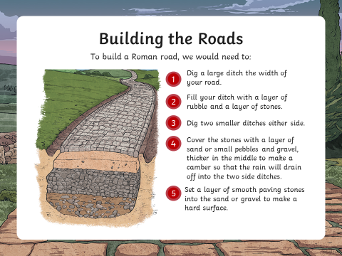
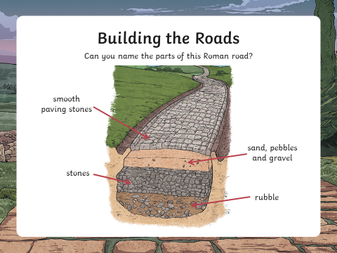

3.00pm – Story Time
Please watch the adult’s stories being posted on the School Story on classdojo.

Tuesday
9.15am – Success for All (for 90 minutes)
Please see the Success for All videos posted by myself or Mrs Robinson on classdojo.
Our SFA book today is: The Hodgeheg by Dick King Smith – Cycle 2 – Lesson 5

Today’s SFA story is a chapter book, so here are the YouTube links broken up into three parts:
Part 1: https://www.youtube.com/watch?v=htPjCiZxoZ4
Part 2: https://www.youtube.com/watch?v=2epukcKBpDc
Part 3: https://www.youtube.com/watch?v=_V7ga2_x_hk

Learning Packs
Starter:

11.00am – Maths (for 60 minutes)
Giving Change
Watch this video https://vimeo.com/479816820 to recap how to find change when buying something with a certain amount of money. Complete the worksheets below (also in your learning pack or on classdojo).
Remember that £1 is the same as 100p. £2 is the same as 200p. £3 is the same as 300p. And so on…
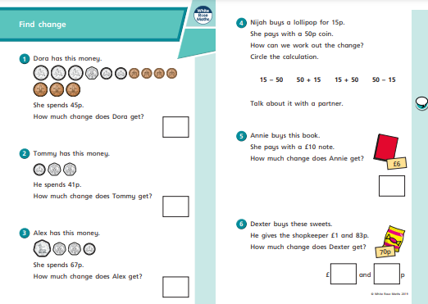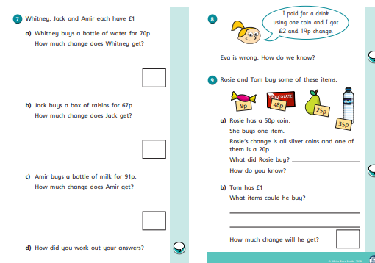

1.00pm – Assembly
Online Behaviour – please see PowerPoint on school website or classdojo.

1.15pm – SPAG (up to 20 minutes)
This week we are looking at using possessive apostrophes with plural nouns. Read these slides to support your learning:
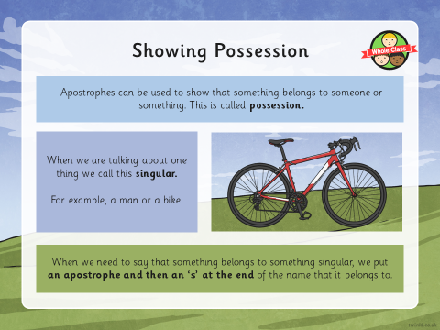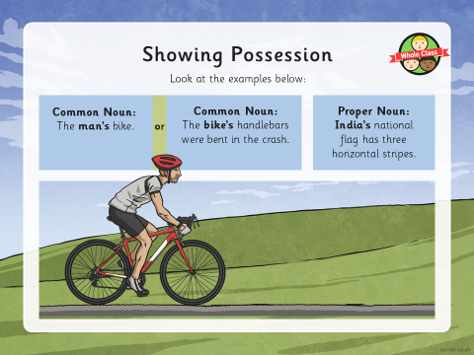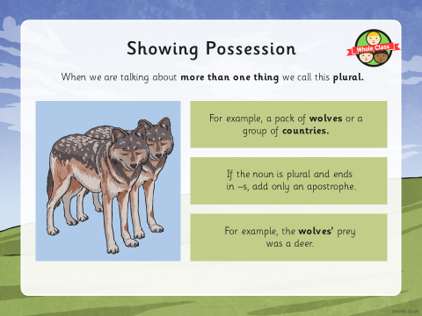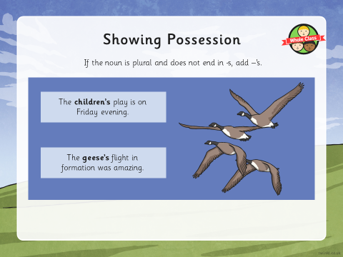
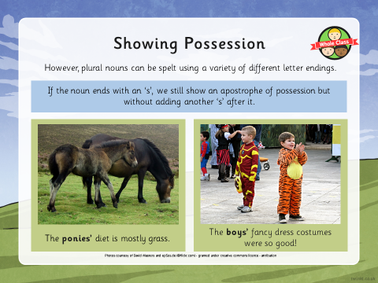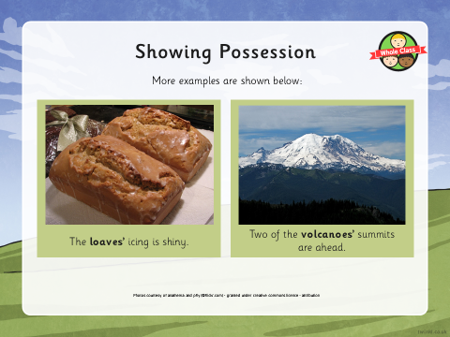
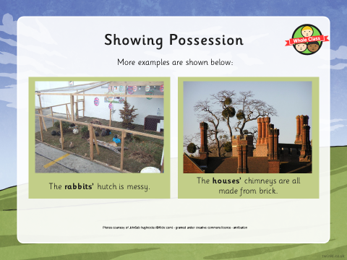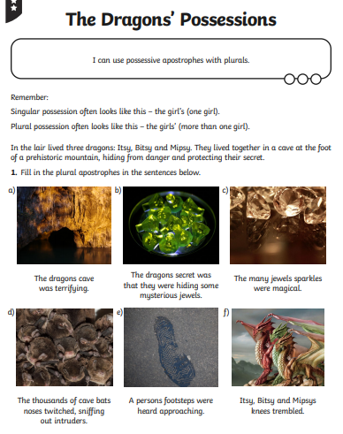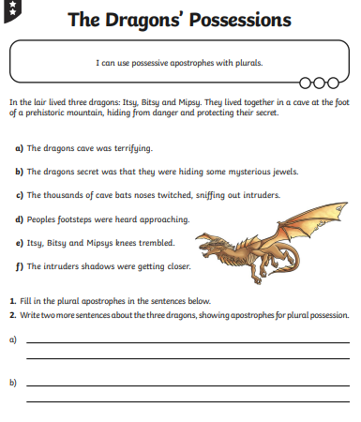

Science
Show the children the pictures of magnets on the slides. Which of these pairs of magnets will attract and
which will repel? Children to make their predictions, then either give them bar magnets so they can check or show the answers on the slides. Were your predictions correct?
• We have found out that magnets can attract or repel each other but can you think of any other materials that are attracted to magnets? Invite children to share their ideas.
• Which of these materials do you think are magnetic? Show children the pictures on the slides and as a
class tick whether or not you predict they will be magnetic.
• Tell children that today they will be testing different materials to see if they are magnetic by using a magnet against the material to see if there is a force (either attraction or repulsion). If there is not force, the material is not magnetic. If there is, the material is magnetic.
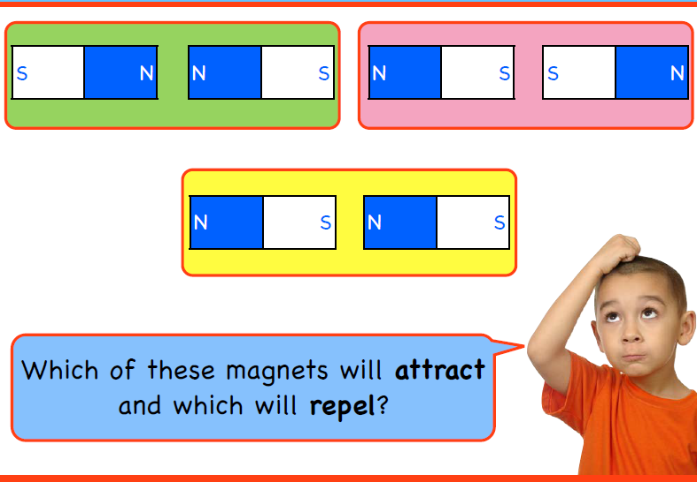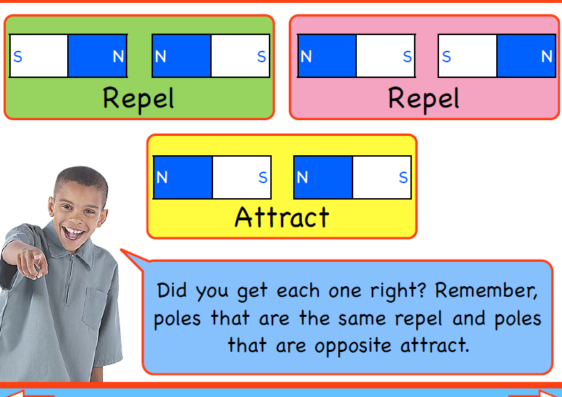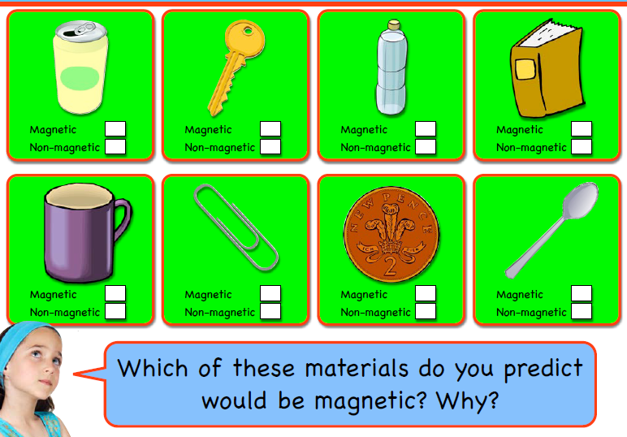
Children to predict what kinds of materials they think will be magnetic before walking around the house testing as many materials as they can and recording on the worksheet. Children to then answer the questions.

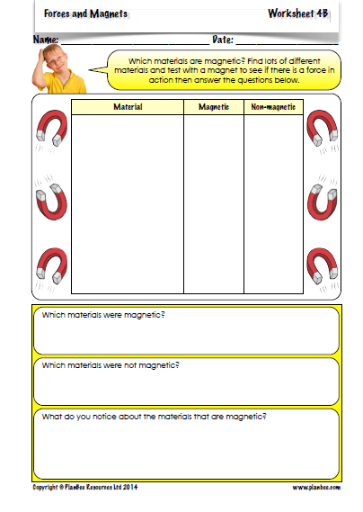
3.00pm – Story Time
Please watch the adult’s stories being posted on the School Story on classdojo.

Wednesday
9.00am – Success for All (for 90 minutes)
Please see the Success for All videos posted by myself or Mrs Robinson on classdojo.
Our SFA book today is: 101 Ways to Save the Planet Before Bedtime by Paul Mason – Lesson 1

Learning Packs
Starter:

11.00am – Maths (for 60 minutes)
Giving Change
Using the PowerPoint slides below (or in your packs or on dojo) have a go at working out how to give change when you buy something from a shop. For example, if I went to the shop and bought an apple that costs me 30p and I pay with £1 how much change do I get? Remember that £1 is the same as 100p. So my number sentence would be: 100p – 30p = 70p. Complete the worksheets.
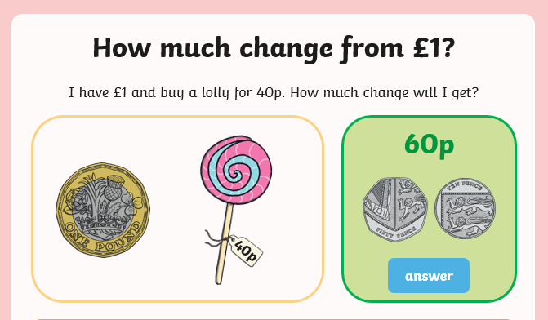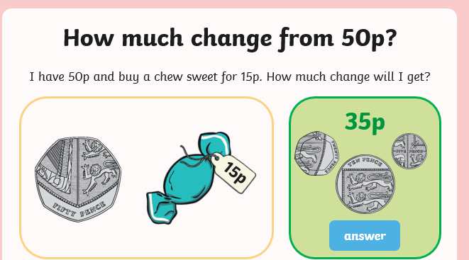
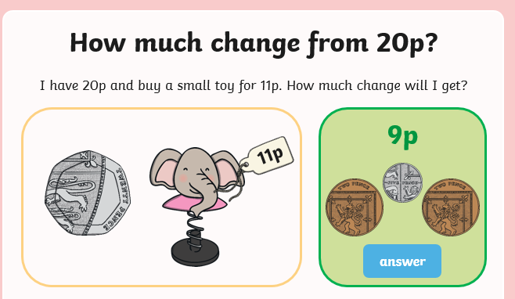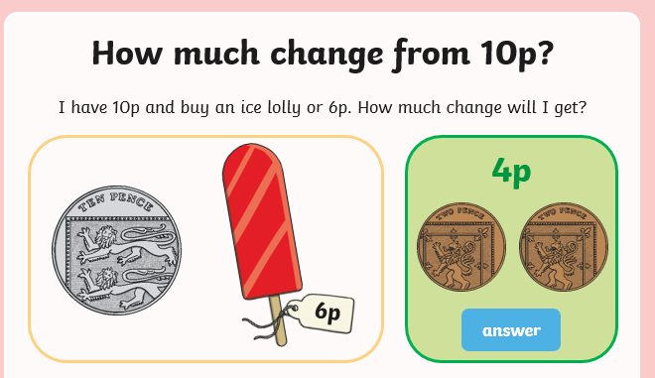
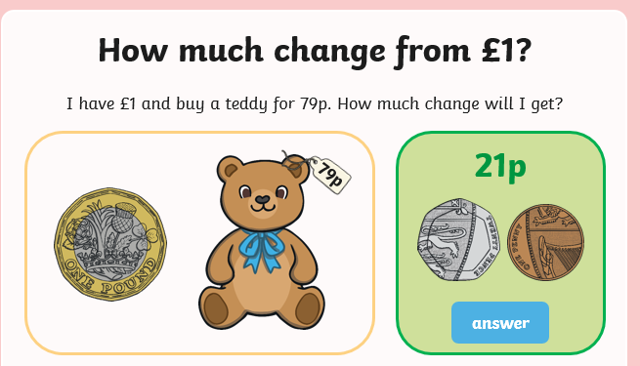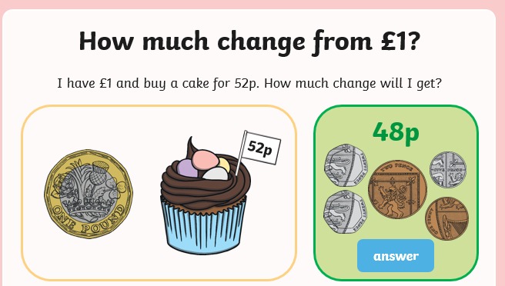
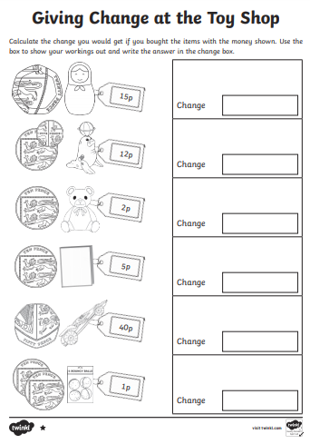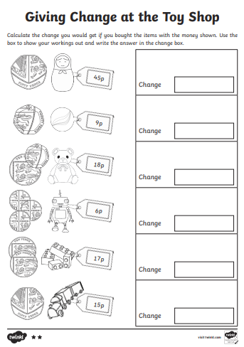
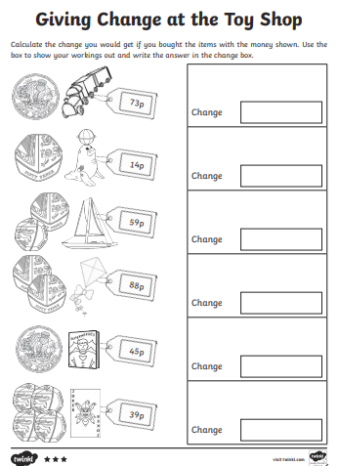
1.00pm – Assembly
Overcoming Challenges – please see PowerPoint on school website or classdojo.

1.15pm – SPAG/Handwriting (up to 20 minutes)
Handwriting

French - 1.35pm
Where do you live?
Watch the video here to find out how to say where you live in French: https://www.youtube.com/watch?v=wTMiO3mybkM
Practise saying out loud the French you have learnt from this video with someone at home. I would love to see some videos of you saying your French vocabulary out loud.

PE – 2.00pm
Join in with this fun gymnastics lesson here: https://www.youtube.com/watch?v=zIKNBYcfQaQ

Be safe and only do what you can do with the space you have in your home.
Remember to warm up first and cool down after!

3.00pm – Story Time
Please watch the adult’s stories being posted on the School Story on classdojo.

Thursday
9.15am – Success for All (for 90 minutes)
Please see the Success for All videos posted by myself or Mrs Robinson on classdojo.
Our SFA book today is: 101 Ways to Save the Planet Before Bedtime by Paul Mason – Lesson 2

Learning Packs
Starter:

11.00am – Maths (for 60 minutes)
Giving Change
Watch the video here: https://vimeo.com/499227948 to learn how to give change. Complete the worksheet below (in your packs or on classdojo).
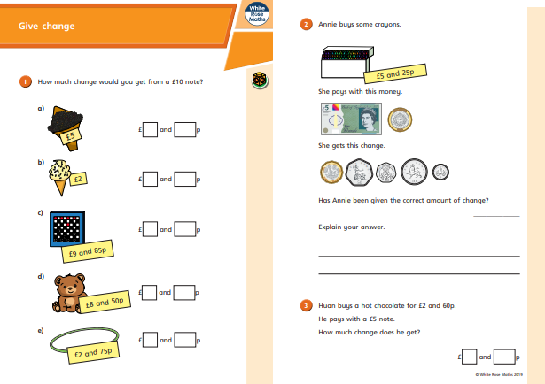

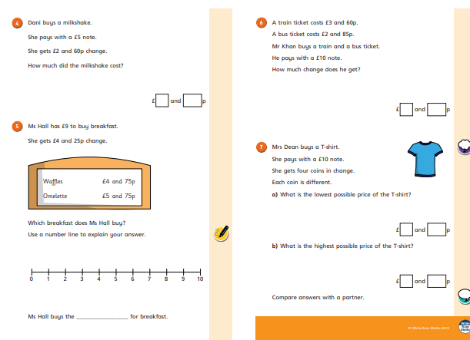
1.00pm – Assembly
Women in science – please see PowerPoint on school website or classdojo.

1.15pm – SPAG/Handwriting (up to 20 minutes)
Handwriting - spellings.

1.35pm – Art/DT
Painting your volcano
Last week you made a 3D model of a volcano that you will hopefully set up next week to erupt. However, today we need to paint our volcanoes now that they are dry. Take a look at the pictures below to get an idea of what a volcano looks like. Think about the colours you may need to paint your volcano. Don’t worry if you don’t have any paint at home – you can make some using things that you may have around your home!
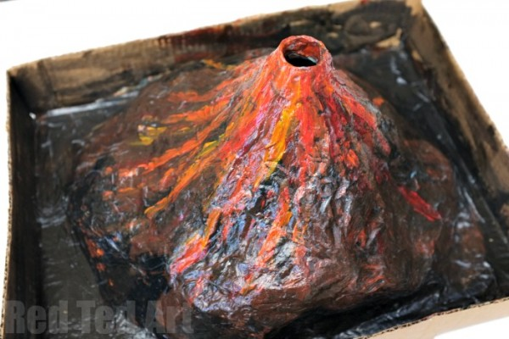
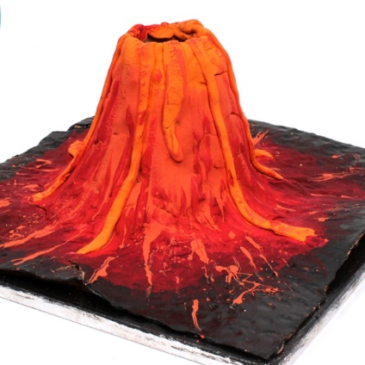

To make the paint you will need:
- 2 cups salt
- 2 cups hot water
- 2 cups flour
- Water-soluble food colouring

How to make paint with flour:
STEP 1. In a large bowl, mix together the hot water and salt until as much of the salt dissolves as possible.
STEP 2. Stir in the flour and mix until completely blended.
STEP 3. Divide into containers and then add food colouring. Stir well.
3.00pm – Story Time
Please watch the adult’s stories being posted on the School Story on classdojo.

Friday
9.15am – Success for All (for 90 minutes)
Please see the Success for All videos posted by myself or Mrs Robinson on classdojo.
Our SFA book today is: 101 Ways to Save the Planet Before Bedtime by Paul Mason – Lesson 3

Learning Packs
Starter:

11.00am – Maths (for 60 minutes)
Giving Change
Use the PowerPoint below to support you with giving change today. Maths should be challenging and I think you will find today’s learning a challenge! Have a go at it and let me know how you get on. Complete the worksheet below with the problem solving and reasoning.
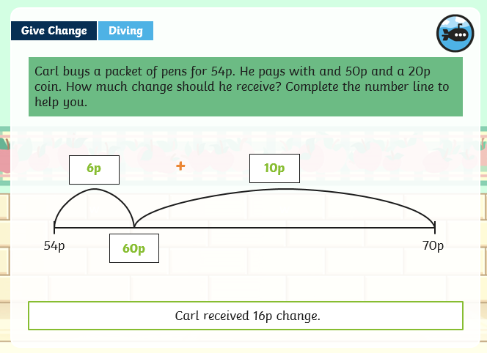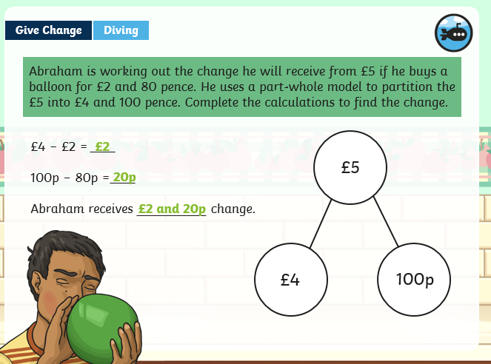
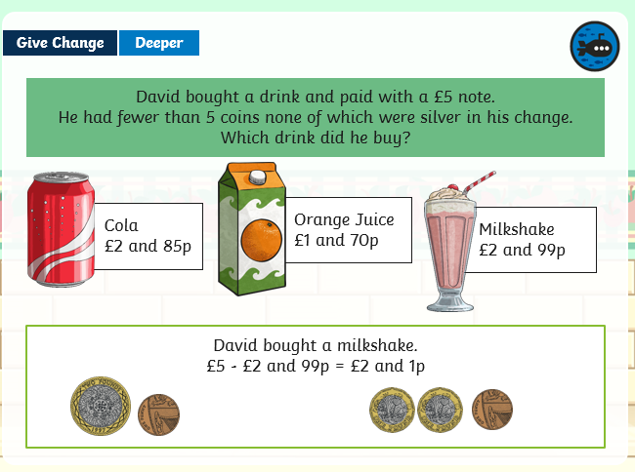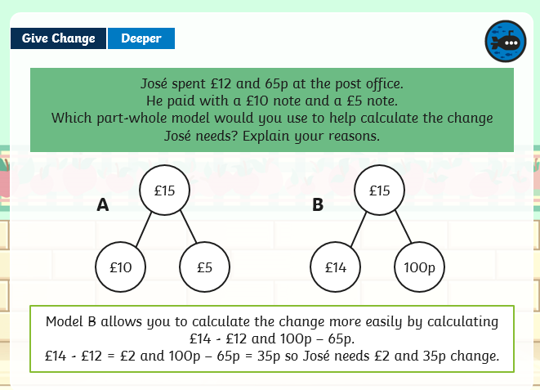
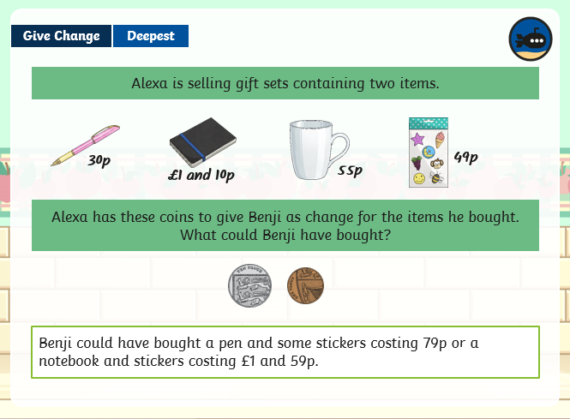
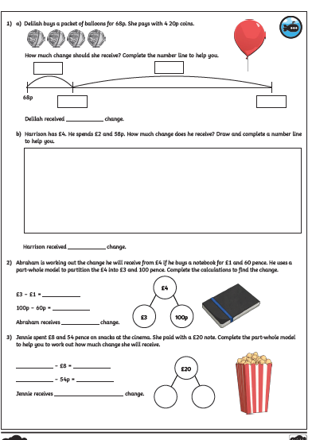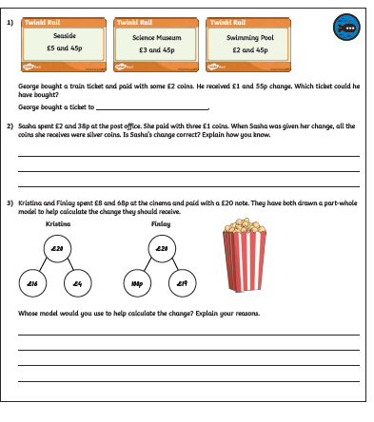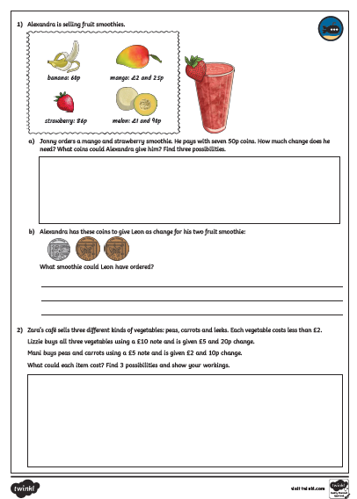

1.00pm – Assembly
Chinese new year – please see PowerPoint on school website or classdojo.

1.15pm – SPAG (up to 20 minutes)
Spelling test: Get someone to test you on these spellings at home (I hope you’ve been practising!)
scent, sent, vain, vein, rode, road, steel, steal, waist, waste, pressure, promise

Geography
This week we are identifying the location of Mount Vesuvius.
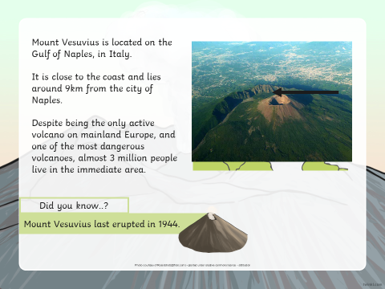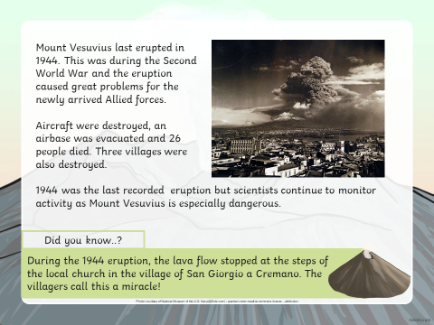
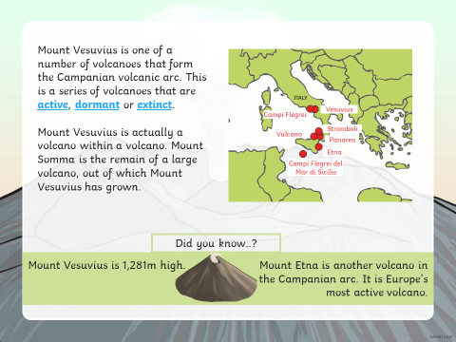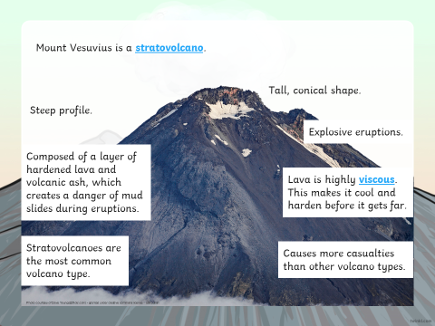
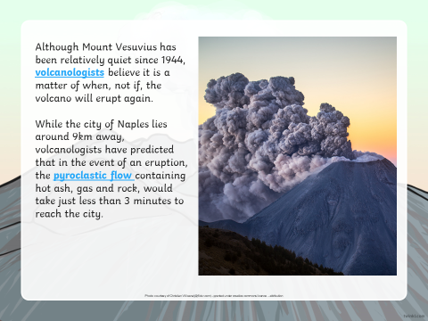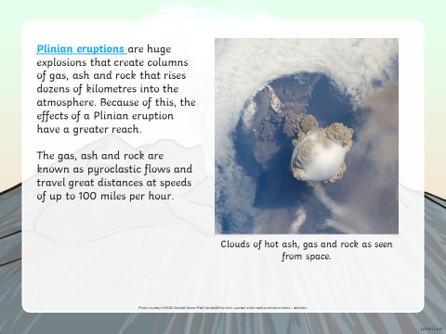
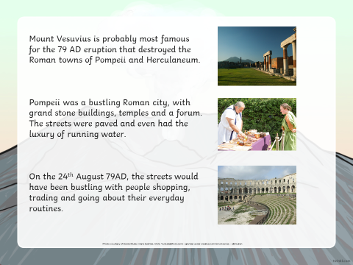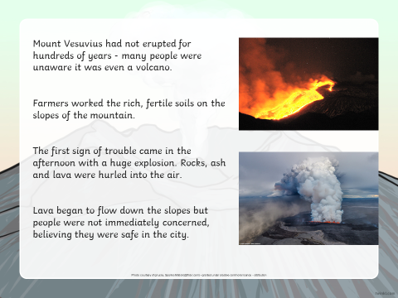
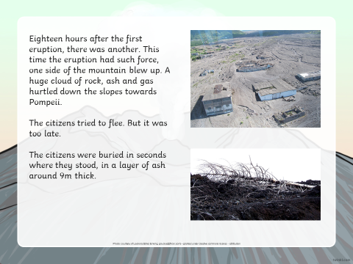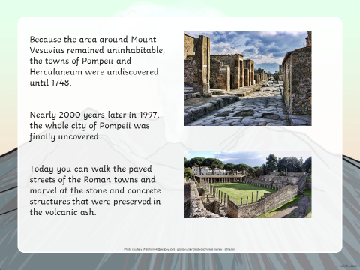
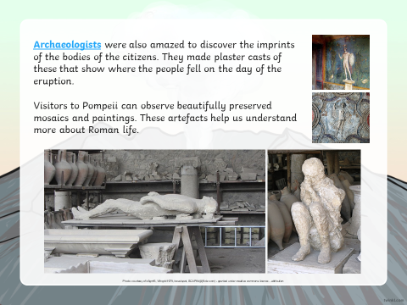
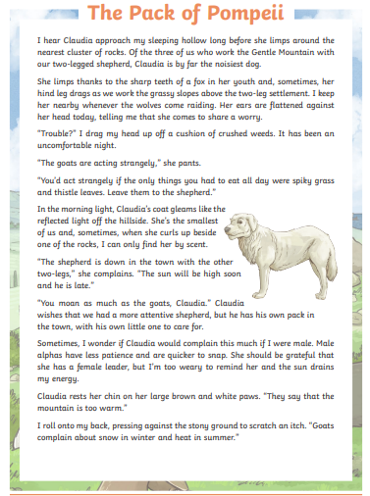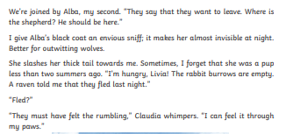
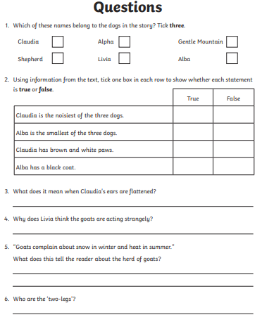
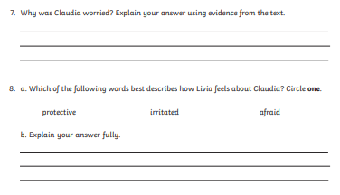
3.00pm – Story Time
Please watch the adult’s stories being posted on the School Story on classdojo.

