This week’s learning for Year 1 Date: 18.1.21
Hello children,
I hope you are all keeping safe and working hard. I have been so pleased with all of the fantastic home learning I have been sent on class dojo so far, keep it up! Remember, there is doing a ‘Home Learning Champion’ challenge where you could win a bike, but to be in with a chance to win you need to either be sending your home learning to me on dojo, or bringing any work in to school, for us to see.
Here are some useful websites you may also want to visit to help with home learning:
https://home.oxfordowl.co.uk/ - access a library of books to read at home
https://www.phonicsplay.co.uk/ - phonics games. It is entirely free due to schools being closed.
https://www.topmarks.co.uk/maths-games/5-7-years/counting - free maths games
If you have any questions or worries, please don’t hesitate to contact us on class dojo, or ring school on 01709 740962. We are here to support you.
Take care,
Miss Platts and Mrs. Gregory x
Monday
9.15 - Success for All
Phonics
Miss Platts – watch the powerpoint and complete the activities. We will be practising spelling our ‘ow’ words.
After the session you can practise them again on www.phonicsplay.co.uk - choose a game to play such as ‘trash or treasure’, and choose to recap all sounds up to phase 5.
Mrs Gregory – watch the powerpoint and follow the instructions. We will be practising our ‘r’ words. After the session you can practise them again on www.phonicsplay.co.uk- choose a game to play such as ‘trash or treasure’, recapping all phase 2
Roots Group 1 – Miss Platts
We will be reading ‘Leaves Fall’ as our shared story (this will be uploaded to class dojo and the school website). Read the story to your grown up, talking about what you have read and the events.
Our STaR story is ‘Weather and the Seasons’ by DK. Today you will write a detailed description about your least favourite season.
Roots group 2 – Mrs Gregory
Our shared story is ‘Miss Sid meets Sad Sam’ (this will be uploaded to class dojo and the school website) Read the story to your grown up, talking about what you have read and the events.
We will be reading ‘Birds’ as our STaR story.

11.00 - Assembly – see school website

11.15 - Maths – Add by making 10
Warm up by recalling some number bonds to 10 – can you remember all the pairs of numbers that make 10? If you know all these, can you make them into number bonds to 20?
e.g 5 +5 = 10, so 15 + 5 = 20
Watch the ‘Oak Academy’ video for ‘add by making 10’, day 1: https://teachers.thenational.academy/lessons/to-use-the-make-ten-strategy-to-add-two-1-digit-numbers-part-1-70r62e
Once you have watched the video, complete the independent task. You need to decide which addition sentences need partitioning, and which don’t
Which addition sentences already make 10? (use your knowledge of number bonds)
Which addition sentences need partitioning?
Afternoon -RE: Jewish Celebrations: Shabbat
Think back to last week’s learning and the story of ‘The Creation’ that Jewish people believe show how the world and everything on it was created.
What did God do on the 7th day?
For Jews, their holy day is called ‘Shabbat’. This is their day of rest.
Shabbat lasts from sunset Friday to Saturday evening – traditionally when 3 stars are seen in the sky. During Shabbat no work is performed so any preparations such as cleaning, tidying the house, food preparation, cooking, washing, ironing etc. must be done before sunset on a Friday. In stricter households even switching the lights on is seen as work and isn’t allowed during Shabbat, so some families use a timer for electrical items. Men often visit synagogue on the way home from work. A synagogue is the Jewish place of worship.
Find out about Shabbat by watching this short video: https://www.youtube.com/watch?v=JpFw7DqRMEc and listen to the story, ‘Sammy the Spiders First Shabbat’: https://www.youtube.com/watch?v=0ipzoL6cFsQ
Why is rest important?
What helps you to rest?
Use the pillow outline to draw or write about things you like to do when you rest.
Tuesday
9.15 - Success for All
Phonics
Miss Platts – watch the powerpoint and complete the activities as modelled in the video. We will be practising spelling our ‘ow’ words.
After the session you can practise them again on www.phonicsplay.co.uk - choose a game to play such as ‘trash or treasure’, and choose to recap all sounds up to phase 5.
Mrs Gregory – watch the powerpoint and follow the instructions. We will be practising our ‘b’ words. After the session you can practise them again on www.phonicsplay.co.uk - choose a game to play such as ‘trash or treasure’, recapping all phase 2
Roots Group 1 – Miss Platts
We will be reading ‘Cupcakes’ as our shared story.(this will be uploaded to class dojo and the school website) Read the story to your grown up, talking about what you have read and the events.
Our STaR story is ‘The Gingerbread Man’ by Estelle Corke. You can listen to the story here: https://www.youtube.com/watch?v=GI3YrmAdvpI.
Today you will write sentences to command people to eat certain foods, and give a reason why.

Roots group 2 – Mrs Gregory
Our shared story is ‘The Ice Cream Man’ (this will be uploaded to class dojo and the school website) Read the story to your grown up, talking about what you have read and the events.
We will be reading ‘Tasty Poems’ as our STaR story. You can listen to the story here: https://www.youtube.com/watch?v=rD-Q8aiyDWY

11.00 - Assembly – see school website

11.15 - Maths –Add by making 10
Recap yesterday’s learning.
Which of these number sentences make 10, and which need partitioning to make 10:
6 +4 7 + 6 8 + 2 5 + 9 4 + 7 9 + 1
Watch the video here for add by making 10, day 2: https://teachers.thenational.academy/lessons/to-use-the-make-ten-strategy-to-add-two-1-digit-numbers-part-2-60rk4t
Once you have watched the video, complete the independent task. In the task you will need to use your knowledge of number bonds and partitioning numbers in to 2 parts to fill in the missing boxes.

Afternoon:
What do you think an astronaut does?
What do you think it’s like on board a space shuttle?
What do you think would be the same / different about living in a space shuttle to your house?
Look at the power point ‘amazing astronauts’ to learn more about life as an astronaut and what they need to wear.
You could also watch some of these videos about what it is like for astronauts to eat, sleep and live aboard a space shuttle:
https://www.youtube.com/watch?v=e3za6ITFfWk
https://www.youtube.com/watch?v=tgRMAVoHRbk
https://www.youtube.com/watch?v=3bCoGC532p8 – how do you brush your teeth in space?
https://www.youtube.com/watch?v=UyFYgeE32f0 – how do you sleep in space?
Would you like to be an astronaut? Why/ why not?
Make a list of things you would take with you to space.
Wednesday
9.15 - Success for All
Phonics
Miss Platts – watch the powerpoint and complete the activities as modelled in the video. We will be practising spelling our ‘oo’ words.
After the session you can practise them again on www.phonicsplay.co.uk - choose a game to play such as ‘trash or treasure’, and choose to recap all sounds up to phase 5.
Mrs Gregory – watch the powerpoint and follow the instructions. We will be practising our ‘f’ words. After the session you can practise them again on www.phonicsplay.co.uk - choose a game to play such as ‘trash or treasure’, recapping all phase 2
Roots Group 1 – Miss Platts
We will be reading ‘Cupcakes’ as our shared story.(this will be uploaded to class dojo and the school website) Read the story to your grown up, talking about what you have read and the events.
Our STaR story is ‘The Gingerbread Man’ by Estelle Corke. You can listen to the story here: https://www.youtube.com/watch?v=GI3YrmAdvpI
Today you will write sentences to command people not to eat certain foods, and give a reason why.

Roots group 2 – Mrs Gregory
Our shared story is ‘The Ice Cream Man’ (this will be uploaded to class dojo and the school website) Read the story to your grown up, talking about what you have read and the events.
We will be reading ‘Tasty Poems’ as our STaR story. You can listen to the story here: https://www.youtube.com/watch?v=rD-Q8aiyDWY

11.00 - Assembly – see school website

11.15 - Maths – Add by making 10
Watch the video, ‘add by making 10’ (White Rose Maths). Stop and pause the video whenever you need to, to explain things further, or re-watch parts as much as you need to, to help with understanding.
Complete questions 1 and 2 on the accompanying worksheet.

Afternoon: Science – Materials
What is a material?
Do you know the names of any materials?
This video tells us about different types of materials and the different objects we may see around us that they are used to make:
https://classroom.thenational.academy/lessons/what-are-objects-made-from-61gp8d?step=2&activity=video
Follow along with the video – it will ask you to join in and answer questions.
Activity – draw 3 objects from around your house. Write what material the objects are made out of.
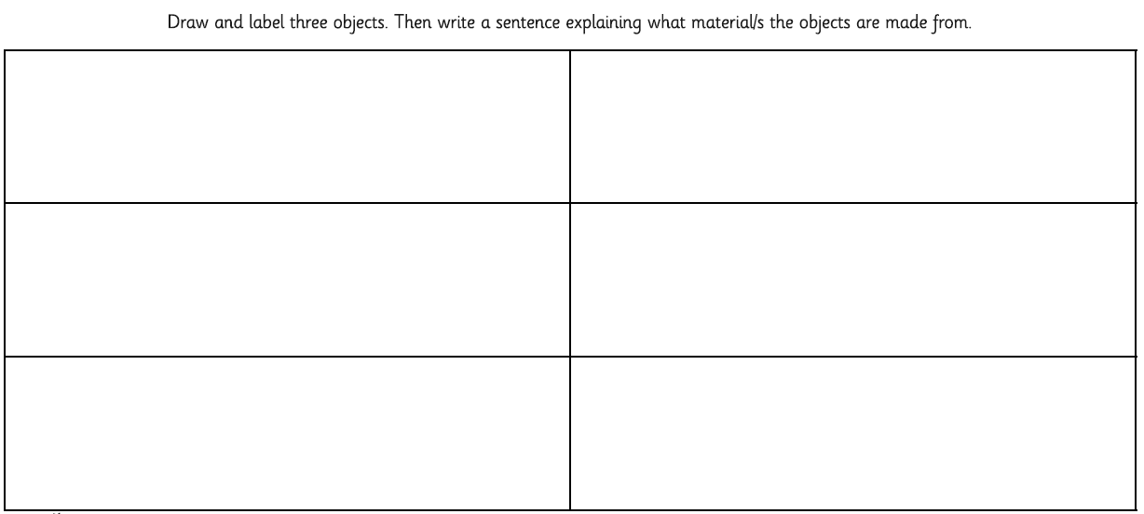

Thursday
9.15am - Success for All
Phonics
Miss Platts – watch the powerpoint and complete the activities as modelled in the video. We will be practising spelling our ‘oo’ words.
After the session you can practise them again on www.phonicsplay.co.uk - choose a game to play such as ‘trash or treasure’, and choose to recap all sounds up to phase 5.
Mrs Gregory – watch the powerpoint and follow the instructions. We will be practising our ‘e’ words. After the session you can practise them again on www.phonicsplay.co.uk - choose a game to play such as ‘trash or treasure’, recapping all phase 2
Roots Group 1 – Miss Platts
We will be reading ‘Cupcakes’ as our shared story.(this will be uploaded to class dojo and the school website) Read the story to your grown up, talking about what you have read and the events.
Our STaR story is ‘The Gingerbread Man’ by Estelle Corke. Today you are going to write a recipe to make a gingerbread man.

Roots group 2 – Mrs Gregory
Our shared story is ‘The Ice Cream Man’ (this will be uploaded to class dojo and the school website) Read the story to your grown up, talking about what you have read and the events.
We will be reading ‘Tasty Poems’ as our STaR story. You can listen to the story here: https://www.youtube.com/watch?v=rD-Q8aiyDWY

11.00 – Assembly– see school website

11.15 – Maths – adding by making 10
Look at the method Rosie has used to work out the answer to 6 +7.
She has thought about her number bonds to help her to make a full 10. Rosie knows that 6 + 4 = 10, so has partitioned the 7 in to two parts, 4 and 3. She has used the 4 to make 10, and then added on the 3.
So 10 + 3 = 13, which means 6 + 7 = 13.
Use your knowledge of number bonds and the same method as Rosie to help you answer the 3 questions.
What will you need to add to make 10 to the first number?
What will you partition the second number in to, to help you make 10?
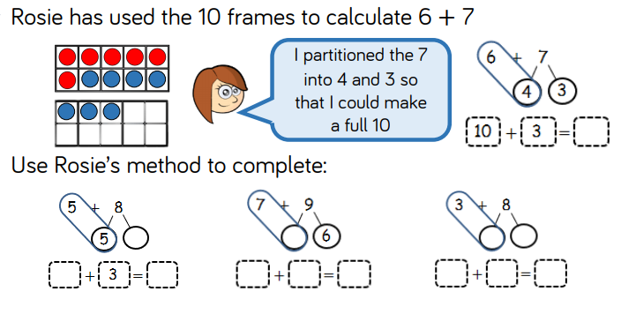

Afternoon: D&T
Look at pictures of vehicles used to explore the moon (power point, ‘moon vehicles’). Discuss what the vehicles look like and why.
Imagine you are going to the moon. Before you go, you must design your own moon buggy for the purpose of exploring the moon when you get there.
What will your moon buggy be made out of?
What will your moon buggy look like?
What features will your moon buggy need to drive over the bumpy surface of the moon?
How will it move?
Use the moon buggy design sheet to design your moon buggy. Label the materials and features you have chosen to include in your design.
Friday
Success for All
Phonics
Miss Platts – watch the powerpoint and complete the activities as modelled in the video. We will be practising spelling our ‘u_e’ words
After the session you can practise them again on www.phonicsplay.co.uk - choose a game to play such as ‘trash or treasure’, and choose to recap all sounds up to phase 5.
Mrs Gregory – watch the powerpoint and follow the instructions. We will be practising our ‘l’ words. After the session you can practise them again on www.phonicsplay.co.uk - choose a game to play such as ‘trash or treasure’, recapping all phase 2

Roots Group 1 – Miss Platts
We will be reading ‘Cupcakes’ as our shared story.(this will be uploaded to class dojo and the school website) Read the story to your grown up, talking about what you have read and the events.
Our STaR story is ‘The Gingerbread Man’ by Estelle Corke. Today you will continue to write a recipe to make a gingerbread man.

Roots group 2 – Mrs Gregory
Our shared story is ‘The Ice Cream Man’ (this will be uploaded to class dojo and the school website) Read the story to your grown up, talking about what you have read and the events. Read the story to your grown up, talking about what you have read and the events.
We will be reading ‘Tasty Poems’ as our STaR story. You can listen to the story here: https://www.youtube.com/watch?v=rD-Q8aiyDWY

11.00 – Assembly – see school website

11.15 – Maths- add by making 10
Today there are 2 questions to problem solve using all we have looked at this week and our knowledge of making 10 to add.
Talk through each question and encourage your child to explain their thinking and reasoning for their answer.
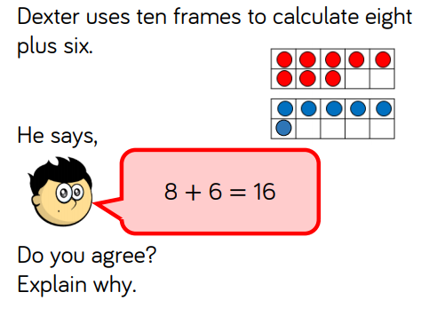
Do you agree with Dexter? Why / Why not?
What should Dexter have done?
(answer: disagree, because Dexter has not added by first making 10 in the first 10 frame)
Can you show what Dexter should have done to find the answer using the 10 frames:
8 + 6 = ____

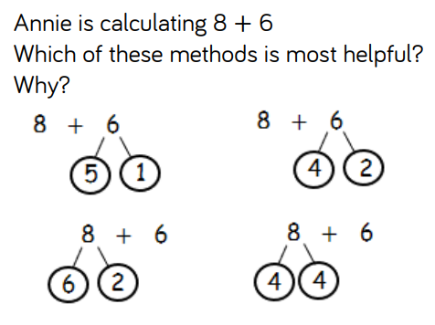
Look at each method and talk through them – think of your number bonds to help you find the most helpful way to find the answer to 8 + 6 (there are 2 ways). Remember, we need to make a 10 first!!!

(answer: the second method where 6 has been partitioned in to 4 and 2, because 8 + 2 = 10, then add the 4, and the last method where 8 has been partitioned in to 4 and 4, because 6 + 4 = 10, then add 4)

Afternoon: PSHE: Keeping Healthy –

We are going to look at the amount of sugar in different food and drinks. Gather some different food and drink items from around your house (around 6-10). Download and use this app on a phone or tablet: Change4Life Food Scanner
It will let you see how much sugar there is in the food/drink if you scan the barcode on the packaging. Write down the food/drink, and how many cubes of sugar are in it. Then, order the foods/drinks from healthiest to least healthy by looking at the amount of sugar in each
Discuss that whilst too much sugar isn’t good for our teeth or bodies, sugary foods can be enjoyed as part of a healthy and balanced diet if we have small amounts.
Now look at the power point – Sophie’s Sugar Smart Day. Can you choose the foods with the least sugar in them for Sophie to eat?
What swaps could you make to cut down on sugar in your diet?

