This week’s learning for Year 4 Date:05.10.20
Hello children,
I hope you are all okay? Please do make sure you’re sending me things on class dojo. Here is this week’s home learning. Remember the parts in blue are really important and you should try your best to do these. The bits in green are other activities that you can do in an afternoon. I have also suggested times for you to do the activities as your brain is more alert in the morning. However, these times can be adjusted by you and your parents, if they don’t fit into your daily routine.
Take care,
Miss Moss
Monday
9.00am – Spellings (for 15 minutes)
Can you practise page these five spellings from the Y3/4 statutory spellings using this format please.
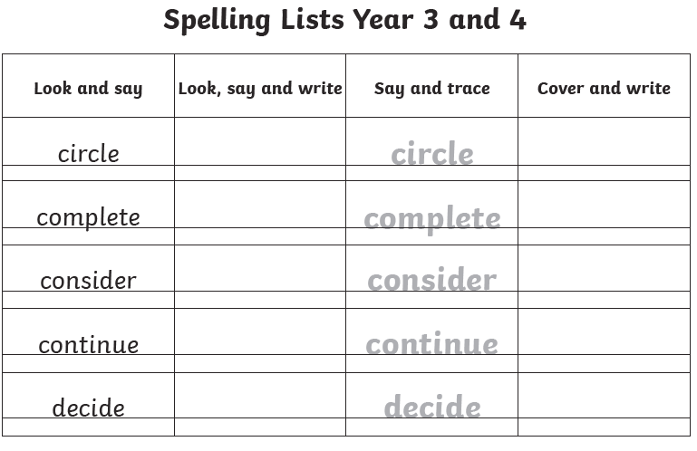

9.15am – Success for All/Literacy (for 60 minutes)

10:15 – Phonics (30 minutes)
Phonicsplay is an exciting website which is free to login – there are plenty of games to choose from, make sure you choose phase 3 please.

10.45am – Fit 15/break (for 15 minutes)
Spend this time doing something active to release all your excess energy!

11am – Maths (for 60 minutes)
Continue to practice adding 2 digits by one digit. REMEMBER TO USE PLACE VALUE AND TO SHOW YOUR EXCHANGING!

Afternoon Activity - Art
Can you draw a picture of your favourite game? I wonder what yours will be? I would draw a picture of Twister as I make sure I always win.

Tuesday
9.00am – Spellings (for 15 minutes)
Using the five spellings from yesterday, can you try and use each word in a sentence. Remember your full stops and capital letters.

9.15am – Success for All/Literacy (for 60 minutes)

10.15am – Phonics (for 30 minutes)
Using the digraph ‘oa’ can you find five words with this sound in? Can you place those words into sentences?

10.15 – Fit 15 (15 minutes)
Can you practice and perfect your times table routines.

11.00am – Maths (up to 60 minutes)
Today is challenge day! Can you being to add 2 digits by 2 digits e.g. 25+36=. Remember to use the column method, place value and to EXCHANGE!

Afternoon Activity – Science
Watch the video of ‘What animals need to survive’. Can you answer the questions in the quiz after? I wonder how many you will get right. https://www.bbc.co.uk/bitesize/topics/z6882hv/articles/zx38wmn

Wednesday
9.00am – Bedrock (for 30 minutes)
Using your login details can you complete one lesson with 70% or over.

9.30am – Success for All/Literacy (for 60 minutes)

10.30am – Reading (for 20 minutes)
Choose a book to read and enjoy.
Use the phonics you know to sound out the words. Don’t forget to try and spot the digraphs and tricky words.
Talk about what happened in the book and ask/answer up to 3 questions with your grown up.
If you don’t have many books, sign up to Oxford Owl to read an e-book.
https://home.oxfordowl.co.uk/

10.50am – Maths (up to 30 minutes)
Continue to practise adding 2 digits by 2 digits. The more you practise the easier it will become to remember all the steps.
REMEMBER TO USE PLAVE VALUE AND TO EXCHANGE!

11.20am- Number Logik (up to 30 minutes)
Using your login details, challenge yourself to improve your score each time.

Afternoon Activity – PE
Think back to last week’s PE session. Can you have a go at practising some of those stations eg press ups, star jumps, jogging on the spot and the plank. See if you can challenge yourself to do ten different exercises!

Thursday
9.00am – Maths (for 45 minutes)
Today is up to you! If you feel you need some more practise with 2 digit addition, then use this sheet:
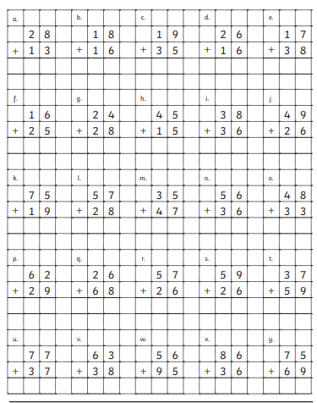

If you feel confident to move onto 3 digit addition here is your sheet. These additions do not need EXCHANGING. This sheet is designed to just secure your confidence with adding within three columns.
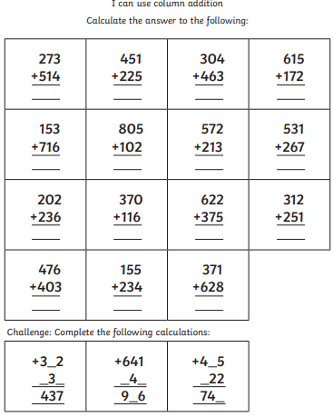

9.45am – Success for All/Literacy (for 60 minutes)

10.45am – Phonics (for 30 minutes)
Using the digraphs ‘ch’ and ‘sh’, can you create some yes or no questions? Eg Does a sheep go to church?
REMEMBER YOUR CAPITAL LETTERS, FULL STOPS AND QUESTION MARKS.

10.45 – Fit 15 (for 15 minutes)
Spend fifteen minutes jogging and stretching in the garden to release your excess energy!

11.00am – Spellings (up to 20 minutes)
Using your spellings from Monday and Tuesday try to put your spellings into different sentences. To challenge yourselves why don’t you try extending your sentences using FANBOY conjunctions (for, and, nor, but, yet or so).

11.20am – Times tables (30 minutes)
Login and challenge yourself to beat yesterday’s scores.

Afternoon Activity – Design and Technology/Craft
Can you make a model of your favourite toy? You could use wool, cotton wool, cardboard boxes, toilet roll tubes. You could make a robot or a teddy bear. What is your favourite toy?

Friday
9.00am – Maths (for 40 minutes)
Again, it is your choice to continue to become more secure with adding 2 digits with exchanging using this sheet:
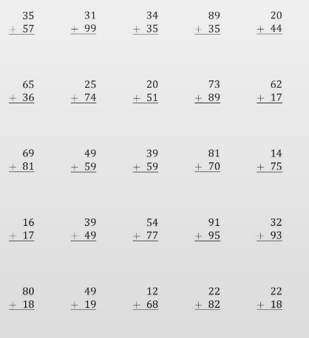

Or challenge yourself to three digit additions with exchanging:
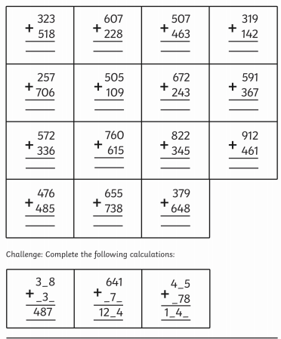

9.40am – Success for All/Literacy (for 60 minutes)

10.40am – Reading (for 20 minutes)
Choose a book to read and enjoy.
Use the phonics you know to sound out the words. Don’t forget to try and spot the digraphs and tricky words.
Talk about what happened in the book and ask/answer up to 3 questions with your grown up.
If you don’t have many books, sign up to Oxford Owl to read an e-book.
https://home.oxfordowl.co.uk/

11.00am – Times tables (up to 20 minutes)
Starting with the times tables I gave your to practise in class, complete those and move on as quickly as possible to the next. See how many you can complete. Make sure you record your times table level to improve on next week.

11.20 – Spellings (10 minutes)
Get an adult to test you on your spellings.
This week’s spellings are: circle, complete, consider, continue and decide.

11.30 – Bedrock
Login to your bedrock account and try to complete one lesson with a score of 70% or more.

Afternoon Activity - PSHE
Have a think about your friends at school. Think about what it means to be a good friend and how you can make sure you can be a good friend when you are back at school. Use the template below – ‘How to be a good friend’ to help you.

