This week’s learning for FS1 Date: 05-01-2021
Hello Everyone
This week’s Success for All (SFA) theme is Art and artists. The art lab with its theme related creative art activities, is an important component of curiosity corner because of its many benefits for the growth and development of young children.
Books to support this theme are: Snail trail, Camille and the sunflowers, Bear Hunt and Katie and the British artists. See story tree section for links to the stories on YouTube.
If you have any questions please feel free to contact us this can be through DOJO, email or phone. Our number is 01709 740962. Email school@fep.jmat.org.uk

Daily Message for each day.
Monday- We will look at how artists work
Tuesday- We will try out some tools artists use in their work
Wednesday- Artists use different materials to create their work
Thursday- Artists use line, shape and colour in their work
Friday- Artists use their imagination to create their work.
Clues and Question
Monday- How do we know who created a picture? Discuss with your child that illustrators’ draw the pictures for books.
Tuesday- What tools do artists use? Talk about how artists use a range of tools such as clay tools, pencils, watercolours, different types of paint.
Wednesday- What media do artists use? Discuss different types of material and the patterns and shapes on these.
Thursday- Artists use line, colour and shape to communicate their ideas. Talk about and explore how you can use shapes to create pictures.
Friday- Artists use their imagination. Talk about different colours and how we can use our imagination to think of pictures to draw.
Rhyme Time
Phonological awareness activity
Swop the colours in the rhyme and repeat the rhyme again this will encourage your child to listen carefully to the instructions.

Phonological awareness activity
Swop some of the words and see if your child can spot the mistakes.

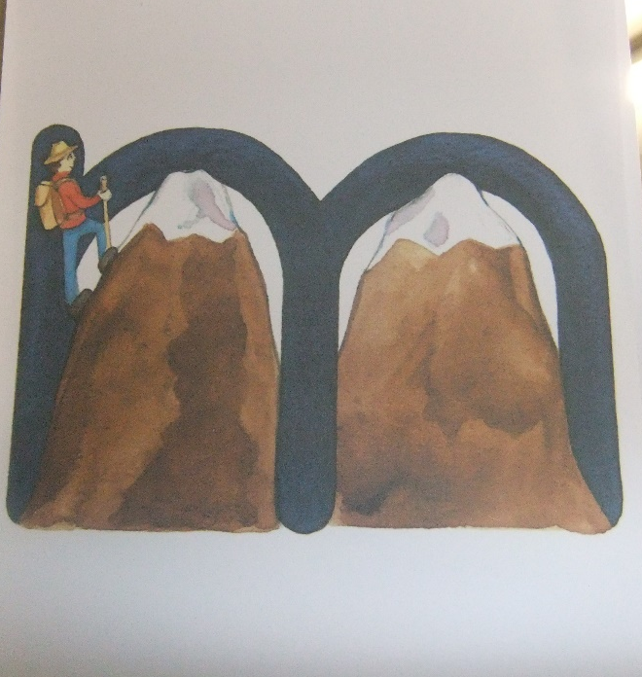
Phonics
Tuesday- Show your child the picture for “M” point to the picture and say the name of the object twice then as “what is it?”
“The man marches on mountains” stretch/ emphasise the “m” in each word “Man”, “Marches”, “Mountain”
Look for items around your house that starts with “m” e.g. “mop” say “mmmmmmop”
Write the letter “M” for your child.
When writing “m” Say Lets look at the man marching on the mountains. From the man go down, climb one mountain and another. Look closely at this letter. Can you see how it looks like a mman mmmarching on the mmmmountains? This letter says “M”. When you see this letter say “m”. What does this letter say (m).
Support your child to write the letter in the air using ther finger.

Wednesday- Review “M” Look at the picture and say The man marches on mountains
Review the objects you found at your house that start with “m”.
Make the “mmmmm” sound
Review the shape of “m” From the man go down, climb one mountain and another, mmmm.
Write “m” in the air
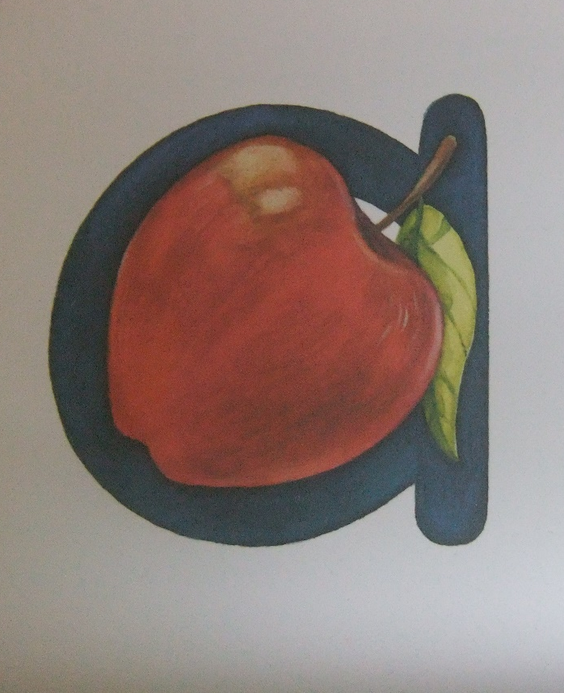
Then have a go at writing “m” saying From the man go down, climb one mountain and another. Mmm. In order to help support your child to correctly form the letter.
Thursday- Say the phrase Alphie asks for apples. Ask your child what sound they can hear at the start of Alphie and apples.
Repeat Alphie asks for apples, look at the apple. Aaaple. The first sound I hear in apple is a. say aaa.
Look for objects around your house that start with “a”.
Make the sound “a”. then say Today’s sound is “a”. You have to open your mouth wide to say “a”, don’t you? “a” is a loud sound. It is not like “m”. “m” is quiet. “a” is loud. Let’s say the sound together.
Write the letter “a”. Run your finger around the “a” and say Left around the apple and down the leaf.
Tell your child to trace the letter with their finger and attempt to write the letter in the air.

Friday- Review the sound “a”
Review the objects that start with an “a” sound.
Make the sound.
Review the shape of “a” and practise writing “a”.

Art
Paint using finger paints, water colours and sponges.
Make a collage using different materials.
Experiment with string and paint.
Dramatic Play
Decorate the house with fabrics.
Use face paints.
Maths
Assemble jigsaws, discussing shapes.
Permanent activity Discuss with the children what day of the week it is including the date and month. Discuss what the weather is like each day and what season it is.
NEW counting 1-20 this can be objects around the house, stair or cars. Support children to recognise numbers 1-5 or 1-10 if they can recognise 1-5.
Science
Explore colour with paddles, magnifying glasses, coloured chalks and sorting trays.
Writing
Paint with cotton swabs.
Construct Q using materials.
Permanent activity Encourage your child to practise writing their name

Story Tree
Monday- Snail trail
Tuesday- Camille and the sunflowers. https://www.youtube.com/watch?v=0ax9UVo8oRQ
Wednesday- Bear Hunt https://www.youtube.com/watch?v=-d1_Z068z74
Thursday- Katie and the British artists. https://www.youtube.com/watch?v=ObHIQ2JonsA
Friday- Pick your favourite.

