This week’s learning for Year 4 Date:4.1.21
Hello children,
Welcome back Year 4! I Please do make sure you’re sending me things on class dojo and also check for the daily assemblies Here is this week’s home learning. I have also suggested times for you to do the activities as your brain is more alert in the morning. However, these times can be adjusted by you and your parents, if they don’t fit into your daily routine.
Take care,
Miss Moss
Tuesday
9.00am – Spellings (for 15 minutes)
Using this format, can you practise these spellings please:
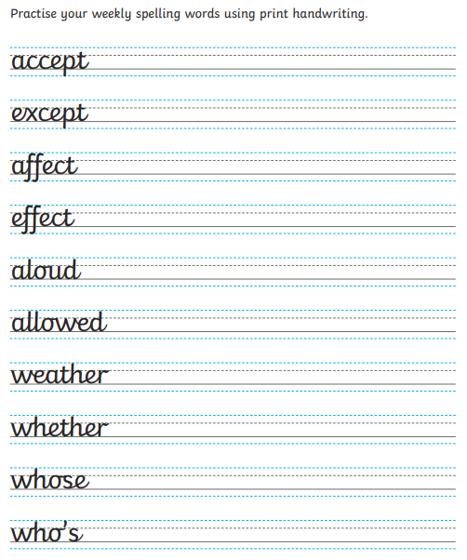

9.15am – Success for All/Literacy (for 60 minutes).
Thinking back to what you have watched/read from George’s Marvellous Medicine and the Twits. Can you explain in writing what both of the stories are about? Do they have any similarities? Did the adults in the story behave like normal grown-ups? How? Were there clear goodies and baddies? Did the baddies get what they deserved? Does anyone get taught a lesson in the stories? Are the books funny/shocking/sad/frightening/naughty? Are the stories mostly description or do lots of things happen?

10.15am – Phonics (for 30 minutes)
Using the digraph ‘ng’ can you find five words with this sound in? Can you place those words into sentences?

10.15 – Fit 15 (15 minutes)
It’s time to challenge yourself and make a new routine to go with your next set of timetables. I can’t wait to see what you come up with.

11.00am – Maths (up to 60 minutes)= All Groups!
This week we are moving onto multiplication. Here is a video to support you to use bar modelling and part-part-whole models: Multiplication using bar model Year 3 - YouTube.

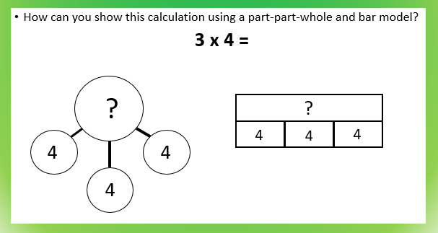

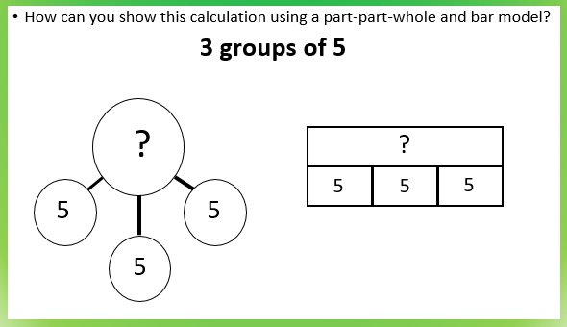

Can you complete these sums using the part-part-whole model and the barmodel: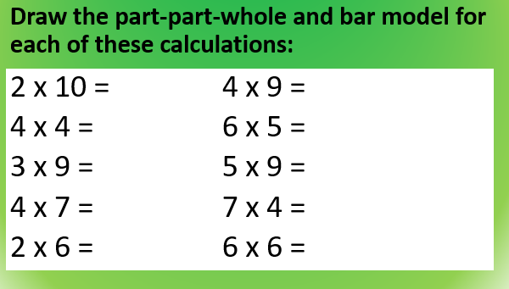

Afternoon Activity – Science
This term we are looking at Rocks. Can you watch this video to support your learning:Rocks for Kids - YouTube

Using the information from the video can you complete this worksheet please:
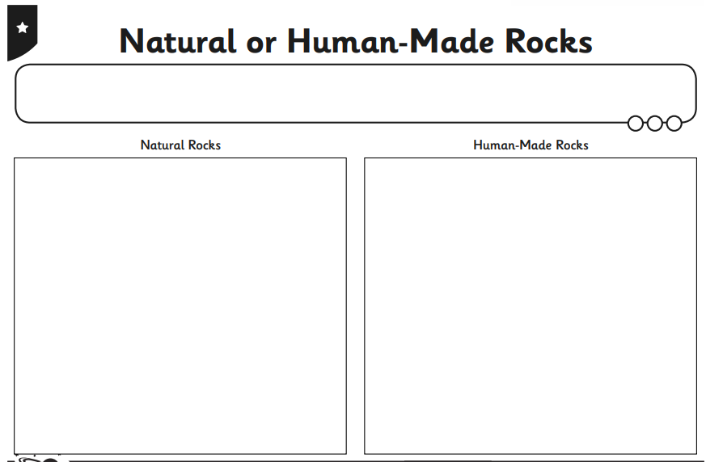

Wednesday
9.00am – Bedrock (for 30 minutes)
Using your login details can you complete one lesson with 70% or over.

9.30am – Success for All/Literacy (for 60 minutes)
Today, we are looking at James and the Giant Peach – here is the online readable version: James and the Giant Peach (books-library.online) Read to the end of page 17, can you explain in writing some of the similarities and differences between this story and The Twits?
Can you read from page 42-49 of George’s Marvellous Medicine? Why do you think Roald Dahl says that Grandma was like a piece of elastic when she started to grow? How did Roald Dahl explain why did Grandma stop swelling up? Do you expect Roald Dahl to make his characters do the most obvious or sensible thing? Explain your answer and give an example to show what you mean?

10.30am – Reading (for 20 minutes)
Choose a book to read and enjoy.
Use the phonics you know to sound out the words. Don’t forget to try and spot the digraphs and tricky words.
Talk about what happened in the book and ask/answer up to 3 questions with your grown up.
If you don’t have many books, sign up to Oxford Owl to read an e-book.
https://home.oxfordowl.co.uk/

10.50am – Maths (up to 30 minutes) – All Groups!
Continuing with using bar modelling and part-part-whole models can you answer the questions on this slide?
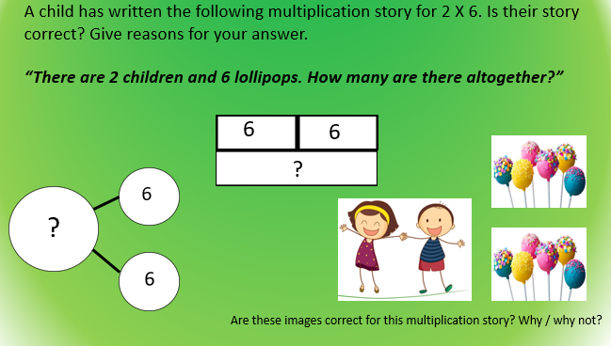

Can you write a multiplication story and answer the number sentence please?
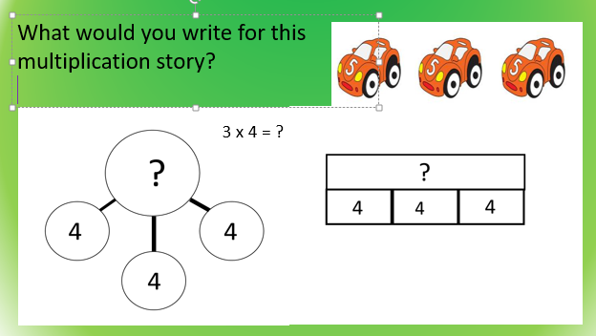

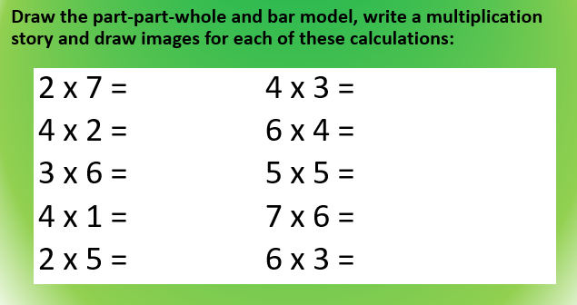

11.20am- Number Logik (up to 30 minutes)
Using your login details, challenge yourself to improve your score each time.

Afternoon Activity – PE
This week in school we are trying to complete a mile a day challenge. Try timing yourself jogging on the spot and challenge yourself to last longer each time! It’s also important to take time to relax, using this youtube video complete these yoga exercises: Celebrating Our Differences 🌎 Yoga Club (Week 22) | Cosmic Kids - YouTube

Thursday
9.00am – Maths (for 45 minutes) – All groups!
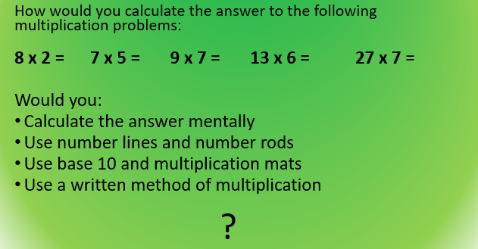

Starting with *
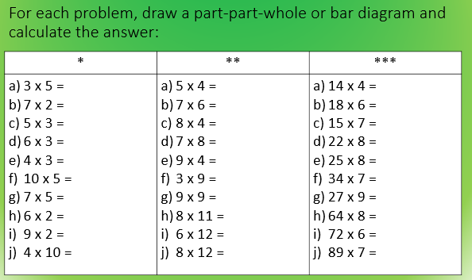
If you find * too easy, challenge yourself to ** and then ***.

9.45am – Success for All/Literacy (for 60 minutes
Today, we are looking at Fantastic Mr Fox : Fantastic Mr Fox by Roald Dahl- Free Books Online (readbooksol.com). Is there anything in the first page that reminds you of the other stories we have looked at? Read to the end of chapter 2 and explain all the similarities and differences.
Read page 50-58 of George’s Marvellous Medicine. Why do you think George is so worried about Grandma going through the roof of the house? If someone asked you what kind of stories Roald Dahl wrote, what would you say? Explain your answer and give an example to show what you mean. Which is your favourite of all the Roald Dahl stories you have read this week? Explain why.

10.45am – Phonics (for 30 minutes)
Using the trigraph ‘ear’, Can you create some yes or no questions? Eg How high is the tight tunnel?
REMEMBER YOUR CAPITAL LETTERS, FULL STOPS AND QUESTION MARKS.

10.45 – Fit 15 (for 15 minutes)
Spend fifteen minutes jogging and stretching in the garden to release your excess energy!

11.00am – Spellings (up to 20 minutes)
Using your spellings from Monday and Tuesday try to put your spellings into different sentences. To challenge yourselves why don’t you try extending your sentences using FANBOY conjunctions (for, and, nor, but, yet or so).

11.20am – Times tables (30 minutes)
Login and challenge yourself to beat yesterday’s scores.

Afternoon Activity – Art
In Art this week we are looking at looking at different artists styles of mountains, using a range of media and materials.
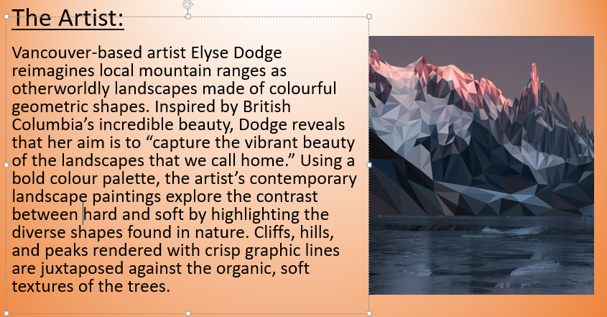

Using these ideas can you attempt to sketch and recreate a mountain landscape?

Friday
9.00am – Maths (for 40 minutes) – Revision day - Both Groups!
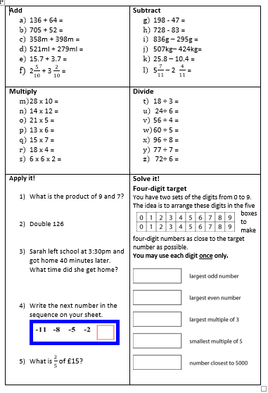

9.40am – Success for All/Literacy (for 60 minutes)
Using the recurring themes of Roald Dahls writing that we have discussed over the last few days, we are going to write a review. What sort of things would you want a reviewer to tell you to help you decide whether to try reading a book by a particular author? Which of Roald Dahl’s characters did you like best and why?

You must start your review with an introduction so that any reader will know what the writing is about and you must summarise your views at the end. REMEMBER TO USE YOUR NOTES THAT YOU HAVE MADE OVER THE PAST FEW DAYS.
10.40am – Reading (for 20 minutes)
Choose a book to read and enjoy.
Use the phonics you know to sound out the words. Don’t forget to try and spot the digraphs and tricky words.
Talk about what happened in the book and ask/answer up to 3 questions with your grown up.
If you don’t have many books, sign up to Oxford Owl to read an e-book.
https://home.oxfordowl.co.uk/

11.00am – Times tables (up to 20 minutes)
Starting with the times tables I gave your to practise in class, complete those and move on as quickly as possible to the next. See how many you can complete. Make sure you record your times table level to improve on next week.

11.20 – Spellings (10 minutes)
Using the spelling practise sheet from Tuesday, can you choose five that you would like an adult to test you on please!

11.30 – Bedrock
Login to your bedrock account and try to complete one lesson with a score of 70% or more.

Afternoon Activity - RE
Introduction to the Hindu religion. Can you watch this video and explain the key points of the Hindu religion: What Is Hinduism?? - YouTube

