Eight Times table word problems

1. Count forward by 8’s from 8 to 160.
2. Count backwards by 8’s from 160 to 8.
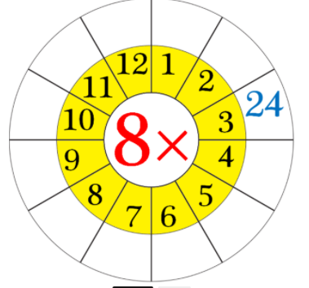
3. Complete the chart multiplying the numbers by the centre number:

4. Jack is 5 years old. His father is 8 times older than him. How is the father?

5. Kelly reads 8 pages of a book each day. How many pages will she have read in 9 days?

6. What are 8 eights?
(ii) 8 times 7?
(iii) 11 eights?
(iv) Eight times 3?
(v) What are 9 times 8?
(vi) Sevens 8?
(vii) 10 times 8?
(viii) Eights 6?
(ix) What is 2 multiplied by 8?
(x) 8 multiplied by 12?

7. What does 8 x 10 mean? What number is it equal to?

8. An octagon has eight equal sides. How many sides do 4 octagons have?

9. An octopus has eight legs. How many legs do 9 octopuses have?

10. (i) How many eights in 32?
(ii) How many eights in 56?
(iii) How many eights in 88?

