This week’s learning for Year 5 Date: 2/11/20
Give out spelling for the week
Monday
9.15 – 10.45 SfA
LO: To gather information about a legendary story
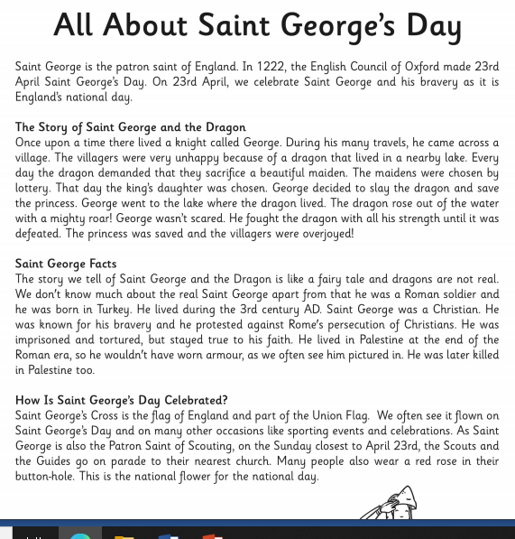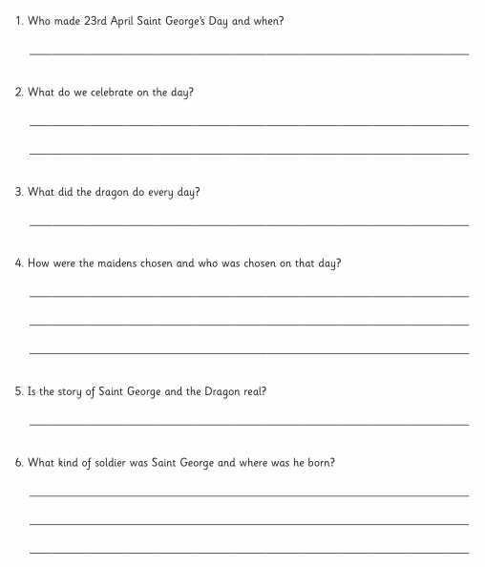

Answers the questions about the legendary story above.

10.45 Break time

11.00 -11.15
Assembly

11.15 – 12.15 Maths (Shape)
- LO: Identify 3D shapes, including cubes and other cuboids, from 2D representations.
Share the PowerPoint from Staff area.
Starter: Shape in bag game. Put a selection of 3d shapes into a bag a describing its properties see if the children can guess which shape I have. Can the children have go? Would anyone like to come and try this?. Use the correct vocabulary and display this on the WW so children can refer to it throughout the week.
Use a cereal box and smarties tube to cut up in front of the children to show them how a 3D shape can be represented by a 2d one (a net)
Activity

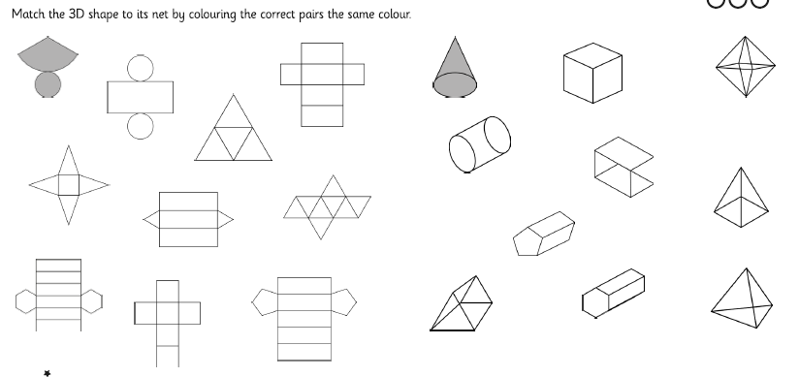

Lorna’s group
LO: To recognise 2D and 3D shapes.
Use the shape bag to identify and discuss different shapes. How many sides? Corners? (2D shapes)
How many faces, vertices, edges? (3D shapes)
Draw around the 2D shapes and label in books – sides and corners
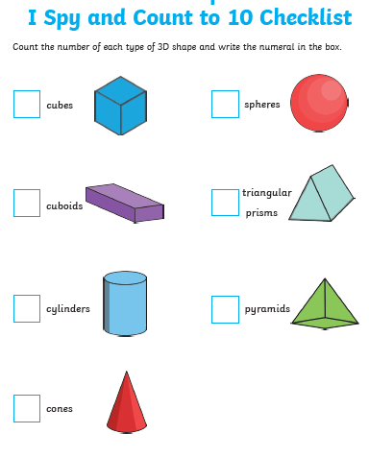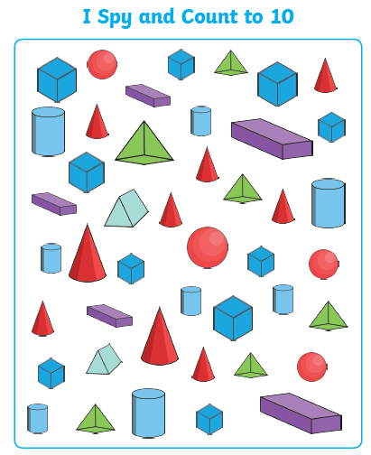

12.15 -1.15 Lunch time

1.15 Reading – quiet reading time. Read a book for your choice for 15 minutes. Think about what the story might be about and the characters that are in it. Maybe you have chosen a non-fiction text, what information can you find in your book ?

1.30pm Spellings/phonics
Use booklet and PowerPoint to go through spellings and meanings
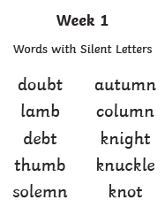

2.00pm
Staying safe online
Look at the video together and think about top tips that we would give to an alien who didn’t know how to stay safe online.
https://www.bbc.co.uk/bitesize/topics/zfcvhbk/articles/zkcj92p

Look at the Powerpoint presentation together as a class. Make a comic based on the one below.
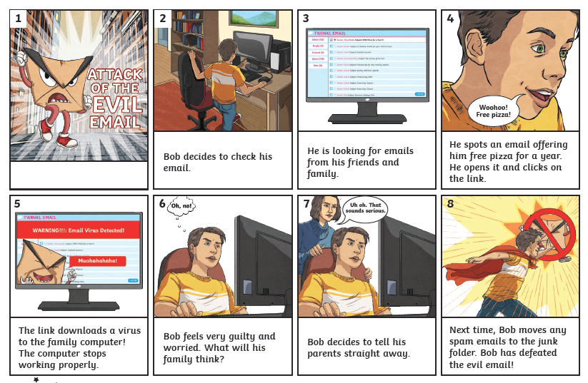
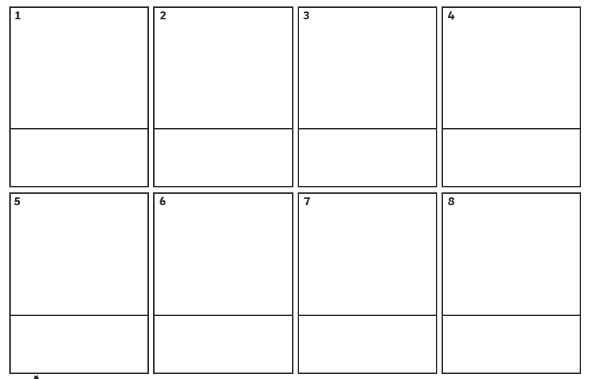
2.40 Story

Tuesday
9.15am SfA
LO: To gather information about a legendary story using the internet

Research using the internet to find out further information about the story of George and the Dragon.
https://learnenglishkids.britishcouncil.org/short-stories/george-and-the-dragon
Breaktime
11.00-12.00

Maths
LO: Identify 3D shapes, including cubes and other cuboids, from 2D representations.
Warm up activity - Play shape net bingo as a class – see resources
Reasoning with 3d shapes questions
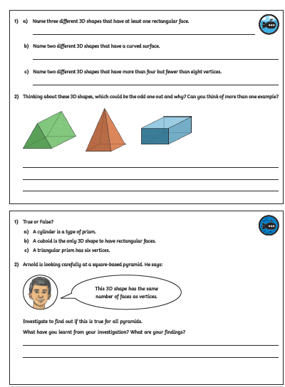

Lornas maths group
LO: To recognise 2D and 3D shapes
Shape hunt
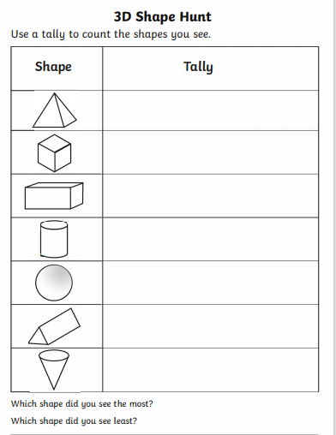

12.00- 12.15 Assembly
Lunchtime
1.15 Reading in class
Checking reading records
1.30pm
Handwriting – spellings
2.00pm
PE in Sports Hall.
Start dance for this half term. Starting with looking at dance through time - Charlston
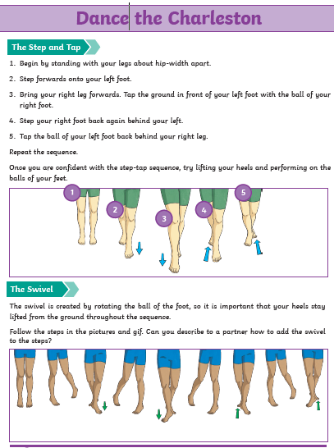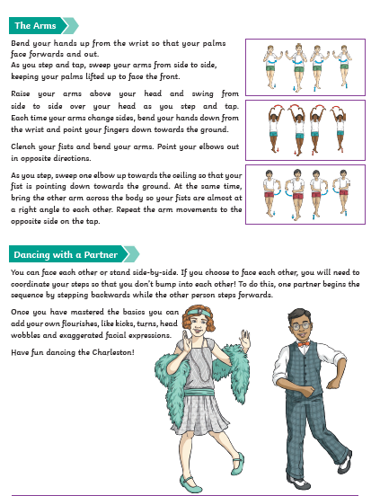

Wednesday

9.15 – 10.45 SfA
LO: To plan a recount (newspaper report)
https://www.bbc.co.uk/teach/class-clips-video/how-to-write-a-recount/z7dg92p
Watch the video above about how to write a recount. Think about the research you have dome all about the story of Geroge and the Dragon. You are going to imagine you are writing a newspaper article the day after George slayed the dragon. Use the planner below or think of you own way of planning your recount.
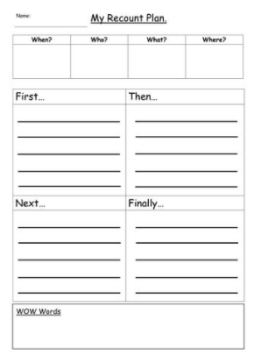

10.45 Break time

11.00 -11.15
Assembly – see the assembly on the school website
https://www.ferhamprimary.org.uk/assemblies

11.15 – 12.15 Maths
- Use the properties of rectangles to deduce related facts and find missing lengths and angles.
Share the PowerPoint
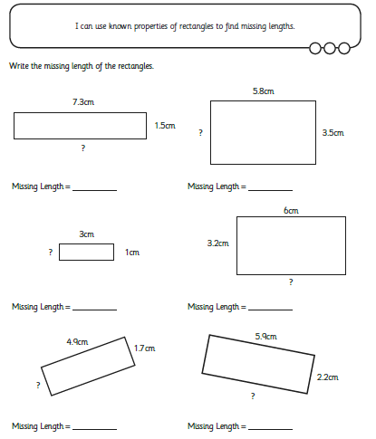

Lornas group
LO: To know the properties of 2D shapes

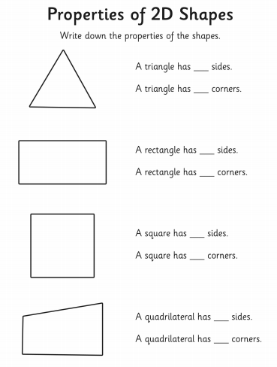
1.15
1.15 Reading – quiet reading time. Read a book for your choice for 15 minutes. Think about what the story might be about and the characters that are in it. Maybe you have chosen a non fiction text

1.30
PE outside
Playground games

Thursday
9.15 – 10.45 SfA
LO: To write a recount of an event
Use the frame below to help you turn your plan into a written recount
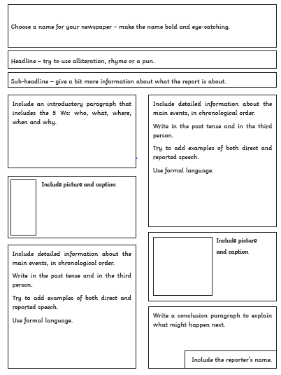
10.45 Break time

11.00 -11.15
Assembly – see the assembly on the school website
https://www.ferhamprimary.org.uk/assemblies

11.15 – 12.15
Maths
LO: Distinguish between regular and irregular polygons based on reasoning about equal sides and angles.
Diving into mastery – reasoning with rectangles and properties

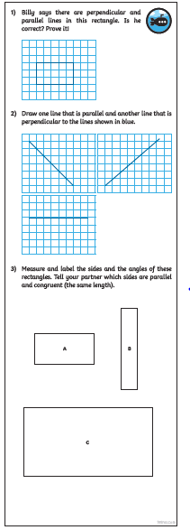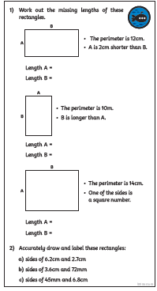

Lorna’s group
LO: To know the properties of 3D shapes
Play the shape in the bag game. Put a 3D shape in the bag – can you guess what it is?
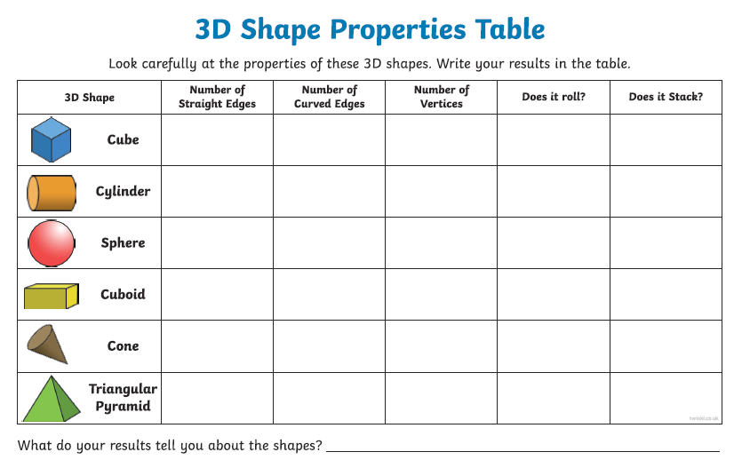
1.15
Reading
1.30
Sarah D DT (PPA SW)

Friday
8.45 – 9.10

9.15 – 10.45 SfA
LO: To refine the recount
Make your final copy of your newspaper article. Edit and refine to ensure It makes sense and you have all the correct punctuation. Can you get someone at home to read it for you and check it all?

11.00 – 11.45
Brass
https://www.bbc.co.uk/teach/school-radio/music-ks2-heroes-of-troy-1-is-it-love/zrmht39

Look at this website and try some of the music activities here.

11.45-12.15
Assembly – see the assembly on the school website
https://www.ferhamprimary.org.uk/assemblies

12.45
Reading

1.30
Spelling test

1.50
Remembrance activities, make a wreath with poppies
Watch the video where children are discussing why is important for us to remember.
https://www.bbc.co.uk/teach/class-clips-video/r-is-for-remembrance/zjypy9q

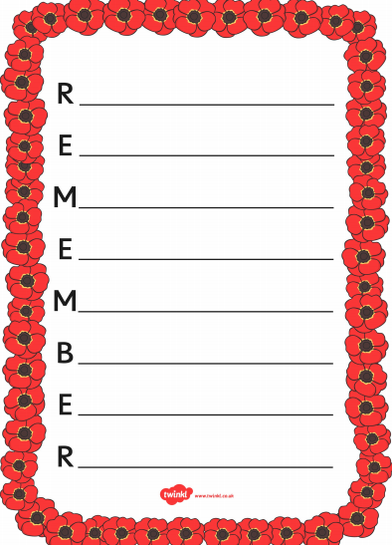
2.30
Celebration time
2.40
Story

