This week’s learning for Year 1 Date: 04.01.21
Hello everyone
Firstly, HAPPY NEW YEAR! I hope you all had a nice break whatever you did.
Secondly, I know the news that we have to close and stay home again will be upsetting for you all. I was looking forward to seeing all of you back in school, but it is important at this time that we keep ourselves and our families safe.
Home learning will follow as close as is possible to what we would have been doing if we were in school, and is varied to cover the different curriculum subjects. The timing beside each subject is flexible and only a guide – if you need to spend more time on anything, then do what you feel is needed. If you have children in other classes, you may want to swap the morning learning to the afternoon learning so you can provide support to them equally.
Please do not feel stressed or anxious about delivering the learning – I am always available to support you via Class Dojo for any questions or worries you may have.
Take care,
Miss.Platts x
Tuesday
9.00am – Maths (for 30 minutes)
Recap what ‘addition’ and its mathematical symbols mean:
what does it mean when we add? (we combine 2 or more groups of objects/numbers together to find a total)
which symbol shows us we are adding? (+)
what does this symbol mean: = ? (equals)
Recap and discuss where the symbols are used by reading this number sentence:
4 + 2 = 6 (4 add 2 equals 6) – the + comes between the 2 numbers we are adding together, and the equals sign comes before the answer/total.
Revisit how to add by counting on using our fingers.
Look at this number sentence: 6 + 3 = ?
How could I work out what 6 + 3 is by using my fingers? (listen to your child’s suggestions)
To count on using fingers, we start with the first number in the number sentence.
Which number is first in the number sentence? (6)
We are going to put this number in our head, and this is where we will start counting from.
How many am I adding to the 6? How do you know? (3, because the number sentence says + 3)
We are going to count on from 6, and add on 3.
What will happen when we add by counting on? Will the total be more or less than 6? (the numbers get bigger, it will be more because we are counting on)
Which number will be next when I count on? (7, because we are starting counting from 6, and 7 is after 6)
Model how to count on – put your hand on your head and start by saying “6” aloud. Now count on 3 using fingers, saying 1 number for each finger (7, 8, 9). Show that you have added 3 by counting how many fingers you have used. Explain that it is important to keep check on how many fingers you are putting up to make sure that you get the right answer. You could start by putting up 3 fingers and put them down as you count on if you think this will be easier.
What is the answer to 6 + 3 = ? (9, because you counted on 3, and stopped counting at 9)
Work through these questions by counting on to add. Each time, work through step by step asking:
Which number are we starting with from?
How many are we adding?
Which number will come next when you count on?
What is the answer?
How can we check?
- 3 + 4 = 2. 5 + 2 =
3. 9 + 3 = 4. 12 + 5 =
Now look at the power point for Tuesday and work through the slides about counting on, and then have a go at the activity at the end. If you don’t have any number cards or dice, just write down numbers to 10 on pieces of paper and choose 2 numbers to add together by counting on.
Alternatively, watch the power point on video here: https://vimeo.com/490879063

9.30am – Phonics (for 30 minutes)
Look at the grapheme ‘ue’. We know it can make the alternative sound ‘oo’, but it can also make a ‘yoo’ sound too. Watch the video at: https://www.youtube.com/watch?app=desktop&v=fLrAGcK26s4 – look at how the difference in sounds and see if children can identify the words where it makes the ‘yoo’ sound.
Break down these words in to their sounds to read: cue, hue, fuel, argue, tissue, rescue, value, statue continue. When sounding out, emphasise the ‘yoo’ sound, e.g. c-ue, f-ue-l
Have children practice writing the words, cue, hue, fuel, argue, tissue, rescue, value, statue, continue; and the sentence The car needs fuel, stretching out the sounds to spell.
10:00am – Reading (for 15 minutes)
Read through a selection of green and red words. Look out for ‘ed’ and ‘ing’ endings, and say-spell-say the red words (say the word, spell out each letter and clap for each, say the word)
Backpack tramped panted camping nodded soft after bring jumped agree hear that
please going can’t where rolled down

Read STAR book – The Camping Trip
10.15am – Literacy (for 30 minutes)
Look at the front cover for the book, ‘Three Billy Goats Gruff’ by Alison Edgson. This is a traditional tale you may already know.
Do you know anything about goats? If necessary, look on the internet at pictures and videos of goats.
Explain that ‘billy goat’ means that they are male. Female goats are called ‘nanny goats’, and baby goats are called ‘kids’.
Look at the STAR words and discuss what they mean:
Meadow | Grassland (look at images on google)
Bridge | Structure over water that allows people to pass
Hooves | Animals feet
Roared | Shouted

Listen to the story here: https://www.youtube.com/watch?v=IU0FTtSUtBI
Who were the characters in the story?
What was the setting?
Where did the billy goats want to go?
Why did they want to go there?
What was the problem in the story?
Who lived under the bridge?
What was it like under the bridge?
How was the problem solved?
We are now going to write comparative sentences about the billy goats, and use the endings –er and –est to compare their sizes. We are also going to use the conjunction ‘but’ for the last comparison.
What sizes were the billy goats? (big, bigger, biggest)
How can we list their sizes in order?(big, bigger, biggest)
What sorts of words are big, bigger, biggest? (adjectives, because they are describing the size)

Share and write the sentence: The Small Billy Goat Gruff is big, the Medium Billy Goat Gruff is bigger, but the Big Billy Goat Gruff is the biggest.
Discuss that this sentence is a list, so we have used something called a comma (point them out) because it helps us to read each part separately. Point out the different endings –er and –est as the sizes get bigger, and the conjunction but.
Now write a sentence to compare the sizes of the Billy Goat Gruff. When you have finished, check that you have used capital letters, finger spaces and a full stop. Make sure you have used either the ending –er or –est to describe the sizes in your sentence and that it makes sense.

10.45am – Spellings (up to 20 minutes)
Using the Look, Cover, Write, Check strategy practice this week’s spellings. How many can you get right without looking at the spelling?
This week’s spellings are: Monday, Tuesday, Wednesday, Thursday, Friday
Afternoon Activity –
What is Earth? (a planet where we live)
What is a planet? What are they made of? (round/spheres of rock in space)
Are there any other planets?
Do you know the names of any other planets?
Do you think anyone lives on any of the other planets?
Find out about the different planets in our solar systems. You may want to watch these videos:
https://www.youtube.com/watch?v=Qd6nLM2QlWw
https://www.youtube.com/watch?v=bf40ruY8UOs.
You could also use non-fiction books about planets, or web searches using websites such as google, to find out information. Discuss how the sun is not a planet, it is a star, and the moon is not a planet.
How many planets are there? (8)
Which is the smallest planet? (Mercury)
Which is the biggest planet? (Jupiter)
Which planet is closest to the sun? (Mercury)
Which planet is the furthest from the sun? (Neptune)
.
Share a fact you have found out about each planet. You could choose one planet to make a fact file about, like this:
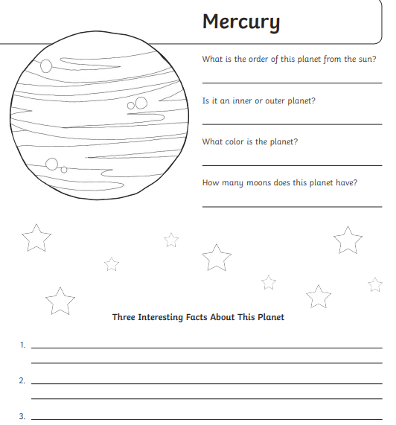
Wednesday
9.00am – Maths (for 30 minutes)
Look at these number sentences and recap how to add by counting on:
6 + 4 = 3 + 5 = 8 + 3 = 10 + 6 = 13 + 4=
Which number are we starting with from?
How many are we adding?
Which number will come next when you count on?
What is the answer?
How can we check?
Now move on to looking at counting on using pictorial representations and 10 frames. Here is an example:
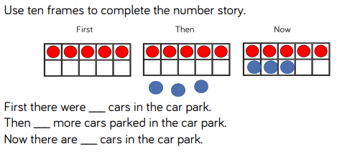
The 10 frames show a ‘first, then and now’ story. Look at the ‘first’ 10 frame, there are 5 red spots. This means first there were 5 cars. The blue spots under the ‘then’ frame show how many are being added, so there are 3 more cars. The last 10 frame (now) shows the total of the red and blue spots, so 5 +3 = 8. There are now 8 cars.
Work out and fill in the last 10 frame for these stories:
1. First, there were 4 coins in a purse. Then, my mum gave me 2 more coins. Now I have ___________ coins.

- First, there were 2 birds in a tree. Then, 4 birds flew to the tree. Now there are ___________ birds.

- First, I had 6 stickers on my chart. Then, I was given 3 more stickers. Now I have ___________ stickers.

9.30am –Phonics (for 30 minutes)
Revisit ‘ue’ by asking the children to break down the words:: cue, hue, fuel, argue, tissue, rescue, value, statue, continue in to their phonemes (e.g. h-ue, ar-g-ue) – which sound do they all have? How do we write it/ what does it look like? Write the grapheme ‘ue’ down to remind them. Ask children to read the sentences:
We do not argue with friends.
Can I have a soft tissue?
You play snooker with a long cue.
Can they identify the word with our focus phoneme?
Say each of these sentences aloud together a few times before having a go at writing them: Ask your child to underline where the ‘ue’ sound is in the sentence.
Put some fuel in the bus.
Can you continue with the story?
Look at the tall statue.
Now see if you can separate these words in to 2 groups – they have the same grapheme ‘ue’, but some words will make the ‘oo’ sound, and some ‘yoo’.
Blue, argue, rescue, glue, true, fuel, clue, continue, cue, statue,

10:00am – Reading (for 15minutes)
Read through a selection of green and red words. Look out for ‘ed’ and ‘ing’ endings, and say-spell-say the red words (say the word, spell out each letter and clap for each, say the word)
Backpack tramped panted camping nodded soft after bring jumped agree hear that
please going can’t where rolled down
Read our STAR story - The Camping Trip

10.15am –Literacy (for 30 minutes)
Recap the story of Three Billy Goats Gruff.
Who are the characters?
What is the setting?
What was the problem in the story?
How was it solved?
Yesterday we wrote a sentence to compare the sizes of the Billy Goats Gruff. We used the endings –er and –est on the word big to do this. Today we are going to use the words more and most to compare. Listen to this sentence: I like pizza, I like chocolate more, but I like ice cream most of all. It shows which foods I like in order of my preference. I like all 3 foods, but it shows that I like chocolate more than pizza, and that I like ice cream more than chocolate and pizza.
Which conjunction have I used before the last comparison? (but)
Which 3 foods do you like? Can you compare them in order of preference?
Use the sentence stem I like….., I like…... more, but I like ….. most of all to answer and order the 3 foods.
Now write down your answer, using the same sentence stem.
Can you remember what we need to use because we are writing a list? (a comma)
Why do we need to use commas? (to separate the ideas so they can be read separately)
Which conjunction do we need to use before your last comparison? (but)
Re-read your sentence. Does it make sense? Have you used more and most to compare? Have you used capital letters, finger spaces and a full stop?
10.45am – Spellings (up to 20 minutes)
Practice your handwriting using this week’s spellings. Write each word 5 times. Remember your ascenders and descenders!
This week’s spellings are:
Afternoon Activity –
Think about the days of the year – which are some of the best days to you? (children may suggest birthdays, Christmas, Eid, Easter etc or even days where they attend a club or activity)
Which do you prefer and why–
Sunday or Monday?
Christmas or Easter?
Eid Al Fitr or Bonfire Night?
Halloween or Diwali?
Your birthday or first day of the summer holiday? (If your child doesn’t know what some of these celebrations are, explain they are religious observations that are important to people in those religions and that not everyone celebrates the same things)
Which days are most important to you and why?
Do you know when those days are? (e.g. date of their birthday, Christmas, Bonfire Night etc)
How do we celebrate special times?
Look at the ‘Celebrations’ picture power point that shows different ways people celebrate.
Make a list of the things that make special days so great – this could be a drawn list, or a written list if able to do so. Things you may include are presents, special food, spending time with family, cards and greetings, remembering important events or people, telling stories, singing songs, new clothes, or any other things they can think of that makes the day different to any other normal day

- First, there were 5 bees on a flower. Then 5 more bees flew to the flower. Now there are ___________ bees.

- First, there were 3 cars in a car park. Then 6 more cars parked up. Now there are ___________ cars.

9.30am – Phonics (for 30 minutes)
Recap the grapheme ‘ue’. What sound does it make? – break down these words in to their sounds: cue, hue, fuel, argue, tissue, rescue, value When sounding out, emphasise the ‘yoo’ phoneme, e.g. c-ue, f-ue-l
Now ask your child to read these sentences:
Can you continue the story?
I need a tissue for my nose.
You play snooker with a long cue.
Can they identify the word with our phoneme in?
Now see if your child can use the sound ‘ue’ to write these sentences. Remind them of what they need to write a sentence.
We do not argue.
Put some fuel in the bus.
Look at the tall statue.
Can your child to underline where our phoneme is?

10:00am – Reading (for 15 minutes)
Read through a selection of green and red words. Look out for ‘ed’ and ‘ing’ endings, and say-spell-say the red words (say the word, spell out each letter and clap for each, say the word)
Backpack tramped panted camping nodded soft after bring jumped agree hear that
please going can’t where rolled down
Read STAR book – The Camping Trip
10.15am – Literacy (for 30 minutes)
Recap the story, ‘Three Billy Goats Gruff’ by Alison Edgson. If you need to, re-watch the story.
Who were the characters in the story?
What was the setting?
Where did the Billy Goat Gruff want to go?
Why did they want to go there?
What was the problem and how was it solved?
Today we will use the words ‘more’ and ‘most’ for comparison, and use the conjunction ‘but’ before the last comparison.
Sometimes we put suffixes on words to compare differences. We can also use ‘more’ and ‘most of all’. For an example, model this sentence:I like pizza, I like spaghetti more, but I like ice cream most of all. Point out where you have used ‘more’ and ‘most of all’ and the conjunction ‘but’ to order them and show your preference of foods.
What foods do you like to eat?
Can you use the words more and most of all to put them in order of preference?
Use the sentence stem ‘I like _____, I like _______ more, but I like ________ most of all’ to say your answer.
Now ask your child to write down their food preferences using the same sentence stem: Use the sentence stem ‘I like _____, I like _______ more, but I like ________ most of all’

10.45am – Spellings (up to 20 minutes)
Using the Look, Cover, Write, Check strategy practice this week’s spellings. How many can you get right without looking at the spelling?
This week’s spellings are: : Monday, Tuesday, Wednesday, Thursday, Friday
Afternoon Activity –
What are some special days for you?
Why are they special?
Which do you prefer and why – Monday or Saturday? Christmas or Easter? Eid or Bonfire Night? Your birthday or Halloween? Diwali or the first day of the summer holiday? – some of these celebrations may not be relevant to your family, and you may not know what they are. Explain that they are different religious celebrations that are important to people who follow a different religion to us.
How do we celebrate special days?
Look at the power point ‘Celebrations’ together as different things that may be used for special days. Talk about what they are and any experiences you have had.
Now ask your child to make a list of things we can use to celebrate – this could be a drawn picture list or a written list.

Thursday
9.00am – Maths (for 30 minutes)
Today we are going to look at adding by counting on using a number line.
Watch the video about how to add by counting on using a number line at: https://vimeo.com/490879463 or alternatively look at the power point for Thursday.
Where do we start on a number line when adding? (the first number in the number sentence)
How do I know how many to add/how many jumps to make from that number? (the second number in the number sentence)
How do we count on correctly? (jump on to the next number from where we are starting from, 1 jump for each number as we count on)
How can we check we have the right answer? (count the jumps – have we done the right amount? Does it match what we needed to add in the number sentence?)
Use a number line to work out the answers to these questions. Practice counting on using this number line practically using your finger for the first 4 questions before doing any recording using a pencil. Remember to read the question to decide where you need to start on the number line and how many you need to count on. Be careful to jump 1 for each number you count on
1. 2 + 4 = 2. 4 + 4 = 3. 5 + 2 = 4. 8 + 6 =

Now record your answers for these questions:
3 + 3 =

5 + 4 =

7 + 5 =

11 + 3 =

15 + 5 =
13 + 6 =

9.30am – Phonics (for 30 minutes)
Introduce the alternative sound ‘u-e’, which can also make a ‘yoo’ sound in words, but it is a split digraph. Look at how this sound is shown within words and then break down these words in to their sounds to read: cube, huge, mute, tune, excuse, refuse, computer
Have children then write the words tube, cute, mule, duke, fume, volume; and the sentence The box is a cube, stretching out the sounds to spell.

10;00am – Reading (for 15 minutes)
Read through a selection of green and red words. Look out for ‘ed’ and ‘ing’ endings, and say-spell-say the red words (say the word, spell out each letter and clap for each, say the word)
Backpack tramped panted camping nodded soft after bring jumped agree hear that
please going can’t where rolled down
Read our STAR story – The Camping Trip
10.15am – Literacy (for 30 minutes)
Today we are going to use words with the suffix ‘-er’ and ‘-est’ and the words ‘more’ and ‘most’ for comparison. We are also going to use the conjunction ‘but’.
When do we use the suffixes ‘er’ and ‘est’? (when we are comparing something with the same characteristic, e.g. size)
When do we use the words ‘more’ and ‘most’? (when comparing nouns or activities)
What is special about words using ‘est’ and ‘more’? (it is the most extreme comparison)
Which conjunction are we going to use before the last comparison? (but)
What do we put between each comparison? (a comma , )

Re-look at the ending of the story, today we are going to make up our own ending to the story which is different.
What would happen at the end of the story if the 3 Billy Goat Gruff made friends with the troll?
Which games could they play together?
In my ending, they are going to play a game to see who can jump the highest.
Who might jump the highest and why?
Ask your child to watch as you write these sentences (say the words aloud and sound out the words as you write)
The Little Billy Goat Gruff jumped high, the Medium Billy Goat Gruff jumped higher, The Big Billy Goat Gruff jumped even higher, but the troll jumped the highest because he had strong legs.
Read the example to them. Show that it has words with the suffixes ‘er’ and ‘est’ (higher and highest) to compare who jumped the highest, and also the conjunction ‘but’ before the last comparison to show who jumped the highest. Point out that there are also comma’s (,) used after each comparison in the sentence.
Which game will the goats and troll play in your sentence and what will happen?
Ask your child to say their idea in the same style of the example you looked at together. Now it is time to write down their idea. Remind them of the non-negotiables they need in their writing (capital letter, finger spaces, full stops) and the grammar features for today’s focus (er and est suffix, but, comma to separate comparisons)
Use this checklist at the end to check their work:
Capital letters  (for the start of the sentence and names) |  | Full stop
Finger spaces |  | ‘er’ and ‘est’ suffixes
Conjunction ‘but’ |  | Comma’s

10.45am – Spellings (up to 20 minutes)
Put this week’s spellings into sentences. Remember your full stops, finger spaces and capital letters.
This week’s spellings are:
Afternoon Activity
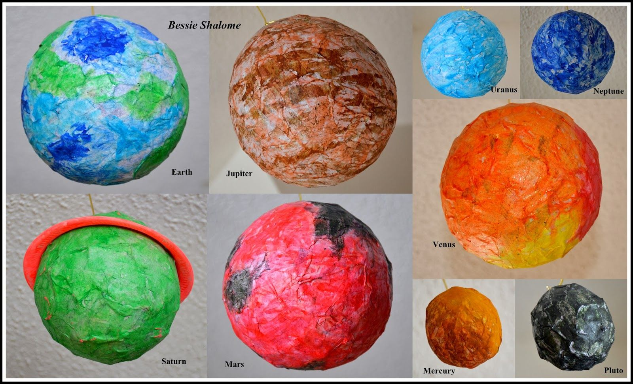
Choose your favourite planet to make a papier mache model of. You will need:
- a balloon
- newspaper or kitchen roll
- paint brush
- watered down PVA glue
- paint
- Blow up the balloon to the right size and fasten.
- Cover the balloon in layers of newspaper/kitchen roll and glue by brushing on glue. You will need lots of layers to make sure your planet is strong and holds it shape when it is dry, but don’t forget to leave a little space at the bottom where the balloon is fastened, uncovered. Glue down any loose bits of paper.
- When the papier mache is dry, pop the balloon. This may take a few days!
- Paint your planet using the correct colour – check. Use different ways to create the textures of the surface of the planet (scrunched paper, tin foil, brushing etc)
- If needed, watch this video here for clearer instructions: https://www.youtube.com/watch?v=M7iokGsaYus

Friday
9.00am – Maths (for 30 minutes)
Recap counting on using a number line.
Where do we start on a number line when adding? (the first number in the number sentence)
How do I know how many to add/how many jumps to make from that number? (the second number in the number sentence)
How do we count on correctly? (jump on to the next number from where we are starting from, 1 jump for each number as we count on)
How can we check we have the right answer? (count the jumps – have we done the right amount? Does it match what we needed to add in the number sentence?)
Look at the following question about how Ron and Mo have worked out the answer to 3 + 11:
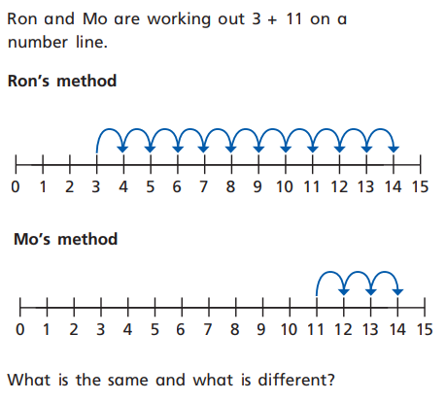
What is the same about what they have done? (they have both got the same answer – 14)
What is different? (Ron started at 3, and counted on 11 (3+11). Mo started at 11, and counted on 3 (11+3) )
Discuss how Mo chose to start counting on from the biggest number in the number sentence 3 + 11.
why do you think he did this? (because it’s easier to count on from 11 and add 3, than it is to add 11 to 3)
Does it matter Mo did this? (no, because he got the same answer – 3 + 11 = 14, 11 +3 = 14. It doesn’t matter which way round we add the 2 numbers because we will always get the same answer)
Now use a number line to work out these questions – Try with the biggest number and the smallest number first for each question – do you get the same answer?
1 + 4 =
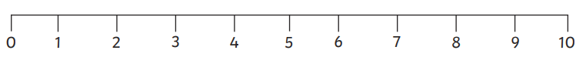
3 + 2 =
6 + 3 =

9 + 5 =
12 + 6 =
4 + 14 =
11 + 5 =
3 + 16 =
9.30am – Phonics (for 30 minutes)
Revisit the split digraph ‘u-e’ by asking the children to break down the words:: cute, huge, cube, mute, volume, tune in to their phonemes (e.g. c-ue-t, h-ue-g) – which sound do they all have? How do we write it/ what does it look like? Write the grapheme ‘u-e’ down to remind them. Ask children to read the sentences:
The fluffy cat is cute.
Can I go on the computer?
I can pay a tune on the flute
Can they identify the word with our focus phoneme?
Say each of these sentences aloud together a few times before having a go at writing them: Ask your child to underline where the ‘u-e’ sound is in the sentence.
Turn down the volume!
The pear tree is huge.
A duke is a royal man.
10:00am – Reading (for 15 minutes)
Read through a selection of green and red words. Look out for ‘ed’ and ‘ing’ endings, and say-spell-say the red words (say the word, spell out each letter and clap for each, say the word)
Backpack tramped panted camping nodded soft after bring jumped agree hear that
please going can’t where rolled down
Read our STAR story – The Camping Trip

10.15am – Literacy (for 30 minutes).
Today we are going to use words with the suffix ‘-er’ and ‘-est’ and the words ‘more’ and ‘most’ for comparison. We are also going to use the conjunction ‘but’.
When do we use the suffixes ‘er’ and ‘est’? (when we are comparing something with the same characteristic, e.g. size)
When do we use the words ‘more’ and ‘most’? (when comparing nouns or activities)
What is special about words using ‘est’ and ‘more’? (it is the most extreme comparison)
Which conjunction are we going to use before the last comparison? (but)
What do we put between each comparison? (a comma , )
Re-cap that yesterday we wrote our own ending to the story. Today we are going to think of another ending.
Look again at the example ending you shared yesterday:
The Little Billy Goat Gruff jumped high, the Medium Billy Goat Gruff jumped higher, The Big Billy Goat Gruff jumped even higher, but the troll jumped the highest because he had strong legs.
Read the example to them. Show that it has words with the suffixes ‘er’ and ‘est’ (higher and highest) to compare who jumped the highest, and also the conjunction ‘but’ before the last comparison to show who jumped the highest. Point out that there are also comma’s (,) used after each comparison in the sentence.
Which game will the goats and troll play in your sentence today and what will happen?
Ask your child to say their idea in the same style of the example you looked at together. Now it is time to write down their idea. Remind them of the non-negotiables they need in their writing (capital letter, finger spaces, full stops) and the grammar features for today’s focus (er and est suffix, but, comma to separate comparisons)
Use this checklist at the end to check their work:
Capital letters  (for the start of the sentence and names) |  | Full stop
Finger spaces |  | ‘er’ and ‘est’ suffixes
Conjunction ‘but’ |  | Comma’s

10.45am – Spellings (up to 20 minutes)
Get an adult to test you on your spellings. Write down your answers on a piece of paper – how many can you get right?
This week’s spellings are:

Afternoon Activity
What does healthy eating mean?
Why is it important to eat healthily?
Have your child draw a picture of themselves in the middle of a piece of paper – can they draw and label pictures of food around that they think are healthy for them?
Ask them to talk about what they have drawn and why, and address any misconceptions – i.e. have they drawn any unhealthy foods?
Watch this short video about why it is important to eat healthily - https://www.youtube.com/watch?v=kteZneJm1EI

