Ferham Recommended Reads

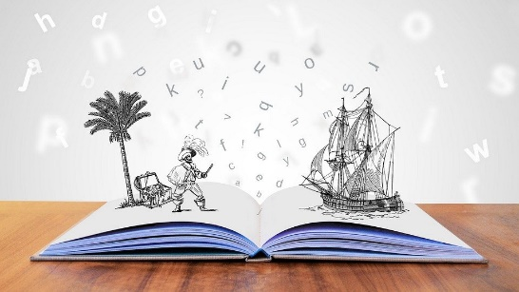

The following list includes only books that our staff have personally read and would fully recommend to our classes. We have hard copies of most of these books so if you would like to borrow one, ask and we will see what we can do!
‘There is more treasure in books, than in all the pirates loot on Treasure Island’ – Walt Disney
June 2021 – These are all recommended reads from staff and children in school
Book Cover | Title | Author | A Brief Guide
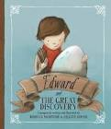 | Edward and the Great Discovery | Rebecca McRitchie | Edward’s parents are archaeologists and have made some great discoveries. But he never has until now…  Edward discovers an egg!  Join him on his quest to figure out what it is.  I loved this story and Edward’s journey to a great discovery.  Review by Mrs Robinson
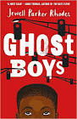 | Ghost Boys | Jewell Parker Rhodes | Very good, a great book that shows the importance of Black Lives Matter. Review by Zak Y4  Really interesting, about a kid called Jerome killed by a white police man. Chapters change from the future to the past. Review by Umar Y4  FABULOUS! Couldn’t put it down! Review by Miss Southall
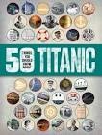 | 50 Things you should know about The Titanic | Sean Callery | Do you love history? If you do, then this book is for you. This book is packed full of facts about The Titanic. From how and where it was built to how a nearby ship could have helped save more lives. There are lots of pictures from actual events so you can get a real feel for what it was like aboard the famous ship.  Review by Mrs Robinson

