Morning maths Monday 8th February 2021
WALT: check calculations using the inverse.
Check these answers are correct by using the inverse. Use a formal written method.
8.67 + 9.8 = 18.47  Correct  Incorrect | Inverse? | 9.5 - 9.01 = 9.4  Correct  Incorrect | Inverse?
6.42 + 8.6= 14.02  Correct  Incorrect | Inverse? | 8.37 - 4.6 = 3.77  Correct  Incorrect | Inverse?
8.14 + 8.1 = 16.24  Correct  Incorrect | Inverse? | 9.99 - 9.3 = 0.06  Correct  Incorrect | Inverse?
6.78 + 7.8 = 15.16  Correct  Incorrect | Inverse? | 9.99 - 9.66 =1.03  Correct  Incorrect | Inverse?

Morning maths Tuesday 9thFebruary 2021
WALT: round to the nearest tenth.
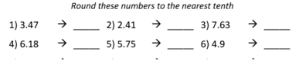
Morning maths Wednesday 10th February 2021
WALT: Order negative numbers.
Put these numbers in descending order:
- -7, 3, 6, -3, 2 _________________________________________
- 0, -6, 2, 8, -3 _________________________________________
- 2, 0, -7, -2, 9 __________________________________________
- 1, -7, 8, -11, 10 ___________________________________________
- -14, 8, 15, -15, 7 ___________________________________________
Morning maths Thursday 11th February 2021
WALT: understand Roman numerals.
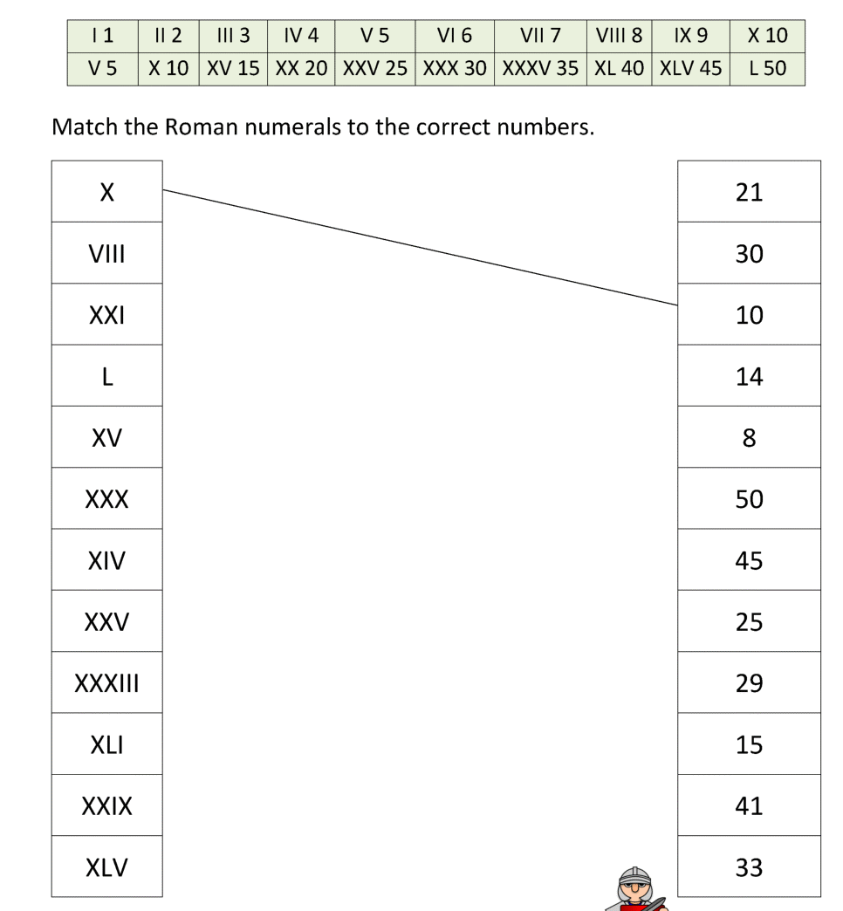

Morning maths Friday 12th February 2021
WALT: multiply
