This week’s learning for Year 1 Date: 14.12.20
Hello children,
Here is the home learning for you to complete this week.
I hope you all have a lovely holiday, however you celebrate, and see you in the New Year!
Take care,
Miss.Platts x
Monday
9.00am – Maths (for 30 minutes)
How do I find 1 more than a number? (count on by 1, jump forwards on a number line)
Warm up by recapping 1 more than using picture stories. Challenge by adding 2 more.
How did you work it out? Show me (can use a number line, counting on using fingers etc)

How do I find 1 less than a number? (count back by 1, jump back on a number line)
Look again at part 1 of the ‘counting on and back’ power point (white rose maths) and the picture stories (taking away)
If an object is taken away, how can I work out the new total? (find 1 less, count back)
Show how we can visually work this out by jumping back on a number line, counting back on our fingers, or crossing out one of the pictures to help us. Work through the questions together, asking children to explain their working out for an answer. Provide number lines for those who need concrete objects for support.

9.30am – Phonics (for 30 minutes)
Revisit the phoneme ‘oo’ (long sound) with the children – say the words soon, moon, room. What sound do they all have in common? can you remember what it looks like/ how to write it? Watch the video about ‘oo’ at: https://www.youtube.com/watch?v=kL074H5XdNI
Read through some words that contain the ‘oo’ sound: zoo, soon, pool, roof, food, school, shoot, broom, balloon. Can the children break them down in to their sounds? (e.g. z-oo, s-p-oo-n).
Have children write some words out: moon, cool, room, tool, boot, spoon, mushroom, shampoo and the sentence: Can you see the bright moon?

10:00am – Reading (for 15 minutes)
Read STAR book – Let’s go Fishing
10.15am –Literacy (for 30 minutes)
Look at the front cover for the story, ‘Big Blue Whale’ by Nicola Davies.
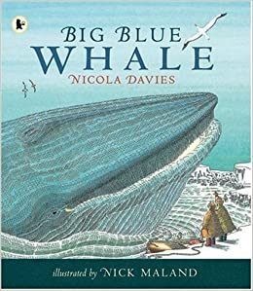
This book is a non-fiction book; can you remember what that means? (it’s a book that tells us true information and facts)
Recap our STAR words and what they mean:
whale | a very large mammal that lives in the water
protected | Kept safe
slippery | Smooth and hard to grip
slithers | Slides smoothly

Listen to ‘Big Blue Whale’ again up until the 5:39 mark (https://www.youtube.com/watch?v=Sl28RVuEODs
Today we are going to write a sentence using nouns and adjectives.
What is a noun? Can you give an example? (person, place, animal, object, e.g. cat, Rotherham, teacher, boy, pencil, car, lion etc)

What is an adjective? Can you give an example? (a describing word, it describes a noun e.g. blue, red, fluffy, big, small, hard, soft etc)
We are going to write sentences using facts about blue whales we have learned from the text.
What is special about blue whales?
What do they look like?
How big are they?
What do blue whales eat?

Compose and write a sentence using the sentence starter: Blue whales…. that includes a fact about whales, nouns, and adjectives. E.g. Blue whales have ears that are like small holes.
When you have finished, check your sentence. Does it have a capital letter, finger spaces and a full stop? Have you used a noun and adjective? If so, underline them. Does your sentence make sense?
10:45am – Spellings (for up to 20 minutes)
Write a diary entry about what you have done over the weekend. Try and include our weekly spellings into your sentences.
This week’s spellings are: soon, moon, shampoo, blue, true, rule, tune, fruit,
Afternoon Activity –
Write a letter to Santa, asking him what you would like for Christmas.
What do we need to include in a letter? (who the letter is for, full sentences, and who the letter is from)
How do we start a letter? (Dear…./ To……)
Why do we need to include our name at the end? (so Santa knows who the letter is from)
What do we need to put the letter in? (an envelope)
What do we need to put on the envelope and why? (Santa’s address so it can be delivered to him)
Where does Santa live? (North Pole)
Where do we need to take a letter? (to a post box)
Don’t forget to post it!!
Tuesday
9.00am – Maths (for 30 minutes)
Look at 1 more/ 1 less using a number track in part 2 of the ‘Count on or back’ power point. Discuss the 2 ways we can describe the position of a number on the number track e.g. 17 is 1 more than 16, 17 is 1 less than 18.

How do we find 1 more than a number?
How does the number change? Which digit changes? (the units number changes, it goes up)
How do we find 1 less than a number?
How does the number change? Which digit changes? (the units number changes, it goes down)
What’s the same between the numbers 17 and 16? (they both have 1 10)
Look at describing the numbers in the power point.
Challenge: I am thinking of a number. 1 more than this number is 15. 1 less than this number is 13. Which number am I thinking of?

Complete questions 4, 5 and 6 on the ‘counting 1 more, 1 less’ worksheet (white rose)

9.30am – Phonics (for 30 minutes)
Revisit ‘oo’ by breaking down the words: zoo, soon, moon, spoon, broom, school, balloon, bedroom in to their sounds for the children to blend – what is the word? Which sound do they all have? How do we write it/ what does it look like? Ask children to read the sentences:
Eat your food with a spoon.
I like to go to school.
We went to the zoo.
Introduce the alternative sound ‘ue’, which also makes the same sound as ‘oo’. Look at how this sound is written, and then break down these words in to their sounds to read: glue, blue, clue, true, Sue
Have children first practice writing ‘ue’ down five times, then write the words: glue, blue, clue, true, Sue and the sentence The blue glue is sticky, stretching out the sounds to spell.
10:00am – Reading (for 15 minutes)
Read STAR book – Let’s go Fishing
10.15am – Literacy (for 30 minutes)
Listen to the rest of ‘Big Blue Whale’ from around the 5:39 mark:
https://www.youtube.com/watch?v=Sl28RVuEODs
Today we are going to write a sentence using nouns and adjectives, and look at how we can improve our work.
What is a noun? Can you give an example? (person, place, animal, object, e.g. cat, Rotherham, teacher, boy, pencil, car, lion etc)
What is an adjective? Can you give an example? (a describing word, it describes a noun e.g. blue, red, fluffy, big, small, hard, soft etc)
Our sentence will be about how blue whales communicate. How do blue whales talk to each other?
Write and share the sentence: Blue whales talk to each other in a long, low hum.
Which words are nouns? (whale)
Which words are adjectives? (long, low)
How can we add more detail?
Provide the sentence stem Blue whales talk to each other….. and think of a sentence to write using 2 adjectives. Write it down.
When you have finished, check it through. Have you used capital letters, finger spaces and full stops? Have you included nouns and adjectives? Which words have you used?

10.45am – Spellings (up to 20 minutes)
Using the Look, Cover, Write, Check strategy practice this week’s spellings. How many can you get right without looking at the spelling?
This week’s spellings are: soon, moon, shampoo, blue, true, rule, tune, fruit,
Afternoon Activity –
Make a homemade decoration for your Christmas tree. You could make a bauble using salt dough, then bake it in the oven to paint and decorate. You could use card, felt tips and glitter to make a hanging Santa or snowman. Here are some ideas:
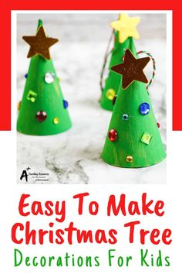 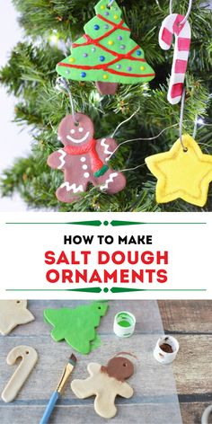 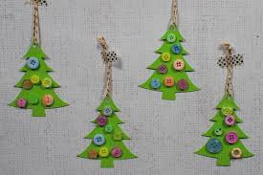
If you don’t celebrate Christmas, and don’t have a Christmas tree to hang it on, you could hang it in your garden if you have a tree or large bush.

Wednesday
9.00am – Maths (for 30 minutes)
Look at comparing groups of objects.
Can you compare groups of objects without counting them? (yes)
How do you know? (by looking at how many is in each group – you can see if one has more than the other)
Look at the ‘comparing groups of objects’ video at: https://vimeo.com/483168827
If you prefer, you can look at the power point version. Talk through the slides and discuss each slide:
Which group has the most?
Which group has the least?
How many more than/less than does group___ have than group _____?
What does less than mean? (smaller)
What does greater then mean? (bigger)
What does equal to mean? (the same)
Work through the questions on the ‘comparing groups of objects’ worksheet
9.30am –Phonics (for 30 minutes)
Revisit ‘ue’ by asking the children to break down the words: glue, blue, clue, true in to their sounds (e.g. g-l-ue, c-l-ue) – which sound do they all have? How do we write it/ what does it look like? Write the grapheme ‘ue’ down to remind them. Ask children to read the sentences:
I have a fluffy blue coat.
We need to look for clues.
Can I have the glue?
Introduce the alternative sound ‘u-e’, which also makes the same sound as ‘oo’. Look at how this sound is shown within words as a split digraph, and then break down these words in to their sounds to read: rude, June, tune, rule, flute, prune,
Have children then write the words: rude, June, tune, rule, flute, prune and the sentence I can play the flute, stretching out the sounds to spell.
10:00am – Reading (for 15minutes)
Read our STAR story –

10.15am –Literacy (for 30 minutes)
Today we are going to make a leaflet about blue whales using nouns and adjectives.
What is a noun? Can you give an example? (person, place, animal, object, e.g. cat, Rotherham, teacher, boy, pencil, whale etc)
What is an adjective? Can you give an example? (a describing word, it describes a noun e.g. loud, blue, noisy, huge)
Look at the sun safety leaflet. Show how leaflets have pictures, a title to tell us what it is about, and have facts and information.
What do you know about blue whales?
What makes blue whales special?
What would you like to write in your leaflet about blue whales?
Use a leaflet template to make an information leaflet about blue whales. Write a different piece of information you know on each page, and draw a picture to go with it. Use adjectives and nouns in your sentences.
When you have finished your leaflet, check through. Have you used:
- capital letters
- finger spaces
- nouns
- adjectives
- the correct punctuation ( ? ! . )
- does it make sense?

10.45am – Spellings (up to 20 minutes)
Practice your handwriting using this week’s spellings. Write each word 5 times. Remember your ascenders and descenders!
This week’s spellings are: soon, moon, shampoo, blue, true, rule, tune, fruit
Afternoon Activity –
Have a go at making this festive chocolate bark. It’s really easy to do and would make a thoughtful gift for family and friends…..or yummy to have all to yourself!
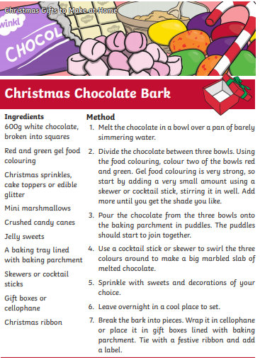
Thursday
9.00am – Maths (for 30 minutes)
Warm up by comparing some groups of objects (comparing power point)
Which group has the most?
Which group has the least?
How many more than/less than does group___ have than group _____?
Move on to comparing numbers.
What does compare mean?
How can we compare 2 numbers? (by looking at their placement in a number line, looking at the digits)
Will zero always be the smallest number when we are comparing? (yes, because it has nothing)

Look at a number line and how this helps us to compare numbers.
Look at the ‘comparing numbers’ video at: https://vimeo.com/483169674
If you prefer, you can work through the comparing number power point (white rose maths)
Which number is greater? How do you know?
Which number is smaller? How do you know?
Answer the questions on ‘comparing numbers’ worksheet (white rose)
9.30am – Phonics (for 30 minutes)
Revisit ‘u-e’ by reading through the words: rude, June, tune, rule, flute, prune, – which sound do they all have? How do we write it/ what does it look like? Write the grapheme ‘u-e’ down to remind them. Ask children to read the sentences:
It is unkind to be rude.
I can play the flute.
In school we follow the rules.
Introduce the alternative sound ‘u’, which also makes the same sound. Look at how this sound is shown within words and then break down these words in to their sounds to read: fruit, suit, ruby, juice, ruler, super, unicorn
Have children then write some of the words and the sentence It is good to eat fruit, stretching out the sounds to spell.

10;00am – Reading (for 15 minutes)
Read our STAR story
10.15am – Literacy (for 30 minutes)
Look at the front cover for the book, ‘Three Billy Goats Gruff’ by Alison Edgson. This is a traditional tale you may already know.
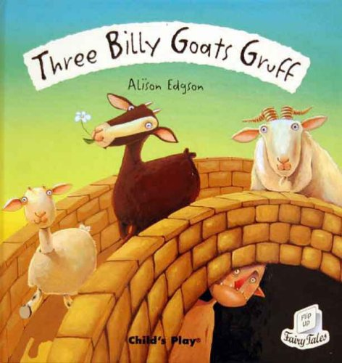
Do you know anything about goats? If necessary, look on the internet at pictures and videos of goats.
Explain that ‘billy goat’ means that they are male. Female goats are called ‘nanny goats’, and baby goats are called ‘kids’.
Look at the STAR words and discuss what they mean:
Meadow | Grassland (look at images on google)
Bridge | Structure over water that allows people to pass
Hooves | Animals feet
Roared | Shouted

Listen to the story here: https://www.youtube.com/watch?v=IU0FTtSUtBI
Who were the characters in the story?
What was the setting?
Where did the billy goats want to go?
Why did they want to go there?
What was the problem in the story?
Who lived under the bridge?

What was it like under the bridge?
How was the problem solved?
We are now going to write comparative sentences about the billy goats, and use the endings –er and –est to compare their sizes. We are also going to use the conjunction ‘but’ for the last comparison.
What sizes were the billy goats? (big, bigger, biggest)
How can we list their sizes in order?(big, bigger, biggest)
What sorts of words are big, bigger, biggest? (adjectives, because they are describing the size)
Share and write the sentence: The Small Billy Goat Gruff is big, the Medium Billy Goat Gruff is bigger, but the Big Billy Goat Gruff is the biggest.
Discuss that this sentence is a list, so we have used something called a comma (point them out) because it helps us to read each part separately. Point out the different endings –er and –est as the sizes get bigger, and the conjunction but.
Now write a sentence to compare the sizes of the Billy Goat Gruff. When you have finished, check that you have used capital letters, finger spaces and a full stop. Make sure you have used either the ending –er or –est to describe the sizes in your sentence and that it makes sense.

10.45am – Spellings (up to 20 minutes)
Put this week’s spellings into sentences. Remember your full stops, finger spaces and capital letters.
This week’s spellings are: soon, moon, shampoo, blue, true, rule, tune, fruit
Afternoon Activity
Look at what an adjective is and how to identify them. Work through the adjective powerpoint together.
Identify the adjective in these sentences:
- The black dog barked.
- I have a pair of red boots.
- A sheep has a fluffy coat.
- I ran up a steep hill.
- I saw a silver moon.
Now think of an adjective to fill in the blank in these sentences:
-The pen is ______.
- I have a ________ teddy.
- I like _______ chocolate.
- A tiger is _______ and _____.
- My bedroom is ______ and ______.

Why not share your favourite book, or reading book. Can you find any adjectives?
Friday
9.00am – Maths (for 30 minutes)
Recap comparing numbers:
What does greater than mean?
What does less than mean?
What does equal to mean?
How can you compare 2 numbers?
What are the symbols we can use? (< > =) What do they mean?
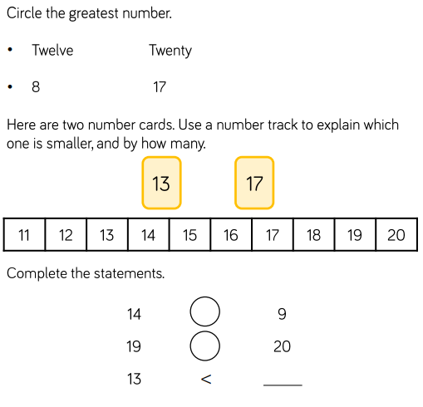
Move on to ordering groups of objects.
How can you order groups of objects? (from smallest to biggest, or biggest to smallest)
How can you work out which is the smallest / biggest group?
Watch the video for comparing objects here: https://vimeo.com/483537557
If you prefer, you can work through the ‘comparing objects’ power point (white rose maths)
What is happening to the numbers as we are ordering the groups?
Can you describe the order?
Work through these questions:
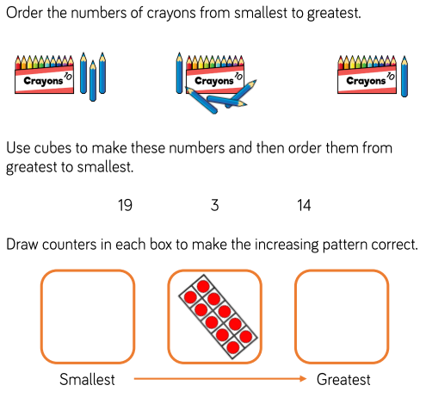
9.30am – Phonics (for 30 minutes)
Play the game trash or treasure: https://www.phonicsplay.co.uk/resources/phase/5/buried-treasure . Select the alternative ‘oo’ sounds to review and practice this weeks learning by reading the words on the coins, and sorting them by real or fake words.
10:00am – Reading (for 15 minutes)
Read our STAR story –
10.15am – Literacy (for 30 minutes).
Recap the story of Three Billy Goats Gruff.
Who are the characters?
What is the setting?
What was the problem in the story?
How was it solved?
Yesterday we wrote a sentence to compare the sizes of the Billy Goats Gruff. We used the endings –er and –est on the word big to do this. Today we are going to use the words more and most to compare. Listen to this sentence: I like pizza, I like chocolate more, but I like ice cream most of all. It shows which foods I like in order of my preference. I like all 3 foods, but it shows that I like chocolate more than pizza, and that I like ice cream more than chocolate and pizza.
Which conjunction have I used before the last comparison? (but)
Which 3 foods do you like? Can you compare them in order of preference?
Use the sentence stem I like….., I like…... more, but I like ….. most of all to answer and order the 3 foods.

Now write down your answer, using the same sentence stem.
Can you remember what we need to use because we are writing a list? (a comma)
Why do we need to use commas? (to separate the ideas so they can be read separately)
Which conjunction do we need to use before your last comparison? (but)
Re-read your sentence. Does it make sense? Have you used more and most to compare? Have you used capital letters, finger spaces and a full stop?
10.45am – Spellings (up to 20 minutes)
Get an adult to test you on your spellings. Write down your answers on a piece of paper – how many can you get right?
This week’s spellings are: soon, moon, shampoo, blue, true, rule, tune, fruit

