This week’s learning for Year 1 Date: 8.2.21
Hello children.
Only one more week to go and then we’ve made it to half term. I am particularly excited because it is my birthday during the holiday.
I am so proud with how hard you have all been working at home these past 5 weeks, and I have been sent some absolutely amazing home learning that has really made me smile. Please do keep sending me in your home learning! If you are having trouble uploading work to classdojo, you can send any files or videos to our class email address at: Class1@fep.jmat.org.uk , or you can bring in any work in to school and leave it in the box at reception. If you haven’t sent me any home learning, I would like you to bring some this week. Remember that we have the home learning champion competition to win a bike, but you can only be entered in to the competition if you are sending home learning back to school.
If you have any questions or worries, please don’t hesitate to contact us on class dojo, or ring school on 01709 740962.
Take care,
Miss Platts and Mrs. Gregory x
Monday
9.15 - Success for All
Phonics
Miss Platts – watch the video on class dojo and complete the activities. We will be revisiting the digraph ‘ow’. After the session you can practise them again on www.phonicsplay.co.uk - choose a game to play such as ‘trash or treasure’, and choose to recap all sounds up to phase 5.
Mrs Gregory – watch the video on class dojo and follow the instructions. We will be looking at the digraph ‘sh’. After the session you can practise them again on www.phonicsplay.co.uk- choose a game to play such as ‘trash or treasure’, recapping all phase 2.
Roots Group 1 – Miss Platts
Our shared story is ‘Slippery Steps’ (this will be uploaded to class dojo and the school website) Todays objective is to blend the sounds that we know to read, including /-y/.
We will be reading as our STaR story, ‘The Emperors Egg’ by Martin Jenkins
You can listen to the story here: https://www.youtube.com/watch?v=nQHaPPNr6zc , listen to up to the 3.37 minute mark only today.
Today you will write down facts you have learned about Antarctica and emperor penguins so far.
Roots group 2 – Mrs Gregory
Our shared story is ‘The Painters’ (this will be uploaded to class dojo and the school website) Read the story to your grown up, talking about what you have read and the events. Today you will focus on blending the sounds you know to read words, including words ending in -s.
We will be reading ‘I’ll Take you to Mrs. Cole’ by Nigel Gray as our STaR story.
You can listen to the story here: https://www.youtube.com/watch?v=Xvqr0ADRwao

11.00 - Assembly – see school website

11.15 - Maths – Counting to 50 making 10’s
We are going to start looking at numbers beyond 20, counting up to 50, by making groups of 10.
The video for today’s lesson can be found here: https://vimeo.com/500465193
Watch the video through to the end. At the end of the video, you are asked to make your own groups of 10 – making 5 groups that you can count in 10’s to make 50. You could use any objects around your house to do this, such as pencils, buttons, sweets, straws etc – anything you can use to make 5 visual groups of 10. Check when you have made your groups that each group has 10 in it.
Can you count each group like this 10, 20,……. Up to 50?

Afternoon -RE: Jewish Celebrations – Hanukkah
Discuss the significance of light in everyday life -
Why do we have lights in our houses?
Why do we have lights in the streets?
When might we use lights for celebrations? (candles on cakes, lights on a Christmas tree, lanterns etc)
Hanukkah is a special Jewish celebration that is also known as the ‘Festival of Lights’.
Watch this video here about what Hanukkah is and how it is celebrated: https://www.youtube.com/watch?v=O3zsTXLjH4s
Watch the story of Hanukkah and find why lights are so significant to Hanukkah: https://www.youtube.com/watch?v=zsXQfCeMHs8
Or look at the power point about Hanukkah and read along.
How much oil did they have left? (enough for 1 night)
How many days did the oil actually burn for? (8 days)
Why are lights so important to Hanukkah? (it reminds Jews of the miracle of the oil burning for a long time)
How many candles are on a menorah? (8)
How long does Hanukkah last? (8 days)
Afterwards, use the dreidel net to make a dreidel, and follow the instructions to play a game of dreidel just like Jewish people do at Hanukkah.
Tuesday
9.15 - Success for All
Phonics
Miss Platts – watch the video on class dojo and complete the activities as modelled in the video. We will be revisiting the digraph ‘oo’. After the session you can practise them again on www.phonicsplay.co.uk - choose a game to play such as ‘trash or treasure’, and choose to recap all sounds up to phase 5.
Mrs Gregory – watch the video on class dojo and follow the instructions. We will be looking at the phoneme ‘z’. After the session you can practise them again on www.phonicsplay.co.uk - choose a game to play such as ‘trash or treasure’, and choose to recap all sounds in phase 2.
Roots Group 1 – Miss Platts
Our shared story is ‘Slippery Steps’ (this will be uploaded to class dojo and the school website) Todays objective is to blend the sounds that we know to read, including /-y/.
We will be reading as our STaR story, ‘The Emperors Egg’ by Martin Jenkins
You can listen to the story here: https://www.youtube.com/watch?v=nQHaPPNr6zc , listen to the whole story today.
Today you will write factual sentences about the emperor penguin.
Roots group 2 – Mrs Gregory
Our shared story is ‘The Painters’ (this will be uploaded to class dojo and the school website) Read the story to your grown up, talking about what you have read and the events. Today you will focus on blending the sounds you know to read words, including words ending in -s.
We will be reading ‘I’ll Take you to Mrs. Cole’ by Nigel Gray as our STaR story.
You can listen to the story here: https://www.youtube.com/watch?v=Xvqr0ADRwao
Today you will write sentences about Mrs. Cole’s house.

11.00 - Assembly – see school website

11.15 - Maths – Numbers to 50
The video for today’s lesson can be found here: https://vimeo.com/500466597. Pause the video when it asks you to, to answer the questions.
Watch the video until it asks you to stop to answer question 1. Count how many sweets there are in picture 1 a) and picture 1 b).
When counting picture b), the sweets are in 10 frames –
Do we need to count each sweet separately if they are in a full 10 frame? Why / why not? (no, because we know a 10 frame = 10, so we can just count it as 10 instead of each sweet separately)
1 c) – which was easier to count and why? The sweets all in a big group, or the sweets organised in 10 frames? (sweets in 10 frames, because we could count in 10’s for each full 10’s frame, and then singular to get the total. We also don’t get muddled making sure we’ve counted correctly unlike when they’re in a big group)
Continue watching the video, and pause it when it asks you to stop and answer question 2.
2 a), b) count the pencils, and then draw that amount of counters in the 10 frames on the sheet.
2 c) How do you know you have counted them all?
Continue watching the video to the end and then answer question 3.
3) Will Rosie say the number 29 if she counts from 21 to 36? How do you know? (yes, because we know that 29 comes after 21, but before 36. Count on from 21 to check, and look on the 50 square/number track to look at place value)
Afternoon: History
Do you think girls can be astronauts?
Do you think there have been any astronauts from the UK go in to space? What about from Sheffield?
Today we are going to find out about Helen Sharman, a female astronaut from SHEFFIELD! She was the first British astronaut to go in to space after entering a competition she heard on the radio. Before she entered the competition, Helen wasn’t an astronaut; she worked as an engineer in London. When she won the competition, she had to go through hard training to learn what to do.
How do you think Helen felt when she heard she had won the competition?
This video shows Helen’s journey, from the training she went through, to going in to space, and returning back to earth: https://www.youtube.com/watch?v=x0-nMl0jf5E
Find out more about her by looking at the power point about her life, and then complete the timeline that shows the major events in her life.
Would you enter a competition to go in to space if you heard it on the radio?
Wednesday
9.15 - Success for All
Phonics
Miss Platts – watch the video on class dojo and complete the activities as modelled in the video. We will be revisiting the digraph ‘oo’. After the session you can practise them again on www.phonicsplay.co.uk - choose a game to play such as ‘trash or treasure’, and choose to recap all sounds up to phase 5.
Mrs Gregory – watch the video on class dojo and follow the instructions. We will be looking at the phoneme ‘w’. After the session you can practise them again on www.phonicsplay.co.uk - choose a game to play such as ‘trash or treasure’, recapping all phase 2
Roots Group 1 – Miss Platts
Our shared story is ‘Slippery Steps’ (this will be uploaded to class dojo and the school website) Todays objective is to blend the sounds that we know to read, including /-y/,and re-read for fluency and accuracy.
Answer the comprehension questions at the end of the book.
We will be reading as our STaR story, ‘The Emperors Egg’ by Martin Jenkins
You can listen to the story here: https://www.youtube.com/watch?v=nQHaPPNr6zc , listen to the whole story today.
Today you will write sentences to compare an emperor penguin’s life to your own life.

Roots group 2 – Mrs Gregory
Our shared story is ‘The Painters’ (this will be uploaded to class dojo and the school website) Read the story to your grown up, talking about what you have read and the events. Today you will re-read the whole story for fluency and accuracy.
Answer the comprehension questions at the end of the book.
We will be reading ‘I’ll Take you to Mrs. Cole’ by Nigel Gray as our STaR story.
You can listen to the story here: https://www.youtube.com/watch?v=Xvqr0ADRwao
Today you will write draw and label Mrs. Cole’s house.

11.00 - Assembly – see school website

11.15 - Maths – counting forwards and backwards within 50
The video you will need for today’s lesson can be found here: https://vimeo.com/500467345
Pause it when it asks you to, to answer the questions.
Watch the video up until it asks you to pause it to answer question 1.
1 a, b, c and d) Look at the pictorial representations to work out if the numbers are going to be counting forwards, or backwards, to fill in the missing numbers on the track.
How do you know which way we are going to be counting? Are the number of objects getting bigger or smaller?
Continue watching the video until it asks you to stop, and then answer question 2.
2 a, b, c, d) Fill in the numbers to complete the number tracks
What is happening to the numbers as we count along?
Are they getting bigger or smaller? How do you know?
Which number will come next? How do you know?
(look at the tens and units to help them work it out if your child isn’t sure which way the numbers are going, so for example 12, 13, 14 – the unit is getting bigger, so we are counting forwards)
Make sure that the numbers are written the correct way around!
Continue watching the video and pause it when it says to answer question 3.
3a) Which number comes before 14?
What does before mean? (the number in front, the number we say before, 1 less than etc)
How can we work it out? (counting back from 14 by 1)
Will the answer be bigger or smaller than 14? (smaller, it will be 13)
3b) Which number comes after 32?
What does after mean? (the number that comes next in the sequence when counting on, 1 more than)
How can we work it out? (counting on from 32 by 1)
Will the answer be bigger or smaller than 32? (bigger, it will be 33)
3c) What are the next 2 numbers after 29?
How can we work this out? (counting on, because it says ‘after’)
Will the numbers be bigger or smaller? (bigger)
Continue watching the video until the end, and then answer question 4.
4) How can we start to work out what the missing numbers will be in the number track? (look at the numbers that we already have on the number track, 23 and 24)
How can I work out the numbers that are missing before 23? (by counting back from 23)
How can I work out the numbers that are missing after 24? (by counting on from 24)
Afternoon: Science – which material is the best for different objects?
You are going to do an investigation to find the best material to make an umbrella from for Ted to keep him dry in the rain.
What does an umbrella do?
What properties in a material do we need to make a good umbrella? (it needs to be waterproof, keep us dry, strong etc)
Look at the power point, ‘Umbrella Investigation’ to see the instructions of what to do to conduct the investigation.
You will need:
- an empty plastic pot/tub orjar
- cotton wool ball to put in the tub/pot/jar
- different materials to test. You could use paper, toilet roll, cardboard, a towel, tin foil, cling film etc.
- Put the cotton wool in the container you choose, and then put the material over the top of the container. It could be laid over, or fastened securely with an elastic band/bobble.
- Make a prediction before you start, which material do you think will work the best and why (a prediction is a sensible guess) Use the experiment sheet to record your prediction
- Decide how many drops of water you will drop on to each material – it needs to be the same so it is a fair test.
- Drop the water on the first material and watch closely –
Does the water drip through and wet the cotton wool?
Does it soak in to the material or run off it?
Does it break/damage the material?
- Record your results on the observation sheet, and then test another material in the same way

What happened to each material?
Was your prediction right?
Which material did you find was best to make an umbrella?
Thursday
9.15am - Success for All
Phonics
Miss Platts – watch the video on class dojo and complete the activities as modelled in the video. We will be revisiting the split digraph ‘u-e’. After the session you can practise them again on www.phonicsplay.co.uk - choose a game to play such as ‘trash or treasure’, and choose to recap all sounds up to phase 5.
Mrs Gregory – watch the video on class dojo and follow the instructions. We will be looking at the digraph ‘ch’. After the session you can practise them again on www.phonicsplay.co.uk - choose a game to play such as ‘trash or treasure’, recapping all phase 2
Roots Group 1 – Miss Platts
Complete the reading comprehension about emperor penguins. Read through the text, then answer the questions using information from the text.
We will be reading as our STaR story, ‘The Emperors Egg’ by Martin Jenkins
You can listen to the story here: https://www.youtube.com/watch?v=nQHaPPNr6zc ,
Today you will write a webpage about emperor penguins and their young.

Roots group 2 – Mrs Gregory
Complete the reading comprehension, ‘The Pup is in the Mud’. Read through the text and answer the accompanying questions.
We will be reading ‘I’ll Take you to Mrs. Cole’ by Nigel Gray as our STaR story.
You can listen to the story here: https://www.youtube.com/watch?v=Xvqr0ADRwao
Today you will write about a house using words from our drawing from yesterday.

11.00 – Assembly– see school website

  - – Maths: 10’s and 1’s
The video you will need for today’s lesson can be found at: https://vimeo.com/500467998
Watch the video, and pause it to answer questions 1 and 2 when it asks you to.
1) How many apples are there?
If the 10’s frame is full, how many apples are there in it? (10, because 10 ones = 10)
How many full 10 frames of apples are there? so how many 10’s do we have? (3 tens)
How many ones are there? (single apples in the incomplete 10’s frame are the ones - there are are 4 ones)
If we have 3 tens and 4 ones, how many apples are there? (34, because 34 is made up of 3 tens, and 4 one’s, count the 10’s and then on in one’s to show this e.g. 10, 20, 30, for the full 10 frames, 31, 32, 33, 34 for the singular apples)
2) What number is shown?
How many cubes are there in a tower? How much is it worth? (10)
How many towers of 10 are there? So we have ____ 10’s (4 full towers of 10, so 4 10’s)
How many ones are there? (the singular red cubes, 8)
So which number is represented by 4 ten’s and 8 ones? (48, because there are 4 tens and 8 ones in 48. Again, to show this count in 10’s and ones – 10, 20, 30, 40 for the towers, 41, 42, 43, 44, 45, 46, 47, 48 for each red cube)
Continue watching the video, and stop it to answer questions 3 and 4.
3a) Draw a base 10 to show 23
How many tens are in 23? How many tens do I need to show? (2) – for this, you will need to draw any representation to show 2 10’s, it could be 2 towers of 10 like in question 2, or 2 full 10 frames as shown in question 1 with the apples
How many ones are there in 23? How many ones do I need to show? (3) – for this draw 3 separate cubes if you have towers, or 3 counters if you have drawn the 10 frames.
b) Draw base 10 to show 3 tens and 2 ones.
How can I show this? (as with the previous question, represent it in towers and cubes, or 10 frames)
Which number is it? (32)
4) look at the given information to work out either the value of the tens and ones, or how many tens and ones are in the number.
Watch the video to the end and then answer question 5.
5) How many tens does Eva have in her number? (2)
How many ones does Jack have? (9)
If they are both making the same number, and it has 2 tens and 9 ones, which number are they making? (29)

Afternoon: D&T
Make some galactic star biscuits at home using the recipe attached (or any recipe you already use for biscuits). You could alter the recipe slightly and add in chocolate chips or sprinkles, or choose a different flavour to vanilla. When they are cooked you could even decorate them with this swirly galaxy icing (use white icing, drip on food colouring and swirl through to make a pattern with a cocktail stick/fork):
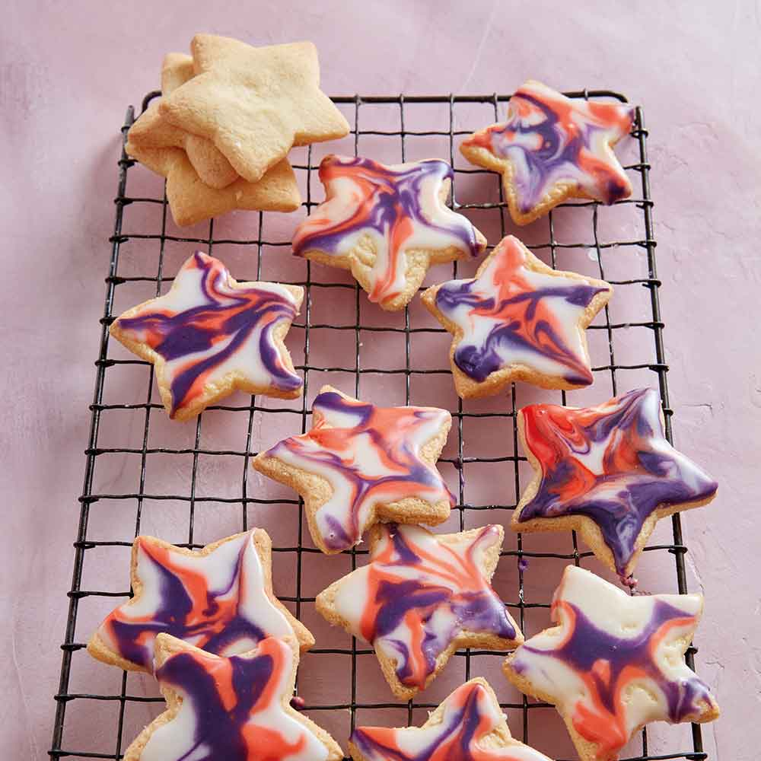
Friday
Success for All
Phonics
Miss Platts – watch the powerpoint and complete the activities as modelled in the video. We will be revisiting the split digraph ‘u-e’. After the session you can practise them again on www.phonicsplay.co.uk - choose a game to play such as ‘trash or treasure’, and choose to recap all sounds up to phase 5.
Mrs Gregory – watch the powerpoint and follow the instructions. We will be looking at the phoneme ‘j’. After the session you can practise them again on www.phonicsplay.co.uk - choose a game to play such as ‘trash or treasure’, recapping all phase 2
Roots Group 1 – Miss Platts
Read your colour banded reading book.
We will be reading ‘This Moose Belongs to Me’ by Oliver Jeffers as our STaR story.
You can listen to the story here: https://www.youtube.com/watch?v=4p7cbOtVl78
Today you will make a fact file about moose. Use the challenge sheet to research which of the facts are true or not (type the fact in to google) and then write the true facts in to the writing box.
Roots group 2 – Mrs Gregory
Read your colour banded reading book from school.
We will be reading ‘I’ll Take you to Mrs. Cole’ by Nigel Gray as our STaR story.
You can listen to the story here: https://www.youtube.com/watch?v=Xvqr0ADRwao
Today you will write sentences about your house and what it looks like.

11.00 – Assembly – see school website

11.15 – Maths: Represent numbers to 50
The video you will for today’s lesson can be found at: https://vimeo.com/500468562
Pause the video when it asks you to answer question 1.
1 a) If the whole is 31, what will go in to the part/part to show the tens and the ones? (30 and 1, because in 31 there are 3 tens which is 30, and 1)
1 b, c) What is the whole? (the whole is the circle at the top, to do this they need to count the tens and the ones to find the total)
What will go in the parts? (the tens in 1 part, and the ones in the other part)
Watch the video to the end, and answer questions 3 and 4.
3 a, b and c) Decide how you would represent the part/part/whole

4) look at the part/part/whole model – What mistake has Mo made? (he has said that 3 ones and 4 ones make 34, instead of writing the 3 in tens as 30)
.
Afternoon: PSHE: Keeping Healthy - How Can I Look After My Teeth?
Last week we looked at keeping healthy and personal hygiene
Can you remember what hygiene means?
Can you remember what things you should do to keep yourselves clean and healthy?
Today we are going to focus on the importance of brushing our teeth.
Why do you think it’s important to brush our teeth and keep them clean?
What would happen if we didn’t brush them?
Are there any foods you know that are bad for our teeth?
Who do we go and see to check that our teeth are healthy?
Look at the power point, ‘Healthy Teeth’
Finish by watching the story, ‘Alan’s Big Scary Teeth’ – you will find that Alan’s has a big secret about his big, scary teeth: https://www.youtube.com/watch?v=Z-rrOeSqfmc

